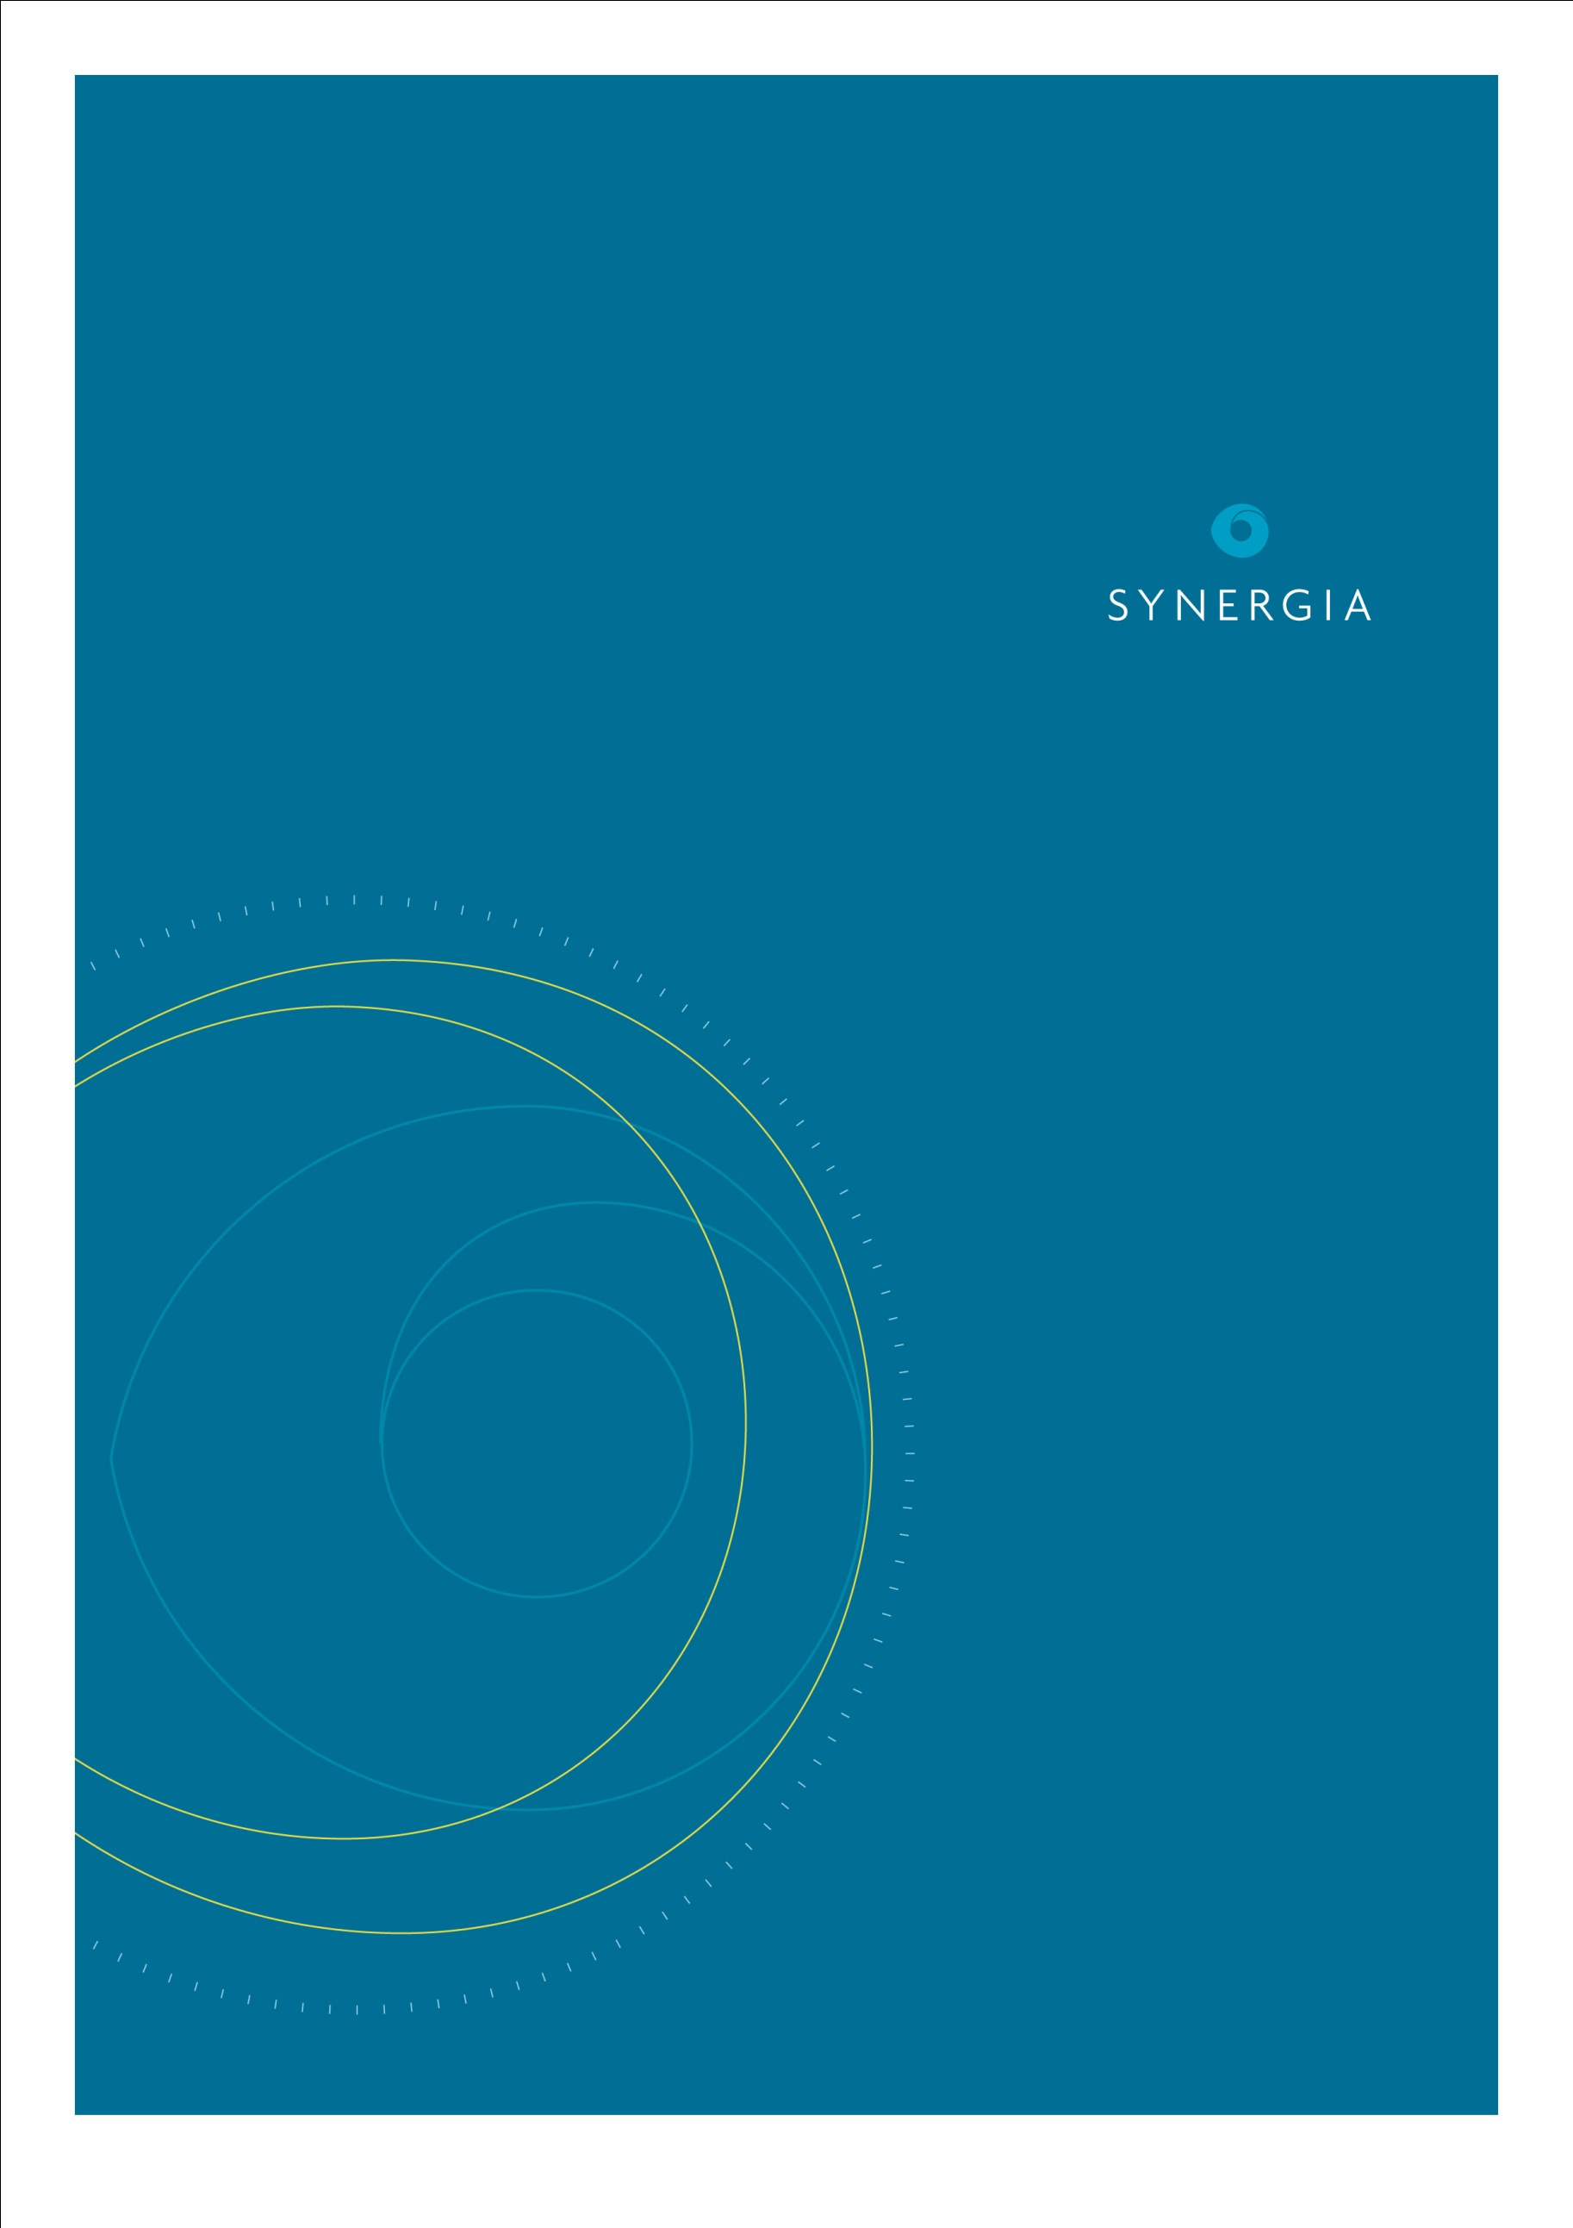

**Understanding the factors that contribute to social exclusion of disabled people**

**Rapid review for   
Think Differently**

**Executive summary**

Dr Sarah Appleton-Dyer

Dr Adrian Field

20 November 2014

Synergia Ltd   
P.O. Box 147 168  
Ponsonby  
Auckland 1144

[www.synergia.co.nz](http://www.synergia.co.nz)

Disclaimer

The opinions expressed herein are the researchers and do not necessarily reflect the views of the Ministry of Social Development.

# Executive Summary

Think Differently, led by the Ministry of Social Development, is a social change campaign that seeks to encourage and support a fundamental shift in attitudes and behaviours towards disabled people. It works across community and national level activities to:

* Mobilise personal and community action
* Change social attitudes and beliefs that lead to disabled people being excluded
* Increase people’s knowledge and understanding of disability and the benefits of inclusive communities.

To support this work, Think Differently commissioned a review of the published and grey literature to understand the factors that cause disabled people to be socially excluded. The review is designed to inform the further development of the Think Differently Campaign. This summary focuses on understanding social exclusion and its key drivers. The methods and a more detailed analysis of the key concepts are provided in the main body of this report.

## Social exclusion

Social exclusion involves the lack or denial of resources, rights, goods and services, and the inability to participate in the normal relationships and activities, available to the majority of people in a society, whether in economic, social, cultural or political arenas. It affects both the quality of life of individuals and the equity and cohesion of society as a whole (Levitas et al 2007).

## Forms of social exclusion

The drivers of social exclusion are complex and multifaceted. The different forms of exclusion identified in the diagram on the following page illustrate this.

**Four key forms of social exclusion**

The diagram above identifies the reinforcing nature of exclusion. For example, disabled people may be excluded from employment due to deliberate exclusion by employers (social exclusion). This exclusion is reinforced by the lack of policy or implementation of policies to promote equality opportunities within the workplace (political exclusion).

## Macro-drivers of exclusion

The Social Exclusion Unit in the UK identifies three major contextual factors that contribute to social exclusion (Social Exclusion Unit 2004a):

* **Demographics** –high rates of youth unemployment, increases in lone parenting, ageing and migration are all demographic factors that can drive exclusion.
* **Labour market** –increases in low pay and the dispersion of income between groups can drive social exclusion.
* **Social policy** –changes in benefits, expenditure on housing, health and social services can increase financial divides, reduce and hinder equity of access.

## People’s exclusion of others

These macro-level drivers of exclusion are reinforced by people’s exclusion of others. The factors that drive people’s exclusion of others include:

* ***mental models***, outlooks and ***values*** that may often be unexpressed and taken for granted,
* mental models of ***difference*** or ***otherness***,
* understanding of the ***ideal***, and
* perceptions of ***valued or devalued roles***.

These ways of thinking have their roots in the exclusion of people over centuries on the basis of such characteristics as ethnicity, gender, identity, disability or other intrinsic features of people (Das 2009). For example, seeing people only in terms of their impairments and the notion of the ‘typical worker’ can result in discriminatory behaviour (Harma at el 2013; Foster and Wass, 2013). These mental models have enabled not only exclusion, but also discrimination, alienation and persecution in different ways (Balibar 2005; Simpson 2011).

Perceptions of valued or devalued roles also drive exclusion. Those who fill valued roles will be treated well, but those who fill devalued roles will be treated badly by others (Wolfensburger 2000). People who fill devalued roles often include those with impairments, unorthodox behaviours, body characteristics that are perceived negatively (e.g. obese, disfigured), who may rebel in some way against the social order, poor, unemployed and culturally unassimilated.

Each of these perceptions and ways of thinking can result in a range of exclusionary practices. For example, people with mental health problems are often excluded because of stigma and discrimination, and low expectations of what they can achieve (Social Exclusion Unit 2004b).

## Structural and socio-economic drivers of exclusion

The key structural and socio-economic drivers of exclusion are summarised below:

|  |  |
| --- | --- |
| **Drivers** | **Associations and impacts** |
| Low income | * Associated with unemployment * Impacts on opportunities in other areas (costs) * Disabled people are among the most low paid |
| Unemployment | * Reduces social networks and income * Associated with ill-health, low education attainment * Disability and perceptions of ability can reduce unemployment opportunities for disabled people |
| Education | * Predicts adult employment and earning * Impacts on health, depression, and civic participation, interaction skills and motivation * Affected by child and family characteristics, school factors, the relationships between parents and school, and locality factors. |
| Transport | * Restricts access to work, education, services, food shopping and socio-cultural activities * Access hindered by costs, reliability and safety * Disabled peoples’ transport options can be limited by ability to drive and the lack of accessible public transport options |
| Housing | * Poor housing and homelessness contributes to poor health and well-being * Housing is affected by its cost and people’s income * Low level of pay and unemployment experienced by disabled people can result in poor living conditions |
| Physical and mental health | * Drugs, alcohol, poor mental health and teenage pregnancy are drivers and consequences of social exclusion * Impacts upon employment, housing, income and access to services and social networks |
| Discrimination | * Reinforces disadvantage and affects people’s self-perception, self-esteem and self-confidence |
| Features of local areas | * Crime, fear of crime, local economies and lack of social networks can drive sense of fragility and isolation |

The literature has also identified the relationships and associations between the different drivers, which can result in individuals and groups experiencing multiple disadvantages.

**Low incomes, unemployment, lack of education, limited access to transport, poorer physical and mental health, and discrimination are key drivers of exclusion for disabled people.**

## Social, community, organisational, personal and individual drivers of exclusion

The drivers of exclusion result in exclusion at a societal, community, relational and individual level. The socio-ecological model (Dahlberg and Krug 2002) is a useful means of organising the different drivers and the contexts where exclusion can occur. For example, the diagram below identifies the role of mental models and their influence on societal levels of exclusion through media portrayal, notions of body image and in policy and legislation.

At a community level, exclusion is driven through perceptions of understanding and knowledge of disabled people, discrimination and bullying, accessibility and transport, education and employment.

Personal and social relationships also drive exclusion. Some disabled people need support from family or support workers to participate in the community, particularly given some of the structural and socio-economic barriers to inclusion. This support can be hindered by limited resources, as well as families’ concerns over discrimination or bullying (Anaby et al 2013, Kramer et al 2011, Milner et al 2004).

At an individual level, drivers of exclusion relate to an individual’s health and well-being, self-confidence and efficacy, access to support networks and material opportunity. These factors can limit opportunities for participation.

Taken together, these factors mutually reinforce exclusionary practice, and negatively impact on outcomes for disabled people (WHO 2011; see on the following page).

**Key drivers of exclusion at a societal, community, relational and individual level**



## Conclusion

Social exclusion is a complex concept that is defined and discussed in different ways. There are also multiple forms of exclusion including political, economic, social and cultural (Bhalla and Lapeyre 1997, GSDRC 2014, Stewart and Langer 2007). The literature presents many frameworks for understanding social exclusion, although the roles of mental models, structural and socio-economic factors are often cited.

The key structural and socio-economic drivers identified in this review were low income, unemployment, education, transport, housing, physical and mental health, discrimination, and features of local areas, such as crime or the fear of crime (Social Exclusion Unit 2004a). The literature also identified the reinforcing nature of these drivers, which can often lead to multiple layers of disadvantage or exclusion for certain groups.

The multiple levels and drivers highlight the complexities of addressing social exclusion, and indicate the need for approaches that work at a systems level. Think Differently’s social change approach offers an exciting multi-layered opportunity to address the social exclusion of disabled people. Often interventions are focused on responding to an event that has occurred, but a social change approach, such as that of Think Differently, is instead focused at challenging the deeper values and structures that form attitudes and behaviours to disabled people.

# References

Anaby D, Hand C, Bradley L, DiRezze B, Forhan M, DiGiacomo A, Law M. 2013. The effect of the environment on participation of children and youth with disabilities: a scoping review. *Disability and Rehabilitation*. 35(19):1589-98

Balibar E. 2005. Difference, Otherness, Exclusion. *Parallax*: 11:1, 19-34

[Bhalla A Lapeyre F. 1997. Social Exclusion: Towards an Analytical and Operational Framework. *Development and Change*,28 (3): 413-433](http://www.gsdrc.org/go/display&type=Document&id=3213)

Dahlberg LL, Krug EG. 2002. Violence-a global public health problem. In: Krug E, Dahlberg LL, Mercy JA, Zwi AB, Lozano R, eds. *World Report on Violence and Health*. Geneva, Switzerland: World Health Organization. 1-56

[Das NK. 2009. Identity Politics and Social Exclusion in India’s North-East: The Case for Redistributive Justice. *Bangladesh e-Journal of Sociology.* 6 (1)](http://www.gsdrc.org/go/display&type=Document&id=3496)

Foster, D. and Wass, V (2013). Disability in the Labour Market: An Exploration of Concepts of the Ideal Worker and Organisational Fit that Disadvantage Employees with Impairments. Sociology 47(4) 705-721.

Governance, Social Development, Humanitarian (GSDRC) Applied Knowledge Services 2014. Social Exclusion Topic Guides. Internet: http://www.gsdrc.org/go/topic-guides/social-exclusion/causes-and-forms-of-social-exclusion-rights-citizenship-and-economic-exclusion. Accessed 15 June 2014.

Harma K, Gombert A, Roussey J. 2013. Impact of Mainstreaming and Disability Visibility on Social Representations of Disability and Otherness Held by Junior High School Pupils. *International Journal of Disability, Development and Education*. 60(4): 312-331.

Kramer JM, Olsen S, Mermelstein M, Balcells A, Liljenquist K. 2012. Youth with disabilities' perspectives of the environment and participation: a qualitative meta-synthesis. *Child: Care, Health and Development*. 38 (6): 763-777.

Levitas R, Pantazis C, Fahmy E, Gordon D, Lloyd E, Patsios D. 2007. *The Multi-Dimensional Analysis of Social Exclusion.* Bristol: University of Bristol

Milner P, Bray A, Cleland G, Taylor J, Entwisle R, Wilson P. 2004. *Community Participation: People with Disabilities Finding their place*. Dunedin: Donald Beasley Institute and NZCCS

Simpson MK 2011. Othering intellectual disability: Two models of classification from the 19th century. *Theory and Psychology*. 22(5) 541-555.

Social Exclusion Unit. 2004a. *Breaking the Cycle: Taking stock of progress and priorities for the Future.* London: Office of the Deputy Prime Minister.

Social Exclusion Unit. 2004b. *Mental Health and Social Exclusion.* London: Office of the Deputy Prime Minister.

Stewart F, Langer A. 2007. *Horizontal Inequalities: Explaining Persistence and Change*. London: Centre for Research on Inequality, Human Security and Ethnicity.

Wolfensberger W. 2000. A brief overview of social role valorization. *Mental Retardation*. 38:105-123.

World Health Organization. 2011. *World Report on Disability*. Geneva: WHO