How is life going for the disability community? (results from the third survey)

29 May 2020
This report provides an overview of some of the key findings from the third online survey on How life is going for the disability community? The survey was open from 6 May to 17 May 2020. The purpose of the suite of surveys is to understand the issues associated with the COVID-19 pandemic being experienced by disabled people and their family/whānau. The surveys also collect information from service providers and others in the disability sector (for example, community advocates).
Questions in the third survey cover a wide range of topics. Topics analysed in this report are:
- some positive experiences in the disability community
- information access and understanding
- access to personal protective equipment (PPE) and food essentials
- wellbeing: safety and loneliness
- access to COVID-19 testing and health services.
These topics were selected based on their importance for the wellbeing of disabled people and their family/whānau in the COVID-19 environment.
214 responses were received, with 94 (44%) completed surveys (every question answered). This 44% response rate compares well with the 49% response rate to the first survey and constitutes a significant increase when compared with the 24% response rate to the second survey.
One possible reason for the increase in the third survey’s response rate may relate to several changes made to this survey leading to less respondent fatigue, including removing and rephrasing questions and shortening the survey. The third survey was also split into separate versions for different groups: Standard-Disabled People/Whānau, Standard-Service Providers, Easy Read, New Zealand Sign Language-Disabled People/Whānau, and New Zealand Sign Language-Service Providers.
Of the 94 respondents who completed the entire third survey, 64 (68%) were disabled people and 13 (14%) were service providers. And of those 64 disabled respondents, 37 and 24 completed the standard (disabled/whānau) (SV) and Easy Read (EV) versions respectively. Three completed the New Zealand Sign Language (disabled/whānau) version.
As in the case of the first and second surveys, there was significant variation in the number of survey questions answered by each respondent. Respondent fatigue could be a factor here.
It is important to bear in mind that the suite of online surveys is not reporting statistically significant differences over time. The survey questions have not been cognitively tested before being put online. In other words, the suite of surveys provides a snapshot of disabled New Zealanders’ life circumstances in the COVID-19 environment.
In addition, we know that there are disabled people without access to digital technology and those with specific impairments (for example, non-verbal persons) who would be unable to complete the online surveys. To mitigate this issue, the Office for Disability Issues funded some non-government organisations to phone call disabled people, who do not have access to the internet, to assist those people to complete the surveys.
Some positive experiences in the disability community
In survey three, we asked respondents to tell us what good things had happened lately. 48 disabled people and their family/whānau shared positive things that had happened in their lives recently. The most common response was increased connection with family and whānau, followed by praise for staff and communities going above and beyond expectations. One response praised the “kindness from neighbours and friends”. Numerous comments supported the increased flexibility of disability services.
Several respondents commented on overcoming mobility and transport barriers by maintaining communication through technology. One respondent shared that “accessibility has increased a lot for me – no need to worry about commuting, all events are online, and I can actually socialise with people on an equal basis”. Respondents also said they had more time to cook, bake and garden.
14 service provider respondents shared similar positives, the increased connection with family/whānau was again the most common. They also noted the benefits of delivering more flexible services for disabled people and the positive impact technology had on the lives of disabled people and their family/whānau. One respondent noted: “The innovative passionate way in which people have come together. As a provider the positive has been the flexibility to finally be able to work with people how they want, not dictated to by a contract line, we want to make sure each individual is leading their best life in this time and into the future”.

Information access and understanding
In the third survey round, a total of 131 respondents to all versions of the survey directed to disabled people and whānau answered the question about the ease of finding and accessing information about COVID-19. Of these respondents, nearly 50% stated that it was “very easy” to find information. This is an increase compared to the second survey’s results, when only 39% of respondents chose this answer. When disaggregated between the EV and SV versions of the survey, 34.2% and 58.1% of EV and SV respondents respectively answered “very easy” (see Graphs 1 and 2).
Very few respondents to the disabled people and whänau surveys indicated that they found it “very hard” to find information about COVID-19. Only 5 of the 131 respondents across all versions chose this answer, that is, a percentage of 3.82% which is an increase on the second survey of 0.02%.
There was an increase in the weighted average of responses to the ease of finding and accessing information about COVID-19 between the second and third surveys. In the first survey, the weighted average for respondents to the SV and EV versions was 4.2, indicating that respondents found it rather easy to find information on a scale of one to five, where one is very hard and five is very easy. In contrast, the weighted average for round two of the SV and EV surveys was 3.5. This increased to 4.1 in round three. This is a promising development.
Some of the substantive comments relating to the ease of finding and accessing information about COVID-19 included: access to the internet and/or technology, needing help and support from others, and multiple modes of access to information. Other feedback related to: lack of time and information overload, and lack of targeted information for disabled people and their unique experiences/needs, particularly around support needs and availability.
Only 26 people responded to the service provider survey question about how easy it is for the people they support to access reliable information about COVID-19. The overwhelming majority agreed that it was easy to find such information.
As to understanding government information about COVID-19, 22% of EV respondents in the third survey said they found it “very easy” to understand, an increase from 14.6% in the second survey. In contrast, under 50% of the 114 SV respondents reported that that they understand government information “very well” (see Graphs 3 and 4).
As with the response to the question about accessing government information about COVID-19, there was an increase to the weighted average for the question relating to understanding this information. The weighted averages for surveys one, two and three were: 4.1. 3.7 and 4.0 respectively. This is a positive result reflecting increased clarity and provision of information in alternate formats.
The service provider responses in the third survey to the question on understanding government information about COVID-19 were similar to the second survey. That is, most respondents neither agreed nor disagreed that the people they support could understand this information. The weighted average remained in the “okay range as it has for all previous iterations of the survey.

Access to PPE and food essentials
9% of disabled respondents said they were unable to access PPE (13 respondents out of the 149 who answered), with 15% stating it was hard for them to access PPE. This is a reduction from the first two surveys. 103 respondents said they were able to access some, most or all of the PPE they needed.
Responses on the ability of disabled people and their family/whānau to access essential items remain similar to the first and second surveys, with 73% of disabled respondents finding it mostly easy or very easy to access food and essentials.

Wellbeing: Safety and loneliness
Of the 119 respondents to the SV and EV versions of the third survey for disabled people and whānau, 25% felt “mostly safe” in the home, whilst almost 65% felt “very safe”. 50% and 23% of the 30 service providers reported that the disabled people for whom they provide services were “mostly safe” and “very safe” respectively (see Graphs 5 and 6).
The number of respondents to the SV and EV versions of the third survey reporting being “very safe” was similar to the second survey. It is also interesting to note that the surveyed disabled people/whānau in both the second and third surveys felt much more positive about being “very safe” compared to the views of the service providers.
The only substantive comment made regarding the home safety question was an EV respondent’s need for more support, including equipment, support staff, respite and home help.
When the 141 respondents to the SV and EV versions of the third survey for disabled people and whānau were asked how well they are doing right now, 63% said they were “doing mostly well” to “very well” (see Graphs 7 and 8). This compares well to the General Social Survey (Stats NZ, 2018/19), in which 61% of the disabled people responding to a similar question on wellbeing rated their well-being as “okay” to “very well”.
It is interesting to note also that almost 56% of the EV respondents to the third survey reported “doing very well”, compared to only 21.5% of the SV respondents.
Service providers did not respond to the individual wellbeing question in the third survey.
Concerns expressed by disabled respondents in relation to the quality of individual wellbeing included: increased mental health issues, increased fatigue, fear and anxiety, uncertainty, and educational and accommodation concerns.
Regarding the question of how their family/whānau are doing at the moment, 27% of the 122 SV and EV respondents to the third survey for disabled people and whānau indicated that their family/whānau was “okay” (similar to the second survey). 38% of the disabled respondents reported family/whānau “doing well”.
Concerns impacting on the wellbeing of family/whānau were similar to the earlier surveys, including: isolation, missing family, increased anxiety, and delays in healthcare treatment.
As to the question of whether they felt lonely in the past seven days, 34% of the 108 SV and EV respondents stated that they felt “a little bit lonely”, whereas close to 54% had “not felt lonely at all” (see Graphs 9 and 10). Interestingly, in the General Social Survey (Stats NZ, 2018/19), 75% of disabled people reported being “not to a little lonely” in the previous four weeks.
Substantive reasons for loneliness mentioned included missing physical interaction and missing family, friends and co-workers.

Access to COVID-19 testing and health services
Responses to the question about access to COVID-19 testing and health services were mixed. Of the 23 respondents to the SV and NZSL versions of the third survey for disabled people and whānau, 56.5% said accessing testing and health services went “very well” or “quite well”. 17.4% of those respondents either said it went “not very well” or “not at all well”. Only one respondent provided a further comment which was around a lack of support for autistic people going for testing.
The Office for Disability Issues considered it important to disaggregate the results for EV survey respondents. Only seven EV respondents answered this question in the third survey, with three responding that it went “very well”, two responding that “it was okay”, and one each responding, “not very well” and “not at all well”. Commentary included the challenge for deaf people to read and understand the facial expressions of the medical staff whose mouths were covered by masks.
In the first survey, disabled people and whānau had similar results to the second survey, with further concerns relating to issues around being denied testing, ineligibility for testing, and lack of service for people without a vehicle or access to a vehicle.
In the second survey, disabled people and whānau answered that access to COVID-19 testing and health services “was okay”. Commentary included: unhelpful Healthline staff, an inaccessible testing process, and lack of transportation.
The quantitative results for all rounds of the survey for service providers track similarly to rounds one and two for the disabled people and whānau versions of the survey (mentioned above). Service providers’ substantive comments were also similar, including the suggestion for home visitations for testing.

Appendix 1: How is life going for the disability community?
Third Survey Graphs
Graph 1: Responses for the Easy Read version of the survey about how easy it was to find information about COVID-19.
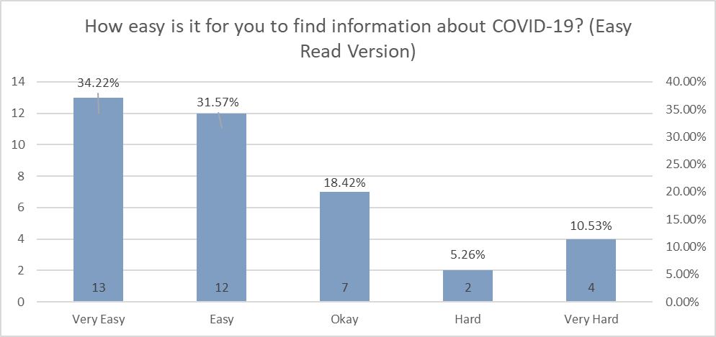
Table 1: Responses for the Easy Read version of the survey about how easy it was to find information about COVID-19.
Response | Number | Percent (%)
Very easy | 13 | 34.22
Easy | 12 | 31.57
Okay | 7 | 18.42
Hard | 2 | 5.26
Very hard | 4 | 10.53

Graph 2: Standard survey – disabled people and their family/whānau on ability to access government information on COVID-19
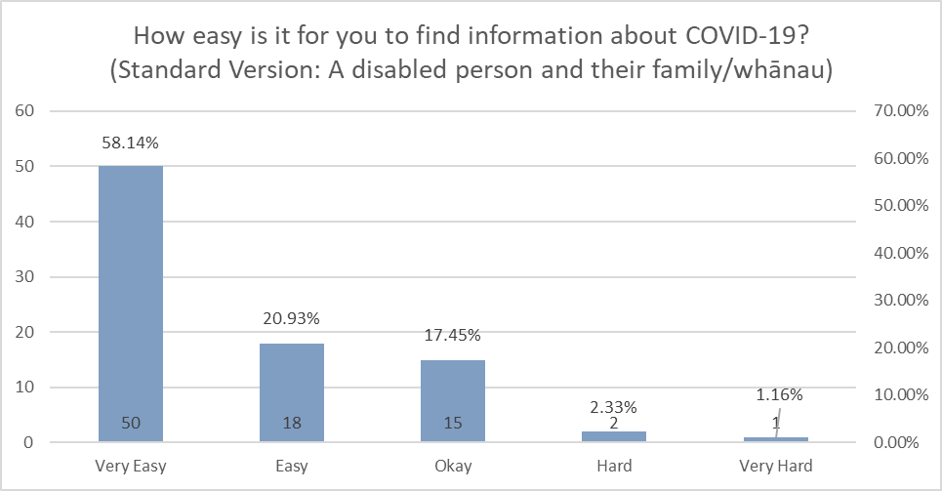
Table 2: Standard survey – disabled people and their family/whānau on ability to access government information on COVID-19
Response | Number | Percent (%)
Very easy | 50 | 58.14
Easy | 18 | 20.93
Okay | 15 | 17.45
Hard | 2 | 2.33
Very hard | 1 | 1.16

Graph 3: Easy Read survey – on ability to understand government information on COVID-19
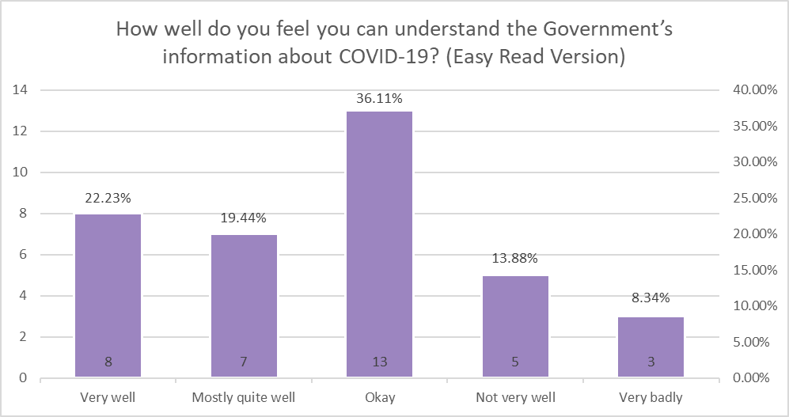
Table 3: Easy Read survey – on ability to understand government information on COVID-19
Response | Number | Percent (%)
Very well | 8 | 22.23
Mostly quite well | 7 | 19.44
Okay | 13 | 36.11
Not very well | 5 | 13.88
Very badly | 3 | 8.34

Graph 4: Standard survey – disabled people and their family/whānau on ability to understand government information on COVID-19
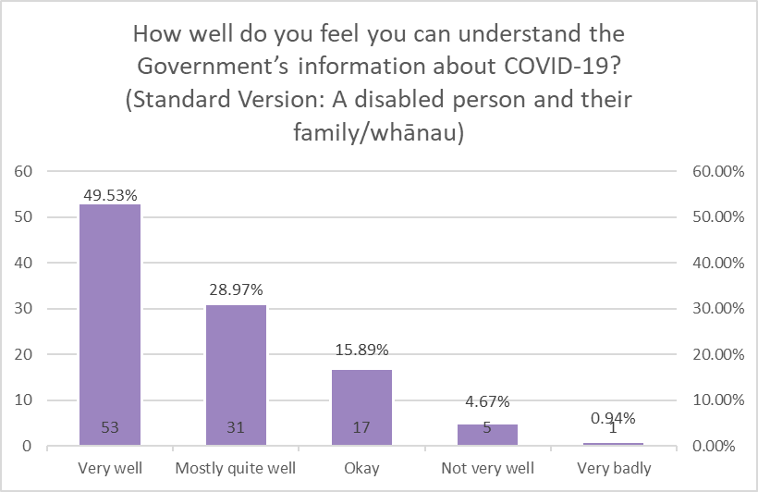
Table 4: SV survey – disabled people and their family/whānau on ability to understand government information on COVID-19
Response | Number | Percent (%)
Very well | 53 | 49.53
Mostly quite well | 31 | 28.97
Okay | 17 | 15.89
Not very well | 5 | 4.67
Very badly | 1 | 0.94

Graph 5: Easy Read survey on how safe respondents feel in their home right now
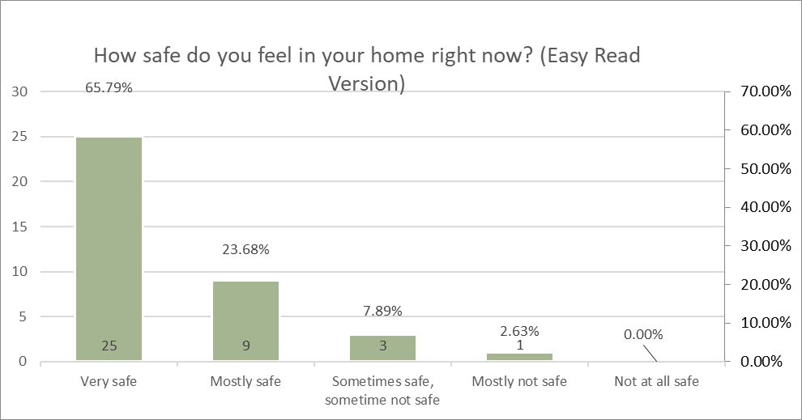
Table 5: Easy Read survey on how safe respondents feel in their home right now
Response | Number | Percent (%)
Very safe | 25 | 65.97
Mostly safe | 9 | 23.68
Sometimes safe, sometime not safe | 3 | 7.89
Mostly not safe | 1 | 2.63
Not at all safe | 0 | 0

Graph 6: Standard survey on how safe respondents feel in their home right now
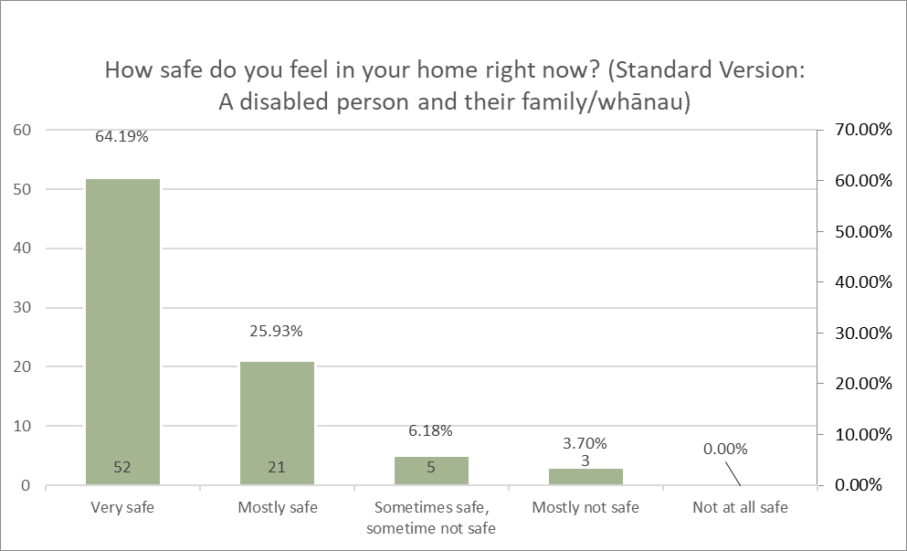
Table 6: Standard survey on how safe respondents feel in their home right now
Response | Number | Percent (%)
Very safe | 52 | 64.19
Mostly safe | 21 | 35.93
Sometimes safe, sometime not safe | 5 | 6.18
Mostly not safe | 3 | 3.7
Not at all safe | 0 | 0

Graph 7: Easy Read survey on how respondents are doing right now
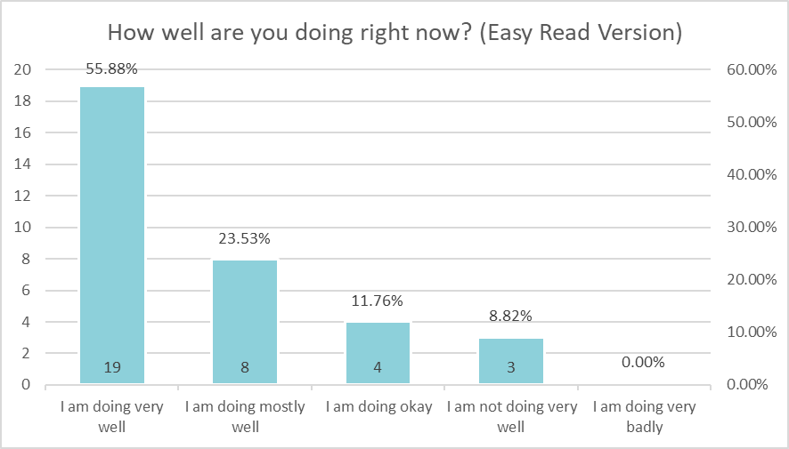
Table 7: Easy Read survey on how respondents are doing right now
Response | Number | Percent (%)
I am doing very well | 19 | 55.88
I am doing mostly well | 8 | 23.53
I am doing okay | 4 | 11.76
I am not doing very well | 3 | 8.82
I am doing very badly | 0 | 0

Graph 8: Standard survey on how respondents are doing right now
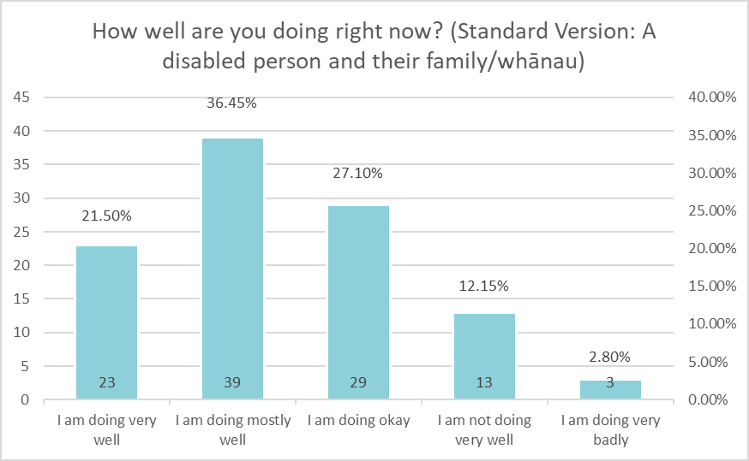
Table 8: Standard survey on how respondents are doing right now
Response | Number | Percent (%)
I am doing very well | 23 | 21.50
I am doing mostly well | 39 | 36.45
I am doing okay | 29 | 27.10
I am not doing very well | 13 | 12.15
I am doing very badly | 3 | 2.80

Graph 9: Easy Read survey on respondents’ loneliness
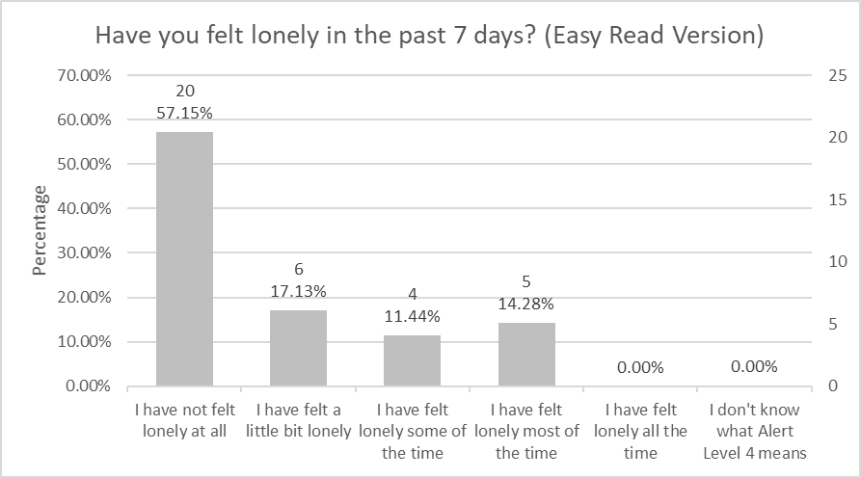
Table 9: Easy Read survey on respondents’ loneliness
Response | Number | Percent (%)
I have not felt lonely at all | 20 | 57.15
I have felt a little bit lonely | 6 | 17.13
I have felt lonely some of the time | 4 | 11.44
I have felt lonely most of the time | 5 | 14.28
I have felt lonely all the time | 0 | 0
I don’t know what Alert Level 4 means | 0 | 0

Graph 10: Standard survey on respondents’ loneliness
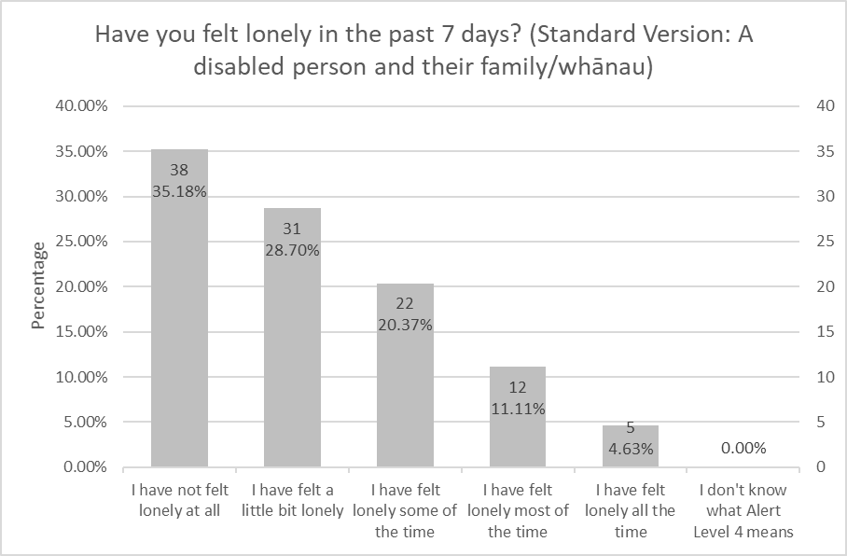
Table 10: Standard survey on respondents’ loneliness
Response | Number | Percent (%)
I have not felt lonely at all | 38 | 35.18
I have felt a little bit lonely | 31 | 28.70
I have felt lonely some of the time | 22 | 20.37
I have felt lonely most of the time | 12 | 11.11
I have felt lonely all the time | 5 | 4.63
I don’t know what Alert Level 4 means | 0 | 0

Note that these comparisons are made with caution, given that the questions were not exactly the same. In addition, the sampling methodology for the General Social Survey is different to the voluntary nature of “How is life going for the disability community?” online survey.

