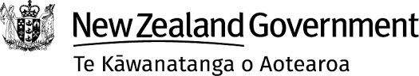
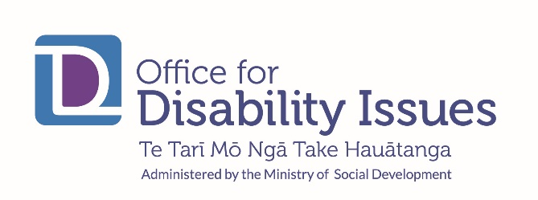

What is the New Zealand Government doing to make sure that

disabled people get their rights?
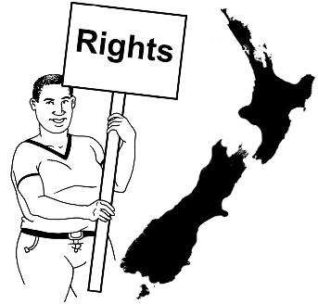

Answers for the United Nations Committee on the Rights of Persons with Disabilities.
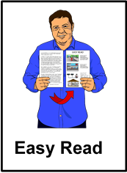

Easy Read information

What is in this book?
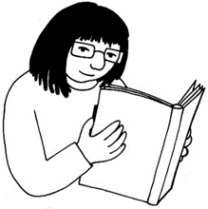
Page
What is this book about? 1

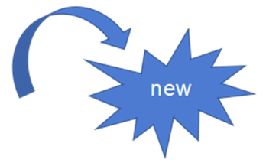
Some big changes for disability 6
issues
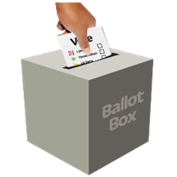
- Change number 1: A new 7
Government

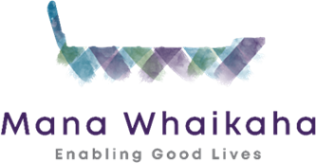
- Change number 2: The 9
disability support system

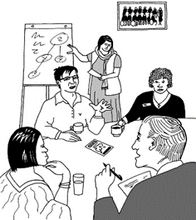
- Change number 3: Making 11
new plans

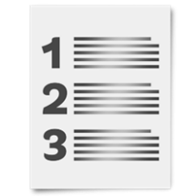
Page
The Articles of the Disability 14
Convention
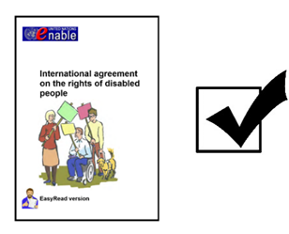

Article 4: What countries must do 16
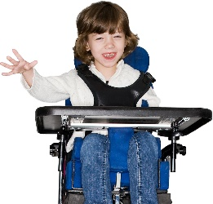

Article 7: Children with disabilities 19
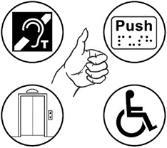

Article 9: Accessibility 22
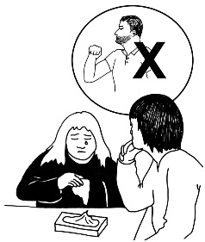

Article 16: Not being used or 25
abused
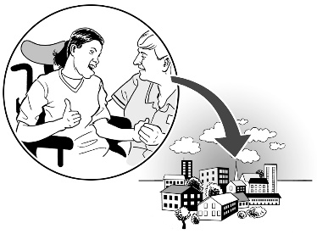
Article 19: Independent living and 27
being part of the community

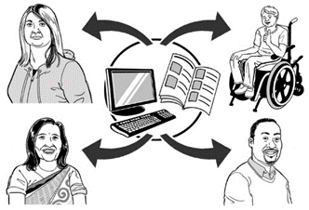
Page
Article 21: Being able to say what 28
you want and get the information
you need
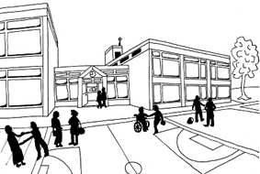

Article 24: Education 31

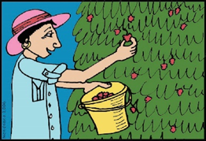
Article 27: Work 32

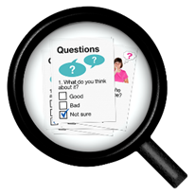
Article 31: Collecting information 34

What is this book about?
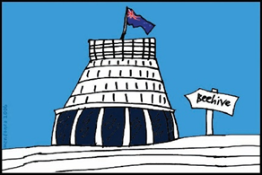
This book is from the New Zealand Government.
It is about what we are doing to make sure that all disabled people in New Zealand are getting their rights.
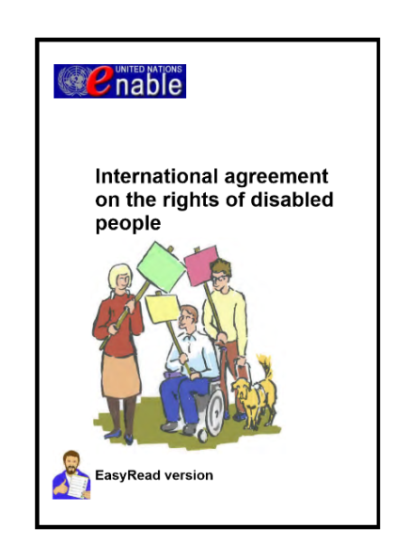
In 2008 the New Zealand Government said that we agree with the United Nations Convention on the Rights of Persons with Disabilities.

This is sometimes called the Disability Convention.
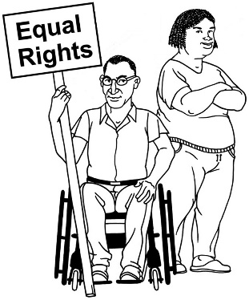
The Disability Convention says that disabled people have the same rights as everyone else.
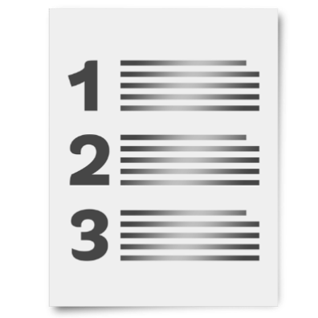
The Disability Convention also says:
- what the rights are that everybody has

- what governments need to do to make sure disabled people get their rights.
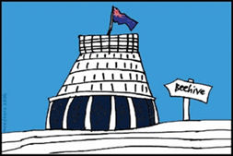
It is our job as the Government to make sure that we are following the Disability Convention.
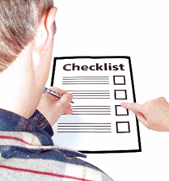
There is a group that checks up on us to make sure we are doing this work.

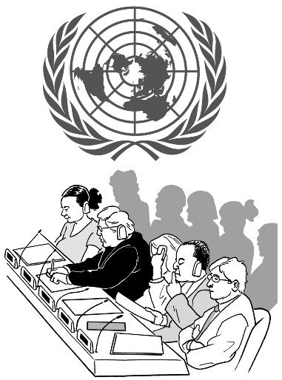
That group is called the United Nations Committee on the Rights of Persons with Disabilities.

In this book we will just call them
the committee.
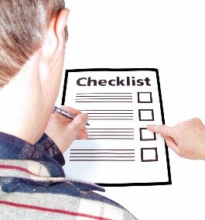
The committee are checking up on us now.
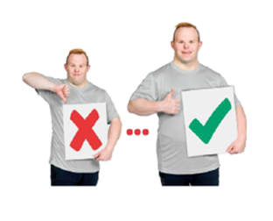
We think this is a good chance for us to get better at making sure all disabled people get their rights.
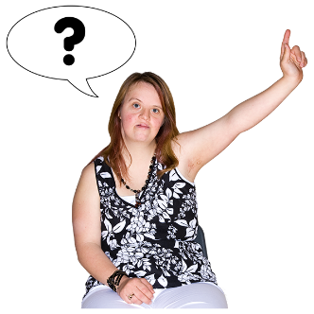
To find out more about what we are doing the committee asked us some questions.

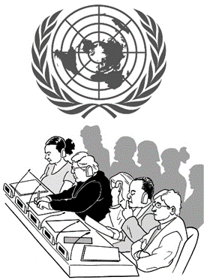
We have sent our answers to them.

Then we will talk to them later this year so they can ask us more questions.

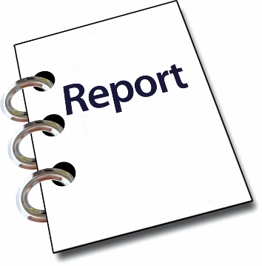
Then the committee will write a report to say:
- what we are doing well

- what we need to do better.
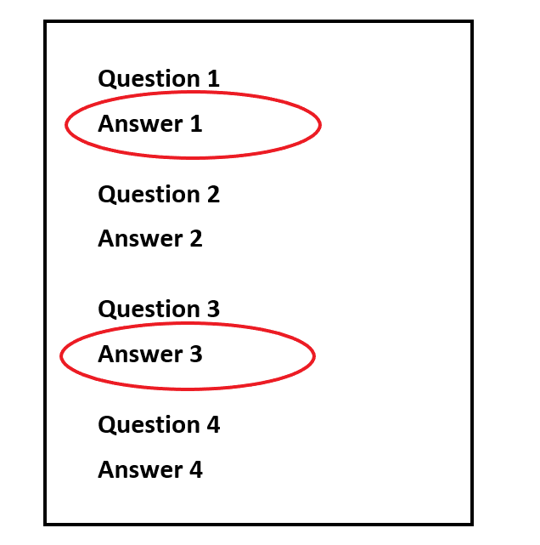
The book you are reading now only has some of our answers to the committee in it.

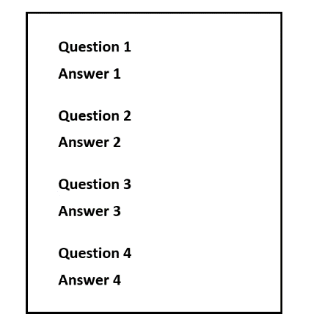
You can go to the website below to see:
- all of the questions from the committee

- all of our answers.
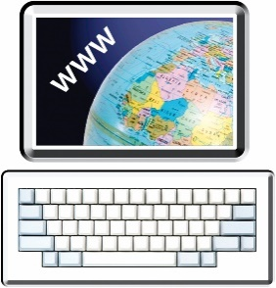
https://www.odi.govt.nz/united-nations-convention-on-the-rights-of-persons-with-disabilities/
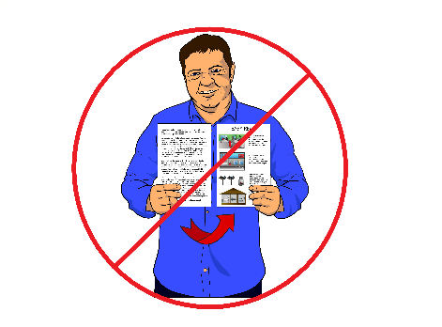
This document will not be in Easy Read.

Some big changes for disability issues
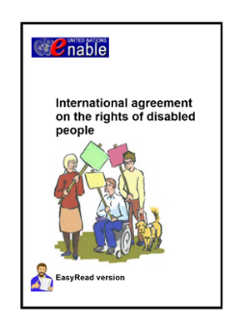
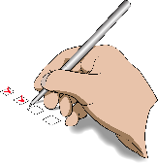
The committee last checked up on how well we were following the Disability Convention in 2014.
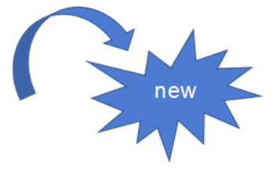
Since then there have been some big changes for disability issues in New Zealand.

Change number 1: A new Government
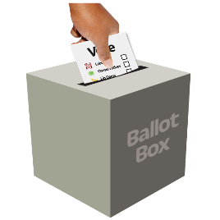
In 2017 the people of New Zealand elected a new Government.
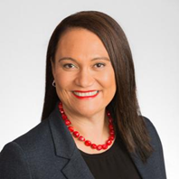
The new Minister for Disability Issues is Hon. Carmel Sepuloni.

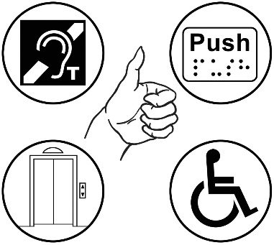
Because Hon. Carmel Sepuloni is in Cabinet she can make sure that the other Ministers are thinking about disability issues.
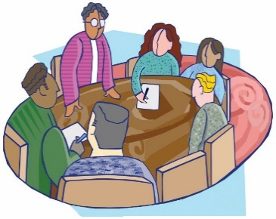
Cabinet is the group of government ministers who meet often to make important decisions.

In 2018 the Government made a plan to spend more money on making things better for disabled people.

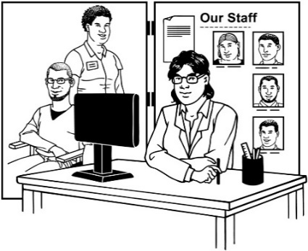
Over the next 4 years the Government will spend about 460 million dollars more than we used to on:
- disability services
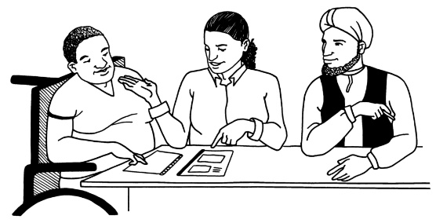
- supports

- work programmes.

Change number 2: The disability support system
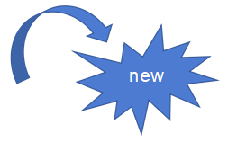
We are also making big changes to the disability support system.
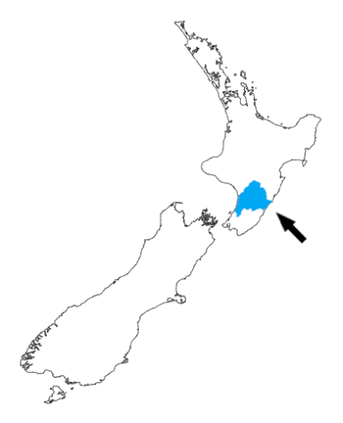
The changes are being tried out in 1 part of the country first.

This is the area covered by the MidCentral District Health Board.
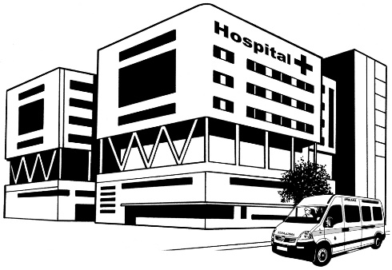
A District Health Board looks after all the health services in its part of the country.

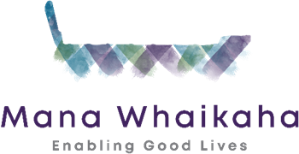
This new way of doing things is called Mana Whaikaha.
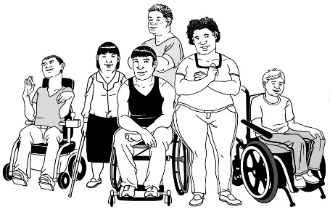
Mana can mean
- dignity

- the influence you have on other people.

Whaikaha is a word that some disabled people use for themselves.

One way to translate whaikaha is to have strength.

Change number 3: Making new plans
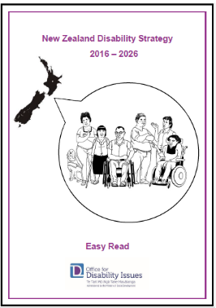
1. In 2016 we made a new Disability Strategy that will last from 2016 to 2026.
The Disability Strategy is a document that helps us to:
- know how to make things better for disabled people in New Zealand
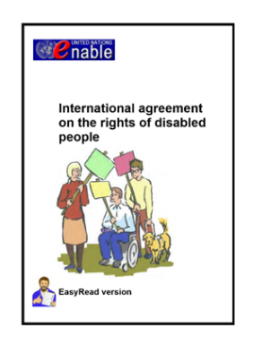
- make sure that we are following the Disability Convention.

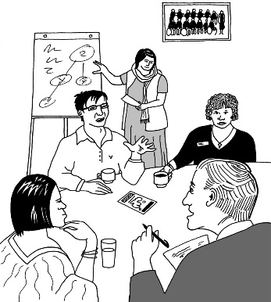
2. We are working on an Outcomes Framework for the Disability Strategy.

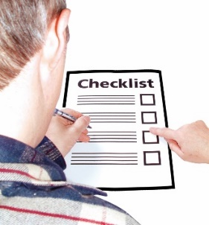
An Outcomes Framework is a way to see if we are making the ideas in the Disability Strategy happen.

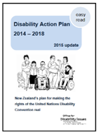
3. The Disability Action Plan says what work the Government is going to do to make the Disability Strategy and the Disability Convention real.

It talks about work that:
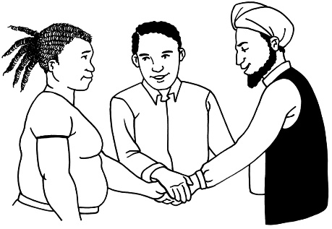
- different parts of the Government will do together

- the Government will do with other organisations.
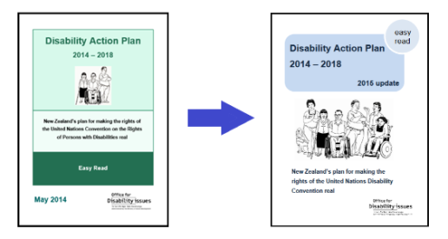
In 2015 the Disability Action Plan for 2014 to 2018 was updated.
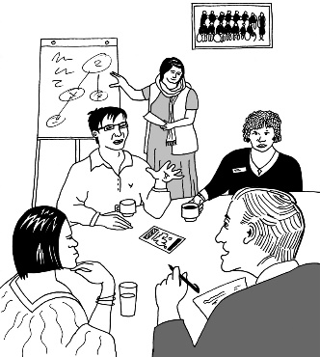
Now we are working on a new Disability Action Plan for 2019 to 2022.

The Articles of the Disability Convention
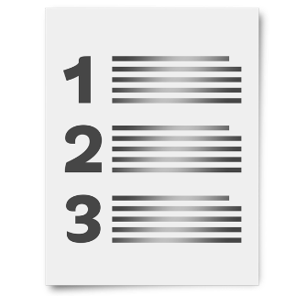
The Disability Convention has parts in it called Articles.

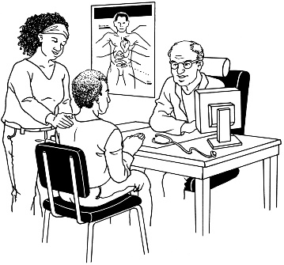
Each Article talks about:
- rights to do with 1 part of life - like health or transport
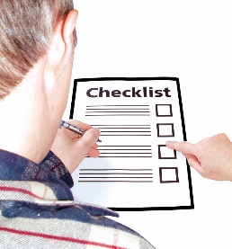
or
- work that Governments need to do to make sure disabled people get their rights.
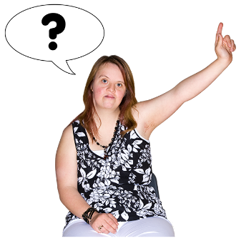
The committee asked New Zealand questions about most of the Articles in the Disability Convention.

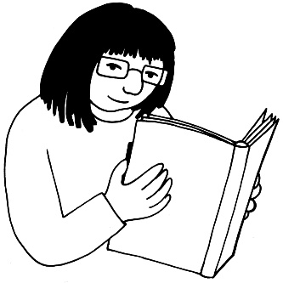
Starting on the next page you can read some of our answers about the work we are doing.
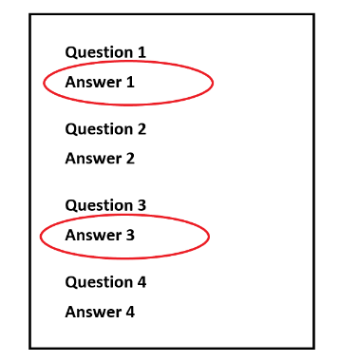
We have just chosen some of the most important things to write about here so you will only see answers for some of the articles.

Article 4: What countries must do

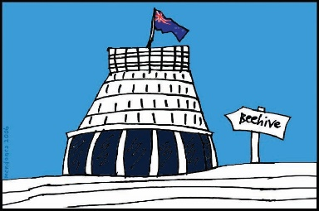
Article 4 says:
- governments must make laws and policies to make sure disabled people get their rights
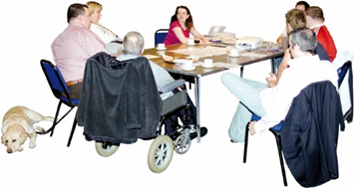
- disabled people must be involved in deciding these laws and policies.

These are some things we are doing to follow Article 4:
1. We are looking after New Zealand Sign Language (NZSL) better.

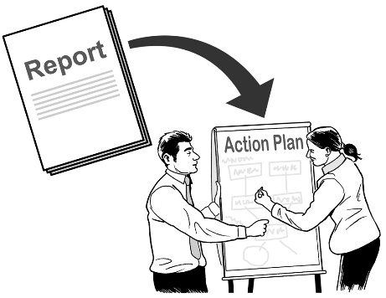
There is now:
- a New Zealand Sign Language Strategy and Action Plan.

- a New Zealand Sign Language Board.
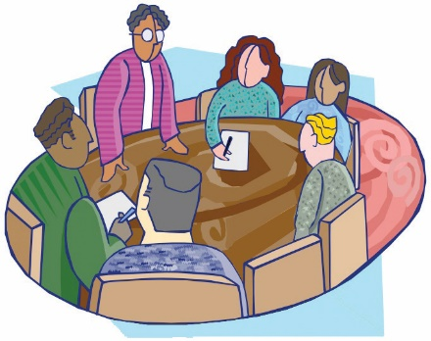
Most people on the New Zealand Sign Language Board are from the Deaf community.

2. With Mana Whaikaha we are trying out a new way of running the disability support system.

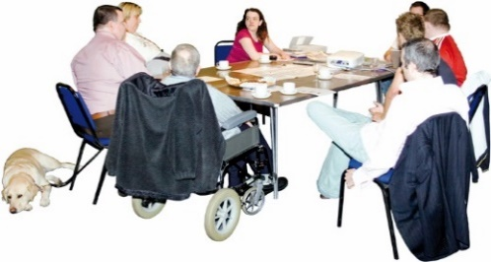
To make Mana Whaikaha we worked together with:
- disabled people
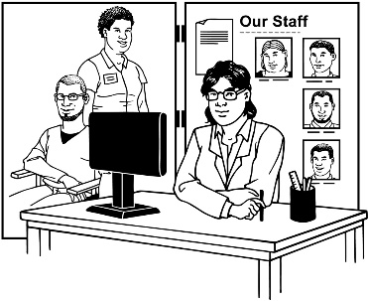
- their families / whānau

- service providers and the people who work there
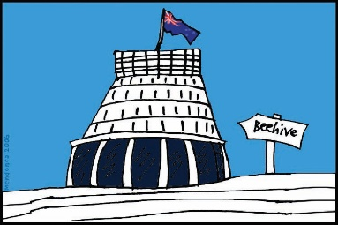
- other government agencies.

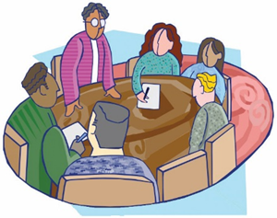
3. We have a Ministers’ Leadership Group on Disability Issues.

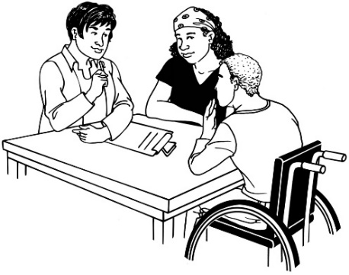
The Ministers’ Leadership Group on Disability Issues is a group of government ministers.

They meet 2 times a year to hear about things that that are important to disabled people.

Article 7: Children with disabilities
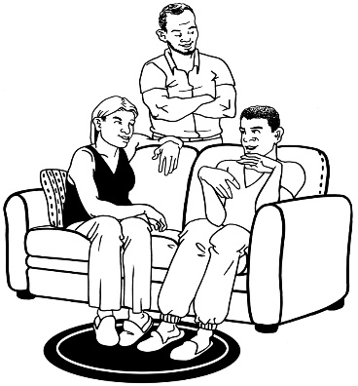
1. With the changes to the disability support system we are trying to make things work better for:
- disabled children

- their families / whānau.

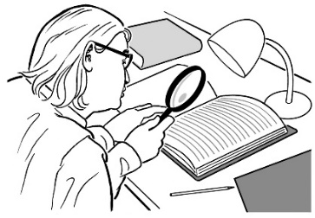
2. There is an investigation happening that will look at the way people were treated when they lived in care.
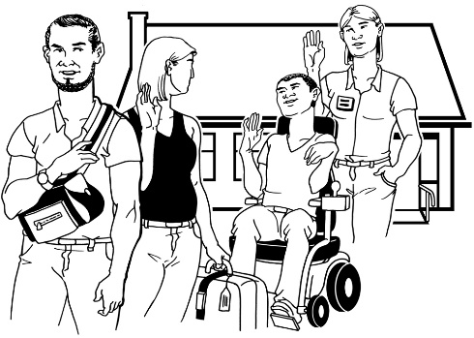
Living in care means being looked after by someone who is not your family / whānau.
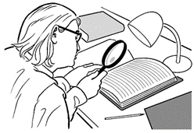
An investigation means looking closely to find out what is happening or what happened.
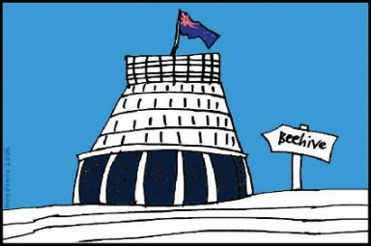
The investigation will look at places where people lived that were run by:
- the Government / the state
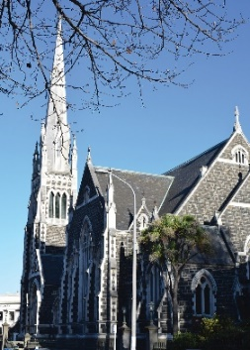
- faith-based organisations like churches.

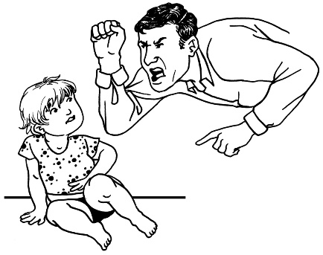
Some of these places were large institutions.

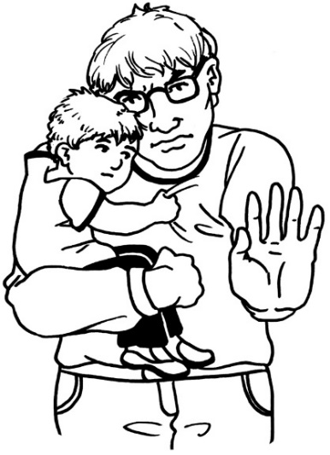
Some disabled children and adults were treated very badly when they lived in care.

The Government wants to find out more about this to make sure it cannot happen again.

Article 9: Accessibility
Accessibility is about people being able to:
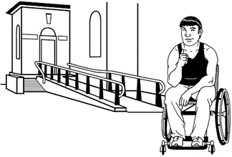
- get the services and information they need

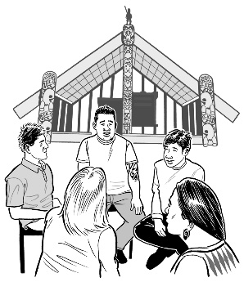
- go to the places they want to go

- take part in groups they want to be part of.

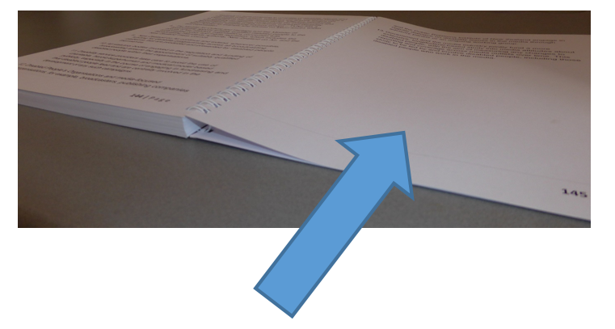
Starting on the next page are some things we are doing to make sure disabled people can access the same things as other New Zealanders.

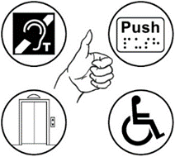
1. We now have an Accessibility Charter.

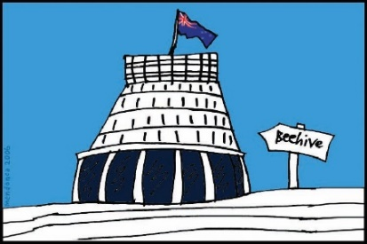
The Accessibility Charter is an agreement between parts of the Government.

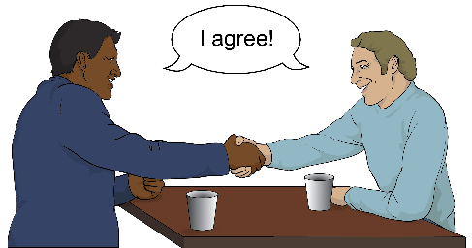
We have agreed to make sure that:
- the information we share with people is accessible

- our services are accessible.

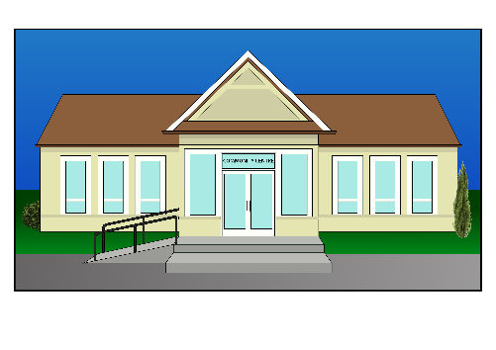
2. We have made a guide called Buildings for Everyone.

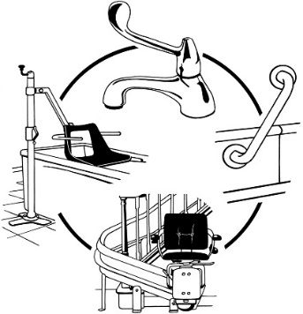
It will help people who are making public buildings to:
- think about the needs of everyone
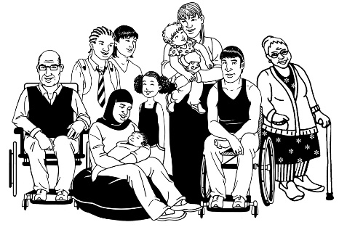
- plan buildings that everyone can use.

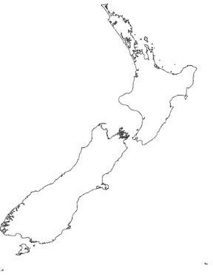
3. We want New Zealand to be fully accessible.

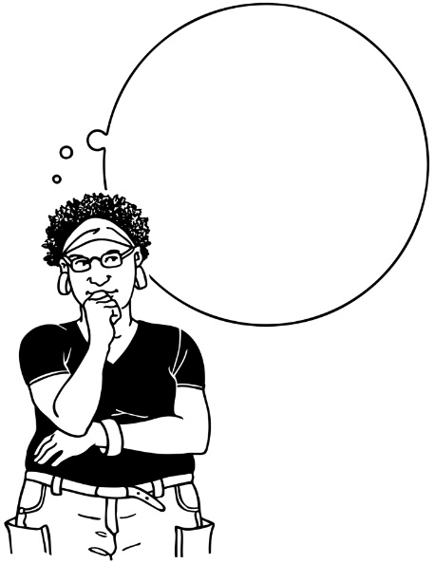
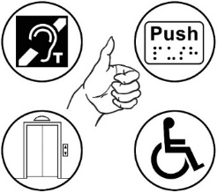
At the moment we are thinking about:
- what fully accessible means

- if we will make laws so that people have to make things accessible.
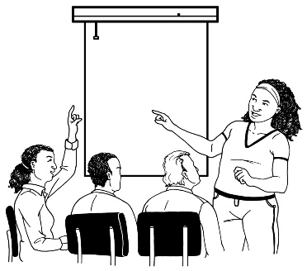
We are talking to other people about this to find out what they think.

Article 16: Not being used or abused
There are 2 important investigations happening at the moment about:
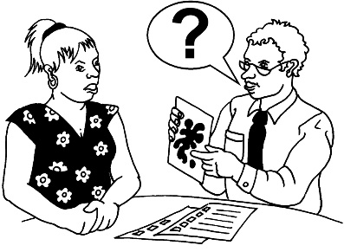
- how well Mental Health and Addiction services are working

- how people were treated when they lived in care.
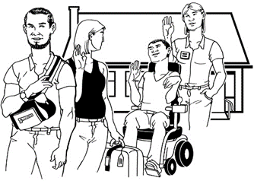
There was more about the second investigation on page 20.

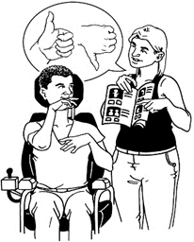
These investigations will help us to know:
- how disabled people have been treated
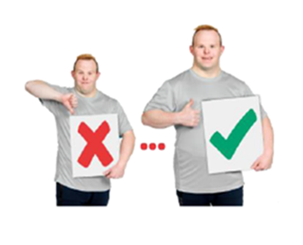
- what needs to change in New Zealand.

Article 19: Independent living and being part of the community
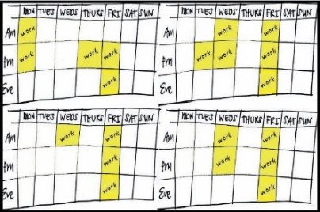
At the moment disabled people often have to fit their lives around getting the services they need.
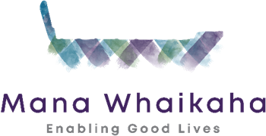
We hope the changes to the disability support system that are part of Mana Whaikaha will give disabled people and their families / whānau:
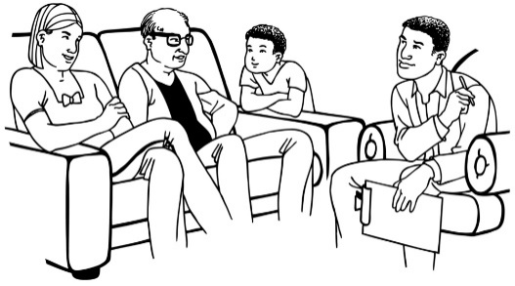
- more choices

- more say in how these services work for them.

Article 21. Being able to say what you want and get the information you need
1. The work we are doing to look after New Zealand Sign Language will make it easier for Deaf people to:
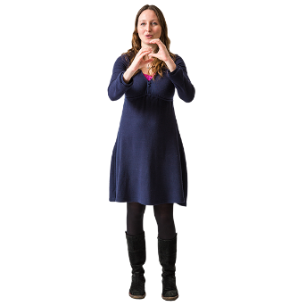
- be understood

- get information in ways they can understand.

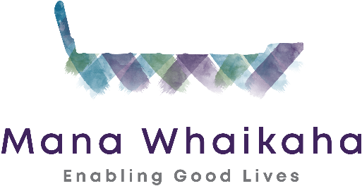
2. 1 of the changes to the disability support system that we are trying out is having people called Connectors.
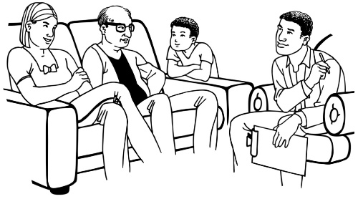
It is the job of Connectors to work with disabled people and their families / whānau to assist them to:
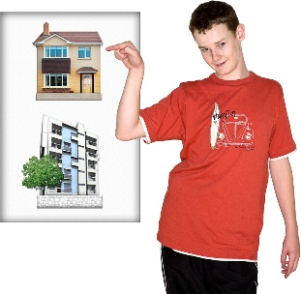
- decide what they want in their life

- work out how to make that happen
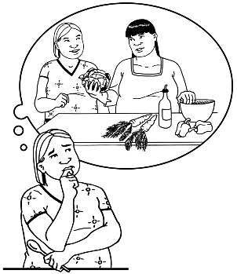
- work out what kind of support they can get to make that happen.

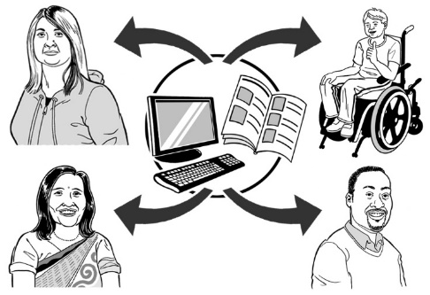
3. To make New Zealand more accessible we are trying to make information more accessible.
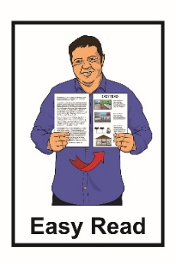
Part of this is making sure people can get information in:

- Easy Read
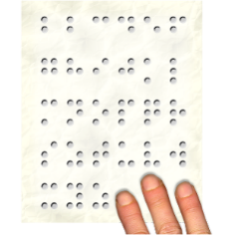
- Braille

- New Zealand Sign Language (NZSL).

Article 24: Education
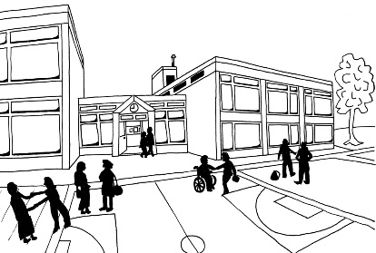
We are making a Learning Support Action Plan.
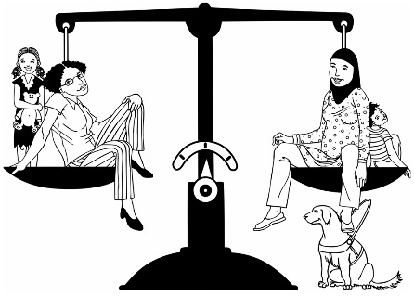
This is to make sure that disabled people get the same chances to learn as everybody else.

Article 27: Work
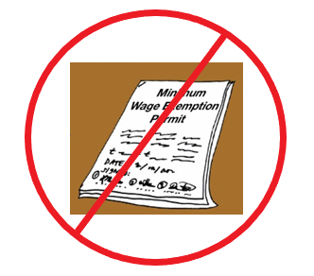
1. We have an idea for getting rid of Minimum Wage Exemption permits.
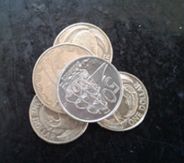
Minimum Wage Exemption permits let workplaces pay some disabled workers less than the minimum wage.
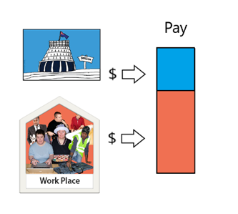
Our idea is for the Government to give workplaces money to help them pay everyone minimum wage or more.
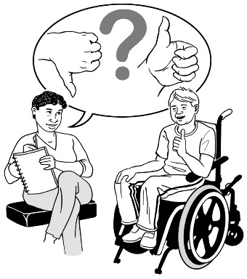
We are talking to people who will be affected by this to find out what they think.

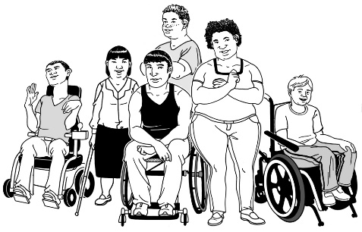
2. We have a new programme called Oranga Mahi for:
- disabled people

- people who have problems with their health.
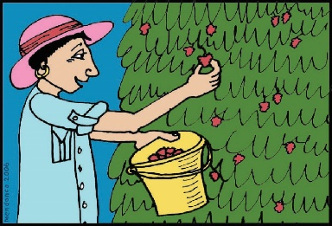
1 way to translate Oranga Mahi is: the kind of wellbeing that comes from work.

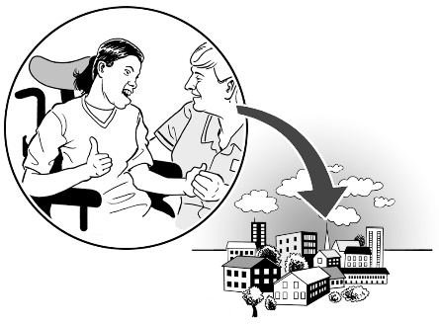
This programme will find ways to assist people to:
- be part of their community

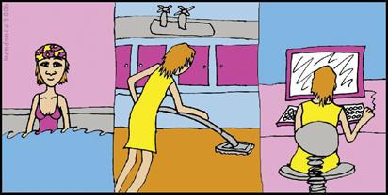
- look after their health

- find a job that works for them.

Article 31: Collecting information
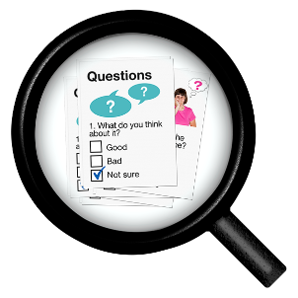
We are collecting better information about disabled people.

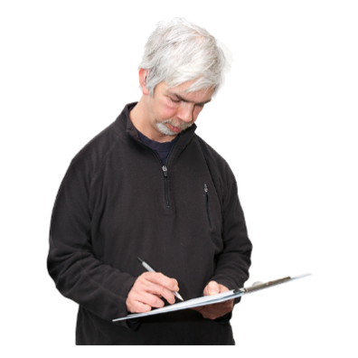
We included a new group of questions about disability in:
- the national census

- some government surveys.
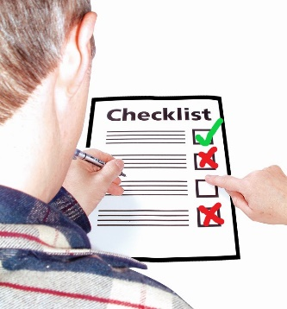
We still need to do better at including questions about disability every time we collect information.

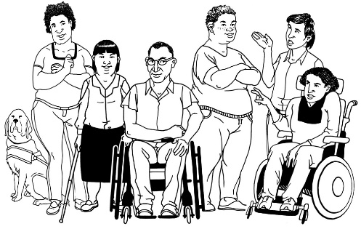
We need to do better at collecting information about:
- disabled children

- different kinds of disability.

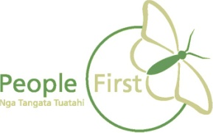
This information has been translated into Easy Read by the Make It Easy service of People First New Zealand Inc. Ngā Tāngata Tuatahi.
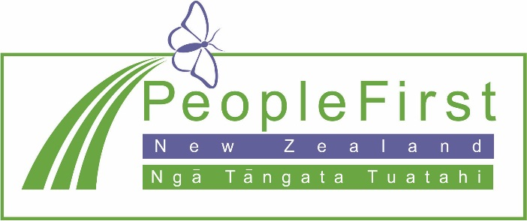

The ideas in this document are not the ideas of People First New Zealand Inc. Ngā Tāngata Tuatahi.
