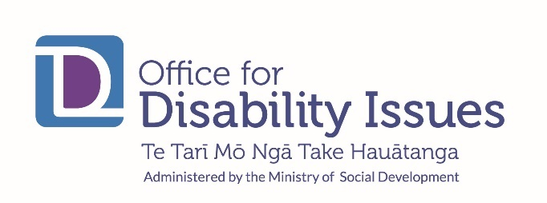

Disability Action Plan Progress Report | July 2020 to December 2020
The Disability Action Plan 2019–2023 (the DAP), launched in November 2019, aims to improve the wellbeing of disabled people through progress on the eight interconnected outcomes in the New Zealand Disability Strategy: education, employment and economic security, health and wellbeing, rights protection and justice, accessibility, attitudes, choice and control, and leadership.
The Office for Disability Issues manages the six-monthly reporting as the key monitoring mechanism of the DAP. This is the second six-monthly report on progress.
For the July to December 2020 period, agencies provided reports across 29 work programmes:
- 20 (68%) work programmes were reported being on-track or ahead;
- 6 (20%) reported being off-track, but with low risks or issues to delivery;
- 2 work programmes were reported to be off-track with significant risks or issues.

Some notable achievements and progress across the 29 work programmes are outlined below.

Outcome 1: Education
The Ministry of Education (MOE) continues to implement the Learning Support Action Plan 2019-2025 to strengthen how learning support is provided, so that all children and young people get the right support, in the right place, at the right time. Progress includes:
- MOE established an online professional network, the Learning Support Network of Expertise, for Learning Support Coordinators (LSCs) and Special Education Needs Coordinators (SENCOs).
- Autism NZ trialled a customed training programme, Tilting the Seesaw, for LSCs with two further tranches planned for 2021.
- A new practice framework for learning support staff, He Pikorua, was launched. The framework supports learning support specialists and specialist Resource teachers to work within the same approach, improving the way we support disabled ākonga and their whānau.
- MOE stood up a trial rollout of the Standardised Learning Support Register. This Register will make it easier for educators to record learning support needs, show the number of learners who need support, and track learners’ progress overtime.
- An Employment Service in Schools pilot was due to commence in February 2021 and will be reported on in the next DAP reporting cycle.

Outcome 2: Employment and economic security
The Ministry of Social Development finalised and released, Working Matters, the Disability Employment Action Plan, in August 2020. Working Matters aims to ensure disabled people and people with health conditions have an equal opportunity to access good work. 22 initial actions are identified for completion between 2020 – 2022 across multiple agencies, involving disability sector organisations and industry partners.

Outcome 3: Health and wellbeing
The Ministry of Health is leading a number of work programmes in the DAP. One work programme seeks to repeal and replace the Mental Health (Compulsory Assessment and Treatment) Act 1992 with legislation aligned to the UN Convention on the Rights of Persons with Disabilities. In August 2020, Cabinet considered and agreed to progress initial amendments to the Mental Health Act, and the Ministry of Health published revised Guidelines to the Mental Health Act in September 2020.

The Ministry is supporting the implementation of the revised Guidelines through education and training, regular engagement with providers and services, and targeted stakeholder engagement.

Outcome Four: Rights protection and Justice
The Ministry of Justice (MoJ) is leading a work programme to improve justice services so they are accessible and able to be understood. This work programme is supported by Ara Poutama Aotearoa, the Department of Corrections. Actions included:
- introduction of Public Defence Service values in September 2020
- Sexual Violence Legislation Bill, reported back to Parliament from Select Committee, in June 2020
- MOJ’s Electoral Programme delivered accessible resources to support the 2020 referendums
- improving disability information collection to inform the design and implementation of policies and facilities to meet the needs of service users.

The Department of Corrections accessible justice work programme is developing a Disability Framework for people in the Department’s care. The Framework will aid the strengthening of support for disabled people in prison through:
- ensuring disability data is collected;
- individual needs are identified upon reception in prison;
- relationships with whānau and other support networks are supported during their time in prison and during their transition back into the community.

The Department aims to complete the Framework by March 2021. The Department is also reviewing signage at Community Corrections sites to ensure signs are accessible, with a programme for installation in late 2021.

Outcome Five: Accessibility
Waka Kotahi, the New Zealand Transport Agency, has commissioned research to gain a better understanding of the transport experiences of disabled people, and to determine what barriers exist for people wanting to use the Total Mobility Scheme. The Ministry of Transport will undertake a review of the Total Mobility Scheme once the research is completed.
The Kāinga Ora Accessibility Work Programme has three components:
- The objective is to increase the number of Kāinga Ora homes that meet universal design standards. Kāinga Ora have set a target of at least 15 percent of their homes meeting universal design standards. Systems and business processes to support this will be in place by June 2021.

- Kāinga Ora is focused on better meeting the needs of their customers through modifications and retrofit programmes for existing properties. Initial meetings were held in August/September 2020 with the Ministry of Health and ACC regarding changes to the current modifications process and inequities with the existing funding arrangements.
Work continues on these issues.
- There is a focus on improving information about customers’ needs and the accessibility of Kāinga Ora properties. Kāinga Ora continue to run a retrofit pilot to confirm the costs and will use learnings from this process to set a target for retrofitting their properties. Kāinga Ora have commenced retrofit property assessments and design across 18 new towns. Construction was expected to start in the first quarter of 2021. Progress in the Hutt Valley Pilot continues with an additional 123 properties de livered from 1 July 2020.

Outcome Six: Attitudes
There was no agreed work programme during this reporting period and therefore there is no agency reporting. While there is no specific programme of work identified it is expected that work programmes delivered under other outcomes will contribute to attitude changes.
More detail on the work programmes and reporting can be found here: (insert link to ODI DAP Reporting page).

