**NZSL Interpreter Registry Design**

**developed for the**

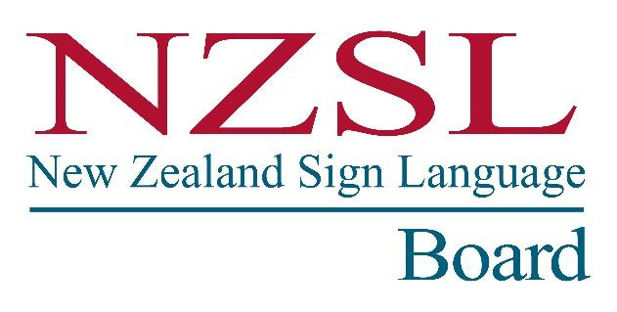

**by**

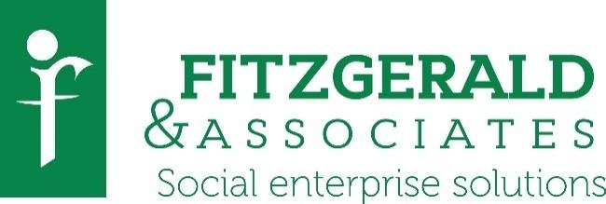

**September 2017**

**Acknowledgements**

*Fitzgerald & Associates* is grateful for the wisdom and guidance of a number of people in developing this report.

This project was formally sponsored by the Office for Disability Issues (ODI), as the secretariat to the New Zealand Sign Language (NZSL) Board. Sonia Pivac, Senior NZSL Advisor**,** was responsible for overseeing the project.

Our greatest thanks go to the interpreters and related organisations that took the time to share their views and ideas with the review.

George Major, Rachel McKee, Wenda Walton, Shiz Sameshima, Rosanne Butler-Stoney, Louise Hackshaw, Micky Vale, Alan Wendt, Shannon McKenzie, Lynx, and Sign Language Interpreters Association of New Zealand (SLIANZ), led by Rebeccah Curtis, were all extremely helpful informants for the project.

*Fitzgerald & Associates* appreciated Dan Hanks’ valuable assistance with information collection, interpreter consultation and wise analysis for the project, and Catherine Greenwood’s expert communications and administrative assistance advice*.*

*Fitzgerald & Associates* would like to thank them all.

Contents

Recommendations 9

1 Introduction 12

2 Methodology 15

3 Options 17

3.1 NZSL Interpreter Registry 19

3.1.1 Registry requirements 21

3.1.2 Housing the registry 23

3.1.3 Registry structure 25

3.2 Professional development 26

3.2.1 Training 26

3.2.2 Mentoring and supervision 28

3.3 Assessment 31

3.3.1 A locally developed system 32

3.3.2 NAATI 33

3.4 Managing complaints 37

3.5 Technology 40

3.6 Market and policy factors 42

3.7 Risks 48

4 Cost estimates and timeframes 51

5 Conclusion 59

5.1 Registry options 59

5.2 Professional development 61

5.3 Assessment 63

5.4 Complaints 63

Appendix 1: Project informants 65

Appendix 2: Focus group survey results 67

Appendix 3: Interpreter Survey on Interpreter Registry 70

Appendix 4: Draft registry overview 81

Appendix 5: Draft Registrar job description 82

Appendix 6: Some comparative fees 84

Appendix 7: Glossary 87

References 88

Executive summary

This report has focused on designing a feasible New Zealand Sign Language (NZSL) interpreter registry that will enhance the quality of NZSL interpreting by providing key developmental services. At the same time, it has aimed to design an organisation as lean, cost-effective, and simple to administer as possible. This report has recommended the greatest development needs as seen by interpreters, on the basis that interpreters know their own needs best and that leadership by and support from a strong majority of interpreters is necessary for this self-regulatory registry to succeed.

The project team has leaned heavily on the advice of leading NZSL interpreting experts in New Zealand, samples of active interpreters in focus groups, and a survey of 57 interpreters across the country. Even though the timelines for this project were very tight, interpreters showed that they are committed to the development of their profession and provided their perspectives freely.

In addition, interpreting agencies as well as Government and Deaf people need to support this registry in a variety of ways, and so it is suggested that at least six months is taken to bring representatives of the parties together and agree on the process going forward.

Because a strong independent registry focus is needed and no other agency was eager to manage the registry, it was concluded that the registry should be a stand-alone organisation with a small but strong governance board that reports to the NZSL Board annually, to ensure accountability to the Deaf community.

The Sign Language Interpreters Association of New Zealand (SLIANZ) has been considered a possible manager of the registry, providing strong interpreting expertise and is already involved in many of the tasks associated with the registry in a voluntary capacity. While there is no doubt that SLIANZ has considerable commitment to better serve the Deaf community, this report considers the role of the registry and a professional association to be quite different. The association primarily exists to serve the interests of their members whereas the registry primarily exists to serve the interests of the public, in this case all interpreting service users.

Separating these functions along these lines is preferred, if possible, because it creates greater clarity of purpose, although it is also acknowledged that there is also always some overlap of interests. The professional association, SLIANZ, will need to work closely with the registry, possibly contracting to provide professional development and continue to assist the Deaf community with early stages of complaints.

**Registration**

The registry would require provisional interpreters to be members of SLIANZ, undertake ongoing professional development in the form of training, sit a standardised test, receive approved mentoring, and submit a portfolio of work. The registration level of assessment would be set at a level expected for an interpreter working full-time for two years after graduation.

Re-registration would occur every three years after this. Senior interpreters with more than five years of work experience would be required to provide proof of membership of SLIANZ, professionally focused training undertaken and demonstrating skills through a portfolio of work. Mentoring and supervision remain important for these more senior interpreters but in the longer term are expected to be arranged personally or through their employer, similar to most other professions.

**Professional development: Training and mentoring**

Training is considered by interpreters to be the most important requirement of the registry. Funds for training interpreters ($50,000 per year) are recommended to be targeted at the greatest interpreter workforce needs, which would then be contracted out to skilled providers.

Balancing interpreter priorities, the need for both mentoring and financial sustainability, the reality that interpreters could and do support each other with mentoring voluntarily, it was concluded that if at all possible, mentoring in the first five years after graduation should be funded. In addition, a two-year period of funding voluntary mentoring sessions every two months for all interpreters is recommended in order to entrench patterns. After this point, more experienced interpreters may make their own arrangements for mentoring or supervision.

It is suggested that funding for training and mentoring could be funded by either Government funding or a levy of all interpreter assignments through the major interpreter coordination agencies and possibly other major providers.

**Assessment**

National Accreditation Authority for Translators and Interpreters (NAATI) provides a good well-tested assessment service that is being considered for spoken languages in New Zealand. There is evidence however, of some dissatisfaction with NAATI assessments by sign language interpreters on both sides of the Tasman. It is also clear that there is sufficient expertise in New Zealand who also have international contacts and comparable resources to develop an assessment at a level expected two years after graduation at a competitive rate that also provides feedback on two pieces of live interpreting work. It is also important that the registry and its assessments reflect the principles of the Treaty of Waitangi and require interpreters to demonstrate some basic level of competence in both official languages and Māori culture.

International interpreters would be expected to be provisionally-registered if their qualifications meet registry requirements, and sit the registration assessment. Similarly, interpreters who are away for some time and have lost substantial skill that is not easily regained could start again at a provisional level.

**Complaints**

There is no widely used method of complaints about NZSL interpreting services in NZ and it is critical that Deaf and hearing people have the ability to complain without prejudice. The Health and Disability Commissioner (HDC) and its advocacy service are in place nationally as an independent service to receive and process complaints about health and disability services, but are not considered accessible for Deaf people. It has been concluded that the development of another independent national complaints service is not realistic financially and that efforts should be made to make the HDC services accessible by utilising available registry-linked interpreter expertise in some advisory capacity. In addition, there should be a clear process outlined and promoted to Deaf and hearing interpreter clients in as many ways (i.e. websites, newsletters, meetings) as possible. Preliminary complaints should be raised initially with the interpreter or agency if possible. SLIANZ or the registry may give further advice and the advocacy service and the HDC should also be available to receive complaints.

**Market and policy factors**

Influencing the provision of interpreter services and therefore the registry are some key market and policy factors, including a market that does not understand interpreting well but perceives it to be of high cost and possibly of dubious value. Nevertheless, potential demand from Deaf people is much higher, at least 10 times higher than supply. These factors create a distorted market in which the purchaser of the service does not see the NZSL interpreting service as essential as the recipient.

A substantial amount of interpreting work is freelance, that is contracting directly with the customer, primarily to lower costs to customers. As a result, current interpreter services are relatively uncoordinated because over a third of interpreting assignments do not go through interpreting agencies. Consequently, the ability to optimise workforce capacity, by matching interpreter availability with interpreting assignments is limited.

The small size of the interpreting profession means that this registry is relatively expensive in comparison to other professional associations. This may be justified because, as the New Zealand Government recognises that Deaf people’s inclusion in society is not possible without interpreting services. However, while there is supportive legislation, nothing guarantees Deaf people the right to interpreters for communication. Government funding is fragmented and funding gaps create significant barriers for Deaf people’s inclusion in mainstream New Zealand society.

Fortunately, there are current moves to standardise the spoken language interpreting profession in New Zealand, and NZSL interpreting may benefit substantially from some involvement, particularly in communication and funding systems.

**Risks**

Key risks associated with this registry include that without Government support in the form of contracts with interpreting providers and instruction to government departments, the registry may not have sufficient mandate to operate. Non-registered and non-qualified interpreters may continue to be used by government departments and Deaf people. Block courses could offer current skilled interpreters a way to formally qualify and at least partly remedy the problem. An ongoing way to educate interpreters outside of Auckland is also essential if this problem is to be addressed.

This report concludes that using a variety of funding sources, the registry could provide a range of valuable services that will enhance interpreter quality. Detailed estimates of costs indicate that the registry may become self-sufficient within three years.

# Recommendations

It is recommended that the Office for Disability Issues (ODI) and the NZSL Board:

**Establishment**

1. Get agreement among key stakeholders (representatives of interpreters and their interpreting coordinating agencies as well as Government and Deaf people) to agree on the process going forward.
2. Develop a stand-alone registry with its own board that is required to report to the NZSL Board annually.
3. Begin establishment of the registry by July 2018.
4. Recruit and appoint a Registrar to take over the role of establishing the organisation and its systems in the first six months of operation.
5. Agree that priorities for registry development within the first year include:
   1. Developing a set of competencies to be assessed;
   2. Developing an assessment process for a standardised test and portfolio of work;
   3. Developing an assessment training process and recruiting assessors for training;
   4. Develop mentoring training;
   5. Recruiting 15 interpreter mentors and train them.
6. Further explore options for amalgamating other Deaf services, including the NZ Adult Assessment Service (providing the Sign Language Proficiency Interview or SLPI) and the NZSL Teachers Association (NZSL), with the registry to improve economies of scale and critical expertise.

**Registry services**

1. Agree that the registry will:
   1. contract with training providers to deliver the highest priorities for the profession, given available funding.
   2. recruit and contract with assessors to assess the skill level of all interpreters over a three-year period, and new graduates at point of registration.
   3. provide mentoring for all interpreters for the first two years, with it being mandatory for interpreters for the first five years and optional for others.
2. Ensure all government contracts for NZSL interpreting agencies require interpreters provided to be registered.
3. Actively support the allocation of dedicated and identifiable budgets for NZSL interpreting within government departments.
4. Seek Government instruction to all government departments to use registered NZSL interpreters, whether they use formal contracts or not.
5. Ensure the registry reflects the principles of the Treaty of Waitangi and develop minimum requirements of all interpreters in Māori pronunciation and culture.
6. Develop performance indicators for the registry to ascertain its impact on quality.
7. Review the impact of the registry within 1 – 2 years and allocate resources to do so.

**Funding and support for the registry**

1. Request Government funding of $140,000 to $170,000 a year or, if not possible, negotiate a 4% levy to be charged against annual accounts with all interpreter coordinating agencies and other key providers (e.g. Deaf schools, tertiary education providers, Workbridge).
2. Note that the total expenditure required by the NZSL Board for the period from 2018 – 2021 is $217,162 (excluding GST), assuming that income sources from either Government or an interpreting levy are found.
3. Encourage the registry and SLIANZ to further explore safe online interpreting and the benefits of reducing interpreter costs it might bring to paying customers, where appropriate.
4. Ensure all government contracts for NZSL interpreting agencies include a requirement to monitor and report on developments in technology to identify opportunities for further efficiencies within the interpreting sector.
5. Discuss accessibility requirements of a complaints service for Deaf people with the HDC and related advocacy service.
6. Identify and promote clear pathways for complaints.
7. Promote the reasons for the need for registered NZSL interpreters and why they are of a higher cost than other disability services to Deaf and hearing users of interpreter services.
8. Agree that the registry might develop or adapt its systems and rules in agreement with the NZSL Board and SLIANZ.
9. Encourage or support the provision of a block course for unqualified interpreters around New Zealand.

**Other matters for the NZSL Board’s attention**

1. Note the areas of service not provided by this registry:
   1. Individualised or un-prioritised training will continue to be self-funded.
   2. Mentoring and supervision remain important for more senior interpreters but they will be required to make their own mentoring arrangements.
2. Note other areas recommended for the registry:
   1. Assess interpreters who have been away from the profession for longer than a year on a case-by-case basis, as to whether they need to re-sit the registration assessment.
   2. Unpaid mentoring should be considered professional development.
   3. Provisionally register international interpreters if their qualifications meet registry requirements, and require them to undertake the registration process.
3. Note that the Office of the Ombudsman can also advise HDC on accessibility of its complaint systems.
4. Note the higher level of funding required for NZSL interpreting if all Deaf people received the amount recommended by the Cost of Disability report in 2010, i.e. seven hours a week.
5. Note the perception of high cost, relatively uncoordinated nature of the NZSL interpreting sector, and difficulty in Deaf people challenging interpreters on service quality.
6. Note that a review of NZSL interpreter pricing is needed to identify whether pricing is fair for both service users and interpreters.

# Introduction

The New Zealand Sign Language (NZSL) Board commissioned a report entitled “A Review of New Zealand Sign Language Interpreter Standards” 2017 (the report) by Fitzgerald & Associates, supported by the Sign Language Interpreters Association of New Zealand Incorporated (SLIANZ). The report identified that current systems are not sufficient to guarantee the quality of interpreting services required by Deaf people.

The report identified that there is a significant need for a regulation system for NZSL interpreter standards in the form of a registry in New Zealand. It was proposed that a national NZSL interpreter standard regulation system would enable the Deaf community to access professional interpreter services of a more consistent and high-quality standard suitable to their requirements.

This proposal is in response to the NZSL Board’s decision to commission a study to identify a recommended national interpreter standards system based upon the ‘substantial’ investment option identified in the earlier report and the indicative costs for the provision of the recommended option within this report. The registry should, in a financial sense, nevertheless be both as lean and self-sustaining as possible. With or without government regulation, the registry will require the support and leadership of the NZ interpreting community in order to use its potential to enhance quality.

NZSL interpreters (herein referred to as interpreters) were asked in a survey for this project their greatest hopes for the registry, which they stated as creating a higher quality service, increasing fairness and consistency for the Deaf community. They also stressed the importance of transparency, and taking an empowering and supportive approach, as well as having a simple system.

This project has aimed to:

1. Provide a high-level overview of one or more national interpreter standards regulation system options which will provide the essential components identified in the report – registration, professional development, mentoring and assessment. At least two service delivery for every registry component is described.
2. Describe an analysis of the risks and opportunities, and the pros and cons of one or more interpreter standards service delivery system considered feasible.
3. From the short-list of systems, identify a recommended option with a clear rationale, which will deliver the most efficient and cost-effective interpreter standards system.
4. The description of this system will include all the essential components (registration, professional development, mentoring and assessment, complaints) and whether all the essential components required could be delivered by one service provider/host or if the different components are required to be delivered by separate providers/hosts.
5. The study will identify agency/s or organisation/s that could potentially have responsibility for the interpreter standards system or components of the system described in the recommended option in this report. This project will seek whether any agency or organisation is able to undertake any designated role. However, the team does not guarantee them meeting this project timeframes.
6. Identify any known existing resources/services etc that could be applied towards implementing and maintaining the recommended option.
7. Outline the key known risks of the recommended option and how the risks could be mitigated, including whether there is sufficient and appropriate expertise available in New Zealand for the recommended option to be established and delivered, and impacts on the interpreter workforce.
8. Describe a timeframe for the establishment of the recommended option.
9. Describe the preferred range of interpreter pathways to registration, from options described in the recent Interpreter standards report, and its pros and cons.
10. Identify and describe current key market and policy factors which may enable and/or prevent/restrict the employment/provision of interpreters that would in turn affect the feasibility of a recommended system for regulating interpreter standards.
11. Identify any recommendations where there are clear solutions for any market or policy factors that restrict the recommended option.
12. Identify if technology is required to implement and maintain the recommended option, provide a high-level description of how the technology would be used. If it is currently available in New Zealand, identify its perceived reliability, and if any required technology is currently not available but required to enable the recommended option.
13. Provide an indicative analysis of the costs for the preferred option to establish and maintain (including administrative costs) the recommended system, which includes but is not limited to:

* the development of a competency framework that may form part of any assessment process
* the development and/or support for a mentoring programme
* the development and/or support for a professional development system
* technology costs to enable the recommended model to operate
* other relevant aspects as identified in the preliminary report or that become apparent during this study, and what is the recommended registration fee for interpreters which could be applied, in light of comparable professional groups, as a component of the total cost to maintain an interpreter standards service?

# Methodology

This review first identified and convened a core group of senior interpreters to discuss the different components of the registry and tease out the issues and possible solutions. A summary of these discussions was sent to these senior experts before further discussion with interpreters.

A list of informants from Government or interpreter-related agencies or other registry bodies were developed together with a range of questions for discussion. A drafted job description was also sent for analysis to Strategic Pay, a company that advises on remuneration. A list of participating organisations is in Appendix 1.

Key issues and possible approaches were discussed in three interpreter focus groups held in Auckland, Wellington, and Christchurch, and in an online forum. Participants were asked to fill in a preliminary survey (see Appendix 2) as well as discuss the issues and options more broadly. The total number of participants in all four groups was nineteen.

A survey was then sent out to all interpreters on key issues and approaches (see Appendix 3). A draft report was sent to ODI and SLIANZ for comment before being finalised.

Fifty-seven respondents took part in the survey. Some key demographics of these participants showed that this population was similar to the interpreter population as engaged in the previous review:

* Over three quarters of interpreters had over 5 years’ experience, a similar proportion (71% had over 6 years’ experience) to the whole population surveyed in the previous review (Fitzgerald & Associates, 2017).
* 96% were members of SLIANZ.
* Most interpreters are both freelancing and working through interpreter coordinator agencies (interpreting agencies), with the remainder working as employees for a single service.

Sample quotes from interpreters in the focus groups and the survey have been dotted throughout this report.

One difference between the groups was that there were half the proportionate number of people who work less than 10 hours a week completing the survey as compared to the previous survey undertaken.

*Table 1: Hours of interpreter work*

|  |  |  |  |
| --- | --- | --- | --- |
| Hours | Responses | N | Previous survey |
| 0 - 5 hours | 9% | 5 | 16% |
| 5 - 10 hours | 11% | 6 | 24% |
| 10 - 15 hours | 28% | 16 | 8% |
| 15 - 20 hours | 21% | 12 | 15% |
| 20 - 25 hours | 11% | 6 | 16% |
| 25+ hours | 21% | 12 | 21% |
|  | **Answered** | **57** |  |

# Options

This report now focuses on the options possible with the registry. Before outlining the most feasible methods for establishing a registry and its professional development, assessment and complaints requirements, a brief discussion on the purpose and means of regulating the interpreter profession is provided.

The New Zealand Government prefers not to regulate if at all possible in all areas of life in favour of self-regulation (Treasury, 2015). The most common approach to the regulation of professions in New Zealand is also through self-regulation. Self-regulation is based on the concept of an occupational group entering into an agreement with government to formally regulate the activities of its members. As a condition of delegation of such regulatory powers, the governing or regulatory body is required to apply such powers in a manner that is guided by the public interest.

Governments are more likely to want some form of regulation in professions when:

* The public does not have the capacity to evaluate the competence of the professional (before it may be too late to do so);
* The public does not have the choice of practitioner;
* There is an imbalance in the power of the service provider and that of those who receive services;
* When the consequences of the actions of incompetent or unethical practitioners are serious (HRPA, 2016).

In the case of NZSL interpreters, all these factors exist. As identified in the previous report, there is little awareness among the public as to what a good interpreter is, and even among Deaf people, the perceived and actual quality of interpreting is often dependent on the context (e.g. interpreter skill and specific experience, service user language preferences, noise levels, etc). Nevertheless, a high quality of interpreting is essential, and failure to provide such can have catastrophic consequences for the Deaf person if communication is even partially unsuccessful with their banker, lawyer, health professional, real estate salesperson, teacher, etc. Deaf people acknowledge the high level of power held by interpreters in assisting them to navigate the hearing world.

The only constraints on interpreter quality currently is that they are expected but, other than in specific legal settings (as determined in the NZSL Act 2006), interpreters are not legally required to have an interpreting qualification (Auckland University of Technology (AUT) or equivalent), and are only encouraged to join SLIANZ, including by all interpreter service providers. SLIANZ encourages but cannot require professional development. Unqualified interpreters are currently still used, particularly in regions where there are insufficient numbers of qualified interpreters, and there are known government contracts for service with unqualified individual interpreters. There are no formal complaint systems consistently used.

It is proposed that a registry could improve the standard of interpreting and decrease the kinds of problems with interpreting identified in the previous report (Fitzgerald & Associates, 2017). There are three levels of regulation that a registry could require: registration, certification, and licensure:

* Registration is the least involved form of regulation. Here the requirement is for professionals to be listed on a sanctioned register.
* Certification is essentially the stamp of approval given to an individual for meeting pre-determined requirements. Certification is often associated with monopoly use of a specific title or professional designation (e.g. registered NZSL interpreter). This level is usually a voluntary process, is managed by a private organisation, and aims to protect the public by providing information about the qualifications of designation holders so that the public can make an informed decision about who they want to receive services from.
* Licensure is one of the most restrictive forms of professional regulation and involves government granting legal authority to practice a profession through legislation or formal regulation (e.g. Health Practitioners Competence Assurance Act 2003, or the current Social Workers Registration Legislation Bill). To practice, individuals must register and only those individuals who have met specific requirements to enter a profession are issued a “license” to practice the profession or to perform certain “controlled acts”. Entry requirements are generally quite detailed and often include attaining specified educational requirements and completion of some form of licensing examination (HRPA, p.5-6).

The NZSL Board must decide whether to recommend formal regulation and licensure of all NZSL interpreters to Government. This decision might be activated in two to three years after the registry is establishment if registration and associated certification proves to be unsuccessful in ensuring NZSL interpreter quality.

Registration, including certification, could provide enough backing for the registry and New Zealand’s needs for reliable and safe interpreting if:

* encouraged by Government in the form of a memo to Government departments to utilise only registered or provisionally-registered NZSL interpreters,
* agreed by the key providers of interpreter services to employ only registered or provisionally-registered NZSL interpreters, and
* agreed and supported by interpreters to register,
* agreed and supported by the Deaf community to request registered NZSL interpreters.

The successful development of a registry depends upon all of these requirements being in place. Funders of interpreter services at both a national and local level need to consistently demand the system that will ensure ongoing professional development. In addition, Government contracts for interpreting providers should require interpreter registration and financial contributions to the registry system. Interpreter providers need to be convinced the registry provides assurance of real continual improvement and value for money. Interpreters and the Deaf community need to find the system of value and affordable.

Unregistered NZSL interpreters may still be able to call themselves a NZSL interpreter, but will not be able to call themselves a Registered NZSL interpreter. It is this title that needs to be prized among all the groups listed above.

The system needs to hold registered NZSL interpreters accountable but in as light a way as possible unless absolutely necessary, preferring instead to be encouraging and supportive of interpreters rather than purely punitive.

It is with all these issues in mind that the following choices in components of the registry have been developed.

## NZSL Interpreter Registry

The interpreter registry aims to be self-regulating as much as possible with the NZSL Board seeking some assistance from Government in directing Government departments to use registered NZSL interpreters through interpreting agencies. The registry would be able to:

* define criteria for registration with and certification by the professional regulatory body;
* receive and consider applications for registration;
* authorise the registration of NZSL interpreters;
* maintain the register and make it available to the public;
* consider applications for practising certificates referred to it by the Registrar;
* recognise New Zealand and internationally-equivalent educational qualifications;
* review the competence of NZSL interpreters;
* establish and provide guidance to NZSL interpreters in the form of codes of ethics, rules of professional conduct, and standards of practice;
* in consultation with providers of NZSL interpreter education in New Zealand, advise on standards for school-age and tertiary education and training;
* set requirements for training undertaken for professional development;
* promote the benefits of registration to departments of State, other instruments of the Crown, other bodies and organisations that employ NZSL interpreters, and the public and among people practising as NZSL interpreters;
* promote through and/or with the NZSL Board the establishment by departments of State, other instruments of the Crown, and other bodies and organisations that employ NZSL interpreters, of accessible and efficient procedures for making, considering, and determining complaints relating to NZSL interpreters they employ; and
* to advise, and make recommendations to the NZSL Board and government in respect of matters relating to the regulation of the NZSL interpreting profession.

The registry would enable all interpreters to join as long as they have a qualification from AUT or an equivalent. Mapping the equivalence in qualification is a process that has been started by SLIANZ and could be built upon by the registry.

All qualified interpreters that have not yet passed registration and certification would be termed “provisionally-registered” interpreters. Provisionally-registered NZSL interpreters can work as an interpreter, although guidelines should be available on recommended restrictions on interpreting in complex assignments with high consequences for interpreting deficiency (e.g. mental health, legal situations).

The pathway for interpreters, shown in Figure 1 below, represents the expected progress of a typical interpreter, beginning with their entry into interpreter training in year one, through to their second registration renewal after ten years. Of course, interpreters may take longer to achieve this for various reasons. The diagram also shows how interpreters who hold interpreting qualifications from overseas could fit into the registration system. Finally, it suggests that individuals currently operating as unqualified interpreters ("communicators") could be eligible for some concession from AUT dependant on their skills and any relevant prior study either through AUT, Victoria University of Wellington (VUW), or community classes. The diagram does not reflect the recommendation that AUT explore the delivery of training via block courses out of Auckland, but rather what is currently confirmed as available.

*Figure 1: Interpreter registration pathway*

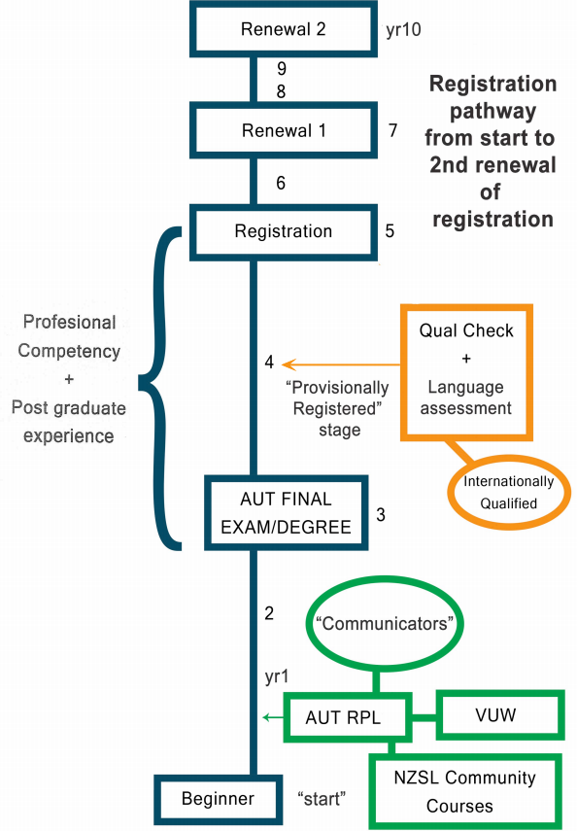

### Registry requirements

Interpreters were strongly of the view (see Appendix 3) that the registry should require new graduates to be members of SLIANZ (91%), undertake ongoing professional development in the form of training (79%), sit a standardised test (71%), receive effective mentoring, and submit a portfolio of work (64%). Difficulties about practically collecting a small portfolio of work were noted and there was some confusion about the difference between mentoring and supervision.

*Table 2: Registration requirements for new interpreters*

|  |  |  |
| --- | --- | --- |
| Requirement | % | N |
| Membership of SLIANZ | 91% | 51 |
| Professionally-focused training | 79% | 44 |
| Standardised test | 71% | 40 |
| Effective mentoring | 71% | 40 |
| Portfolio of work | 64% | 36 |
| Effective supervision | 46% | 26 |

For intermediate interpreters (with 3-7 years’ experience), SLIANZ membership (91%) and training (86%) remained paramount, followed by a portfolio of work (63%) and supervision (55%).

*Table 3: Registration requirements for intermediate interpreters*

|  |  |  |
| --- | --- | --- |
| **Requirement** | **%** | **N** |
| Membership of SLIANZ | 91% | 51 |
| Professionally-focused training | 86% | 48 |
| Portfolio of work | 63% | 35 |
| Effective supervision | 55% | 31 |
| Standardised test | 45% | 25 |
| Effective mentoring | 38% | 21 |

For senior interpreters with eight or more years’ experience, membership of SLIANZ remained very important (91%), professionally focused training was equally important (91%) with effective supervision taking over as the next important requirement (57%) and demonstrating skills through a portfolio of work (55%).

*Table 4: Registration requirements for senior interpreters*

|  |  |  |
| --- | --- | --- |
| Requirement | % | N |
| Membership of SLIANZ | 91% | 51 |
| Professionally-focused training | 91% | 51 |
| Effective supervision | 57% | 32 |
| Portfolio of work | 55% | 31 |
| Standardised test | 36% | 20 |
| Effective mentoring | 21% | 12 |

Most interpreter survey participants (71%) thought registration should require a competency standard for technical interpreting skill equivalent to at least two years full-time practice after graduation, and 60% of respondents thought registered NZSL interpreters need to re-register every three years, and a third (32%) thought it could be every five years. This report supports the majority of interpreters saying that registration should be maintained 3-yearly, with proof of SLIANZ membership, training, self-reflection via portfolio work, and an absence of upheld serious complaint.

Failure to pass the standardised test or meet professional development requirements for re-registering should be met with clear pathways to re-submit at the earliest opportunity so that the interpreter is engaged in constructively working towards re-registration. If the registry decides that an applicant should be registered subject to conditions, it must state the conditions and the time within which each of them must be met and its reasons for imposing them.

Similarly, the registry could de-register an interpreter in extreme circumstances, such as ongoing failure to learn required skills or significant ethical breaches, and clear criteria for these outcomes need to be clearly laid out for all interpreters. If an interpreter is de-registered, interpreting agencies may need to be informed by the registry so that the person is no longer employed until re-registration occurs, when interpreting agencies are also informed.

There were mixed opinions about how long interpreters could be away from interpreting before they needed to re-sit registration. A suggested 18-month period received mixed responses in the interpreter survey, with the highest being *maybe* (43%) and 38% agreeing that could work. Comments indicated the unique context of each person’s circumstances might require variation. Given that interpreting is a female-dominated profession, career breaks to have children might be expected. Some interpreters taking breaks remained connected with the Deaf community or offered voluntary interpreting and so skill levels after a fixed period of time can vary. It might be that on re-entering the workforce, teaming, or links with trained mentors would enable a sensible decision to be made as to whether provisional registration needed to be specified.

*There needs to be a case by case assessment (for people away from interpreting).*

### Housing the registry

A number of government providers were canvassed as to whether co-location and management of the registry was possible in order to reduce costs. The Ministry of Social Development (MSD) and ODI did not think the registry easily sat within their auspices. They do not host or manage any other professional association and so it was not an obvious fit for them. However, both said application could be made for sponsorship in the form of use of meeting rooms, etc.

Te Taura Whiri (the Māori Language Commission) would consider the possibility but a formal approach would need to be made. Te Taura Whiri is also involved in developing standards for Māori language interpreters and although they will be less rigorous than those for NZSL interpreters, they appear committed to advancing making the Māori world accessible for Māori Deaf, and are eager to collaborate with NZSL experts to progress sign language for this group.

It was in the interests of saving resource that approaches were made and it became clear that rent for premises would still need to be paid to any agency responsible for the registry. The authors were also left with a sense that the registry would be better as a stand-alone agency so that it does not take on the priorities of another agency, but rather focuses on the advancement of NZSL.

Considerable thought then was given to the possibility that SLIANZ could provide the registry. The advantages of this would be that strong interpreting expertise would be available for the registry without distraction of the separated interpreter association; SLIANZ is already involved in many of the tasks associated with the registry in a voluntary capacity (mentoring, training, and complaints); there would only be one body for interpreters to join; and there would be less costs for interpreters as a result.

The disadvantages of such an outcome include the need still to design and develop the detail of the registry freshly, and layering new funded systems over older ones provided by SLIANZ may be confusing and time consuming. Secondly, and perhaps more importantly, there are essential differences between professional associations and a registry, in that the purpose of the former is to serve the interests of their members, whereas the registry primarily serves the interests of the public and to do so will develop regulatory and monitoring systems. This is a fundamental difference that goes right to the heart of the organisations (HRPA, p.6).

The registry is expected to undertake a number of roles outlined in section 3.1 above, including:

* defining criteria for registration with and certification by the professional regulatory body,
* providing guidance to members through codes of ethics, rules of professional conduct,
* maintaining a public register, and
* ensuring complaints about members are investigated, and members are disciplined as required.

Professional associations, on the other hand, have no legal requirements other than those which apply to all businesses. Professional associations are constituted to primarily serve the interests of their members through activities such as:

* providing networking opportunities,
* publishing information of interest to its members,
* conducting research,
* staging conferences, seminars, and workshops,
* maintaining links to job opportunities,
* negotiating preferential rates for their members for various products and services, and
* lobbying governments to influence policy in furtherance of the interests of their members.

SLIANZ may well have a collective and individual commitments to serve the Deaf community but nevertheless exists to serve the interests of their members. Due to the potential conflicts of interest between making decisions in the interest of the public versus that of the profession, governments often force a separation between the professional association and regulatory body. If separated, there is a registry whose sole mandate is to protect and promote the public interest by regulating its members; and there is a professional association whose sole purpose is to serve the interests of its members. Separating these functions along these lines is ideal and creates greater clarity of purpose, although it is also acknowledged that there is also always some overlap of interests (e.g. professional development).

Although professional associations and professional regulatory bodies are often separate, this is not always the case. Despite the potential conflicts of interest, in some circumstances, such as when the profession is newly regulated or fairly small, as in this case, or the risk of harm to the public is relatively low, the professional association and regulatory body might co-exist under the same roof, even for a period of time. In this event, the registry would need to be given some ability to represent the interests of the profession. However, it is clear that the protection of the public is most important for the registry, and when there is any conflict between serving the interests of the public and serving the interests of the profession, the public interest must win out. If SLIANZ was to be considered to run the registry, there would need to be an agreement that this would be the case.

If SLIANZ is to be considered as a candidate for managing the registry or undertaking some contracts for the registry, it will need to undergo some significant change and growth to develop a stable board and the infrastructure required to undertake the contracted work.

### Registry structure

Given the lack of interest in managing the registry and that registries and professional associations tend to stand on their own feet, it is anticipated that the NZSL interpreter registry is a stand-alone body. It should be a charitable trust or limited liability company for charitable purposes to ensure any profits are invested in enhancing the quality of the interpreter profession. It should have a small board of no more than five to enhance decision-making speed. The board should prioritise governance expertise (at least two people should be selected for this reason alone), but include interpreter experts and bilingual Deaf representatives to ensure interpreter and Deaf community knowledge. The board could be required to report to the NZSL Board to ensure accountability to the Deaf community, and the NZSL Board would have the power to replace board members as described within the registry’s constitution. The board should be paid for its role in guiding the organisation forward to better guarantee ongoing interest and commitment to the role.

There is one other major option for the registry structure. The small size of the NZSL interpreter profession and indeed the Deaf community prevents some economies of scale. Some consideration was therefore given to the possibility to a larger organisation that could include the NZ Adult Assessment Service, administering the Sign Language Proficiency Interview (SLPI) assessments, NZSL Tutors Association (NZSLTA), and any other future NZSL development agency. If absorbed into the organisation, the board could have a broader brief (such as a NZSL development programme) and would most likely require small expert advisory groups, including for the registry, to inform key decisions for the wider organisation. Another alternative is that the organisations would retain their own boards but this would make the role of staff very difficult in balancing the needs of more than one employer and purpose.

The advantage of the option of combining three activities is that more staff will be required and therefore efficiencies could be gained by employing some lower level of administrative assistance as well as a senior executive. In this way, there could be some efficiencies in task allocation. The main disadvantages are that these three tasks will have to co-locate and learn how to accommodate each other. The registry would not be the only priority. Either way, the organisation is likely to be small and would need to contract in financial, human resources, and technology functions as needed.

## Professional development

Experienced interpreters note that the learning never stops, nor should it as new situations and needs continually arise. Perfect interpreting may be an illusion, but continual improvement is possible and this is why all international interpreter associations require ongoing professional development.

The two main forms of professional development to continue to build competencies in interpreting that were discussed as part of the registry provision in this section are:

* training (i.e. post-qualification non-academic training), and
* mentoring and/or supervision (i.e. individualised coaching of skills by a senior interpreter).

### Training

Over three quarters (78%) of interpreters see professional or post-qualification non-academic training (herein referred to as training) as essential for interpreter development for new graduates and even more so for intermediate (86%) and senior interpreters (91%).

All training would prioritise competencies required for registration as well as identified workforce needs. Priorities would be determined by the registry advisory group or board, after consultation with other key parties such as SLIANZ and interpreting agencies, as well as internally. Interpreter training needs should be informed by assessment, mentoring, and complaints systems so that the overall workforce and individual interpreter needs are targeted. For example, an initial programme on mentoring and using mentors or developing self-reflective skills could be prioritised for all interpreters. Newly provisionally-registered NZSL interpreters should largely focus on meeting their registration requirements, so relevant training expectations should be very clear.

Providers could be contracted for the delivery of training by the registry or another sub-contracted agency. In either way, a sum of money would be made available for training. Key training agencies could then bid for funds to the fund-holder for courses that would be open to all interpreters, not just those who are employed or contracted by the agency.

Some online courses may be included, for reasons of providing access to interpreters nationwide and reducing travel requirements and costs. It is desirable, however, to have at least two face-to-face training opportunities provided during the year for the purpose of enabling professional discussions. All funded training would need to be evaluated by participants so quality and usefulness could be determined.

All training funds should be targeted at the greatest collective gaps known to exist for interpreters. Courses that are not directly funded by the registry but are relevant for an individual interpreter’s skill development (e.g. some post-graduate academic training) would not normally be funded by the registry. This would open the registry or other fund-holder to negotiating with individual interpreters around individual courses, which would simply be too time consuming. These unprioritised courses would need to be funded directly by interpreters, and it is assumed that more experienced interpreters with higher workloads could self-fund some individual training needs.

Low interpreter numbers require some government funding or other funding for training, especially new graduates. Training could possibly be funded partly by a small levy (perhaps 1 - 4%) on total interpreting revenue from key providers and agencies. Some discussion with Deaf Aotearoa (iSign), Connect Interpreting, and WordsWorth Interpreting suggested that this might be acceptable to them if it would ensure training and/or mentoring was provided for their staff, but no details were agreed. If this did occur, the inclusion of other major providers of interpreters to help fund the registry, such as the Deaf schools, Workbridge, and tertiary education agencies should also be involved as their services would benefit from the collective training and subsequently higher levels of quality.

38% of interpreters agreed this would be a good way to fund professional development, and an additional 43% thought it could possibly be a good option. Many thought interpreting agencies should already be involved in training and a few wondered if this would increase prices and make interpreting even less accessible for some people. Several noted that professional development should be funded for all interpreters and not just new graduates.

*If a levy was to be charged, it should provide training across the board; if it only went to new grads this would create divisions, and I think we should be focusing on inclusiveness. In my experience, some so-called 'experienced' interpreters are in equal need of on-going training.*

*Needs to include ongoing training for all interpreters in smaller regions.*

Interpreters were asked if a levy was implemented, would they encourage more people to use those interpreting agencies, so that more interpreting resources could be harnessed through agencies responsible for effective coordination and compliance. There was a mixed response with 39% agreeing, 31% thinking they might do so, and 31% disagreeing that they would encourage this.

*Sometimes people just can't afford to pay (interpreting) agencies.*

*However, if I made more money by direct bookings than via agencies then I would in all reality prefer to have a higher direct income.*

*I would support it if it was benefitting all interpreters not only new graduates.*

### Mentoring and supervision

There is some confusion about the differences between mentoring and supervision and because both have an important role for interpreters, the distinction is clarified here.

Mentoring is usually for a limited period of time, often with targets and a focus on skill and methods to practice and improve in particular areas, e.g. voice over. "In the field of sign language interpreting, the practice of mentorship emerged out of a need to fill the gaps in practical skills of novice interpreters" (Winston & Lee, 2013, p.13). A mentor’s remit allows them to observe a mentee at a live session or view a video clip online (see section 3.5 on technology) and provide feedback and advice, and give a view on the mentee’s areas for development. The mentoring process is detailed in a contract with the mentor (goals, meeting arrangements, etc.). Mentoring can include 1:1 monthly mentoring or groups facilitated by an expert mentor.

More informal mentoring is also possible where interpreters (confidentially) debrief assignments and check in with each other but are not included in this definition of mentoring.

Supervision works very differently, in that it is not time specific and has no end date. Professional supervision offers a safe space that is solely focused on, and led by the supervisee. The role of the supervisor is to ensure that the interpreter is practising safely. The supervisor facilitates a session to allow the supervisee to come to their own understanding of the issue presented, drawing out the thoughts, different viewpoints, and, in some cases, conclusions directly from the supervisee. Supervision encourages support and reflective practice, allowing the supervisee the space to do this. It would never involve observing the supervisee, either during a live session or viewing video clips.

Mentoring is widely considered by interpreters to be essential for new graduates (71%) but less so for intermediate (38%) and senior interpreters (21%). However, supervision is seen as less essential for new graduates (46%), but more consistently preferred for senior interpreters (57%) and intermediate interpreters (55%). (It should be noted that while the concept of mentoring is widely understood among respondents, supervision is less well known and few have utilised this service, so this may have impacted on the results in this survey.)

While supervision is clearly an important part of all professional development, this project argues that there is a broad consensus that mentoring, especially for new graduates, is very important for their skill development, reaching registered status, and most importantly practicing safely. Given the aim to be self-sustaining over time, the project has recommended provision of mentoring during the first five years. For most people, this would enable interpreters time to be registered and then re-register once. Interpreters would be considered ‘senior’ after this time. Payments for mentors could be made through a system that could be authorised and paid online.

Several interpreters commented that they would welcome training in mentoring so they could improve their ability to mentor. A number noted that mentoring required a particular skill and not all interpreters had it nor wanted to learn it. Many also commented that learning to be mentored and receive criticism constructively is also a skill needed by all interpreters to be trained either directly, online, or through a mentor’s handbook[1].

Because there is a strong desire among most interpreters to benefit from mentoring, funding training on mentoring (including how to use mentors well) and a two-year period of funding mentoring sessions every two months (10 sessions) for all interpreters who choose to utilise this opportunity is also recommended. The pattern and usefulness of mentoring should be set in this way. After this point, more experienced interpreters could make their own arrangements for mentoring or supervision. It is hoped that participation in mentoring could also be seen as contributing to professional development points and therefore re-registration.

There is wide agreement that learning occurs for the mentor as well as the mentee. There may also be some commercial advantage for those working as mentors, as doing so acknowledges their higher skill level, in turn making them more attractive for contracting work and employment. A higher than expected number of interpreters (65%) are willing to mentor voluntarily but several commented that they would mentor more interpreters if they were paid to do so. Surprisingly, a lower number in the survey (44%) said they would provide mentoring on a paid basis, whereas in the focus group survey, slightly more people said they would mentor if paid. This result may be because some thought it was not able to be financially supported by interpreters.

*If it was paid, it would free up mentors to mentor more than one and potentially quite a few.*

*Paid basis potentially but would depend on where payment is coming from. Not if it is the mentee interpreter being required to pay - as most of us are aware it is hard enough to earn a liveable income from interpreting due to the largely part-time nature of the work, and this becomes extremely, if not unachievably, difficult to do if we were required to then expend some of that income to pay for a mentor.*

It is estimated that it would take 3 months to redesign and establish formal mentoring systems, building on SLIANZ’s existing systems, including training for interpreter mentors. Contracted training should be provided for ten to fifteen mentors with three regional leaders ensuring mentoring was functioning well. If the mentoring system was found to make a substantial difference to interpreting quality, and registry income levels allowed it, mentoring could be extended to all interpreters or enable both mentoring and supervision to be provided.

As noted under training, mentors could possibly be funded by a levy on interpreting agencies, or another alternative is to charge higher rates for interpreters who act as mentors for a minimum number of mentees. Increasing the levy further than the 4% was believed to put undue pressure on interpreting agencies and their clients to raise interpreter rates. Mentors charging higher rates might create commercial disadvantages for them however, making them less competitive both to interpreting agencies and through direct contracting.

There is some consensus that mentoring is most needed by new graduates and that available funding should focus on this group first. For others, the mentoring system could possibly be self-funded, or delivered reciprocally between interpreters. However, not all interpreters agreed with this.

*(Mentoring is) not just for new grads...all interpreters can develop their skills...itz (sic) ongoing...it is not something that ever stops...Granted new grads need support. Misconception experienced interpreters don't need it and can afford to self-fund. For many interpreting is a part time thing. Dangerous to assume they can afford to self-fund.*

*I think mentoring should be for PD points though.*

The organisation with the greatest interest and experience in mentoring is SLIANZ with their existing programme for new graduates, the Tuakana-Teina programme. Their current experience is that the voluntary system is not working well in that the frequency of mentoring is still lower than expected, and mentors do need to be paid to address this. SLIANZ report that the programme is well supported with 100% uptake from recent graduates. VUW or AUT are likely to be interested in developing and providing the training for mentors across the country.

Mentoring at distance has become more feasible with advances in technology. Some software now enables easy online video feedback that could be used for online mentoring. Other existing programmes allow recording or even just distance discussion for far-flung interpreters (see more in section 3.5 below).

## Assessment

The AUT programme already measures the competence of an interpreter at the point of graduation. There is concern that safe interpreter practice in complex interpreting assignments requires experience and a higher level of technical and ethical competence.

A standardised test would measure the competence of an interpreter set at a competency level equivalent to approximately two years after they have graduated, as agreed by a majority of interpreters. The test would need to be built on the specific competencies sought at this level. This test would examine the ability of the candidate to interpret between languages and their ability to practice according to the code of ethics. This test could identify and build on international examples of competencies and assessment systems to speed its development.

To standardise the test, that is to make sure it measures the same skills in all applicants consistently, it would need to be either frozen, that is a pre-recorded conversation or text, or using live actors with a pre-set text. Interpreter participants considered this potential standardised interpreting proficiency test to be very important only for new graduates and nearly three quarters of all respondents (71%) saw this as most appropriately set at a level expected of a graduate from AUT who has worked full-time and developed effectively for a period of two years since graduation. Although it was noted that many new graduates may not in fact work full time, this timeframe is intended as an approximate measure of expected competency levels.

Most interpreters (77%) thought this test could or could possibly be taken earlier, as long as all the other requirements for proof of training and mentoring could be met. Many interpreters thought that there would have to be exceptional circumstances for this to occur, and that experience as a qualified interpreter, even CODAs (Children of Deaf Adults) skilled in NZSL, need time to adjust to their professional role.

*Experience is necessary for holistic skills and professionalism.*

*Need to work with ethics etc under your belt for 2 years.*

Once this initial assessment and associated systems are established, specialist certifications might be established for complex areas of interpreting, such as legal settings, mental health, and education which can be developed later by the registry.

### A locally developed system

A standardised test could be developed in New Zealand as there is sufficient expertise within the country. Both VUW and AUT could be called upon to oversee the development, which would take around 6 weeks’ work for one person. Once developed, the test would need to be trialled with at least 20 interpreters over a one-year period to ensure that it is a reliable instrument that measures the standard required consistently. AUT and VUW would be valuable allies in training and supporting assessors.

A small expert team would manage the assessments. At least three assessors who are bilingual need to be trained in use of the test. The training is expected to be about four days long in the first year and two-day refreshers would be needed annually thereafter. There would need to be use of international expertise for the first training programme at least (included in costs), so that local skill can be developed. For each interpreter tested, two of these independent assessors would mark the test, with a third on standby to be utilised if there was a significant difference in views by the assessors.

A very competent administrator would be needed to organise and administer the videoed tests, coordinate and process the views of the assessors. This person would travel to two areas of NZ each year to hold the tests, including Auckland, Wellington, and Christchurch, chosen on fairness, demand, and efficiency.

Short selected samples of interpreters’ work in the test would require three hours for each assessor to examine. The portfolio of work could also be examined by the same panel of assessors, also taking around three hours per candidate for two brief pieces of work, including providing feedback, at an expected cost of $360 (excluding administration) to cover the cost of the assessment and feedback. These samples could be filmed, with permission of the clients, on phones or tablets to maintain simplicity. Because the assessor would work with filmed versions of the test, no travel would be required.

A majority of interpreters (71%) strongly believed that international interpreters should be considered provisionally-registered, as long as their qualifications were equivalent, until New Zealand registration requirements are met. Comments indicated there was a sense that international interpreters should not be taking work from local interpreters, and as the quote below indicates, international interpreters should have to meet the same registration requirements.

*It shouldn't be different from NZ interpreters.*

SLPI tests, to be established in 2019, were thought to be very useful in assessing international interpreters in NZSL skill. The SLPI might also be used in the AUT programme as a language development and monitoring tool.

It is anticipated that all assessment tests would be funded by the applicant through the cost of registration. Because of the small number of interpreters and the relative expense of this registry system, it is suggested that registration decisions should be final and cannot be appealed. If the test was not passed successfully, clear pathways to re-submit their work to meet the standard required must be provided for the candidate to re-sit the test at their own cost within the next year. Exceptionally strong reasons for appealing the assessment or registration process may be directed to the registry board.

### NAATI

The National Accreditation Authority for Translators and Interpreters (NAATI) are an initiative owned and supported by all Australian states. They are the dominant provider of accreditation services for interpreters in Australia. NAATI has reviewed its processes and will move to a new system from February 2018. It is the new system that we are reporting on here.

The NAATI test is for general competency, and later specialisms can also be applied for, for example in health, legal, and conference interpreting. Testing is proposed to be performed using a live sample, although currently it is done using a video recording. Even with a live sample, however, actors and scripts are used in order to validate across the interpreter population in all languages. Certification lasts for 3 years, then renewal is required, which requires proof of 120 points of professional development but does not require reassessment.

Those with a lower level of qualification can also be “certified provisional”. In Australia, this category is used for someone who has not trained formally or has done their training at a TAFE institution instead of a university. Other levels currently used by NAATI are “certified interpreter” and “certified specialist”.

This new system will have a preference for eligible applicants to have completed an endorsed qualification at an approved provider. Some applicants could be accepted via a screening test, such as CODAs for example. There will still be the capacity to be certified and not qualified.

However, if New Zealand chose to use NAATI as its certification system, the registry could dictate who has access to that accreditation. For example, the registry could insist that only those meeting other criteria (e.g. mentoring or training hours) could take the test.

New Zealand’s Ministry of Business, Innovation, and Employment (MBIE) is currently considering using NAATI to certify spoken language interpreters in New Zealand, excluding NZSL and te reo Māori interpreters, so use of NAATI could be advantageous and comparable with other spoken languages. ODI is now considering whether to advocate for some form of inclusion for NZSL. There are currently about 200 people in NZ with NAATI certification in either spoken languages or Auslan (Australian Sign Language).

If the NZSL registry does not use NAATI for the assessment system, there could be a risk in unqualified interpreters in NZ taking the NAATI test (for Auslan) and thereby obtaining a form of certification. However, the registry could choose not to accept such certification without evidence of equivalent training, making this loophole less attractive. Similarly, if NAATI decide to develop an NZSL assessment, it could provide local certification, creating a parallel system that local users may find confusing. It seems very unlikely that NAATI would do this without the support of the profession, as represented by SLIANZ, or the public as represented by the registry. Also, again, the registry could decide to not to accept certification without equivalent training, barring access to full registration.

Acceptance of NZSL into the NAATI system is not guaranteed, however, as it would depend on the approval of the NAATI Board of state representatives, and demand for the language assessments, social impact of both including and excluding NZSL, and the economic viability of including the new language. NAATI is confident, however, that NZSL would be accepted, especially if all current interpreters had to take the assessment in the first two years. Their current benchmark is about 40 tests to break even when setting up the test, so 120 tests would far exceed this. Once established, it may only be 10 assessments required a year, based on current graduation rates from AUT and interpreters moving to NZ from overseas.

NAATI testing is often hosted at tertiary providers for ease of access and if run in NZ, NAATI would similarly use local academic institutes for hosting the testing. They would bring administrators from Australia and slowly train up local people to administer the tests in future.

**Costs**

The proposed cost of certification is roughly A$880 (approximately NZ$952) for certification (A$550 for provisional registration and A$242 for re-certification every three years) (NAATI, personal communication). Both of these estimates depend on the successful sourcing of local NZ expertise in assessing and marking as well as the costs of doing so. NAATI has indicated a NZ$5-10,000 cost of setting up NZSL in NAATI and that they could be interested in helping NZ with validation if we decided on setting up our own testing for NZSL.

In Australia, some regional governments subsidise the cost of their interpreters becoming certified, however it is mostly undertaken on a user pays basis. There are some funds for sponsorship for targeted languages and uses, and some interpreting agencies and employers contribute to the costs.

Re-certification is on a three-year cycle. Interpreters must be able to demonstrate 120 points of training and a minimum of 120 hours of interpreting assignments over that three-year period to stay current. NAATI have an ‘easy to use’ online portal for interpreters to record work and professional development. NAATI clearly outline what kind of professional development is accepted and what the point value is for each type of formal event via a published programme. Professional membership of the Australian Sign Language Interpreters Association (ASLIA) attracts points. Interpreters then make a case for each training event in their return. The system is checked by random audit of about 10-15% of submissions. Interpreters holding NAATI certification also get a NAATI ID card, and are put on a database (like a directory) so they can be contacted directly by consumers.

**Advantages of using NAATI**

* It is a mature and well-recognised assessment and related systems are in place.
* If MBIE decides to use NAATI, then it aligns NZSL with other language testing and could bolster the case for NZSL to be included in some way.
* The system is long-standing and the assessments for Auslan have been moderated over time and so in general the assessment process is largely trusted and valid. NAATI has access to a larger subject base for ongoing validation and moderation.
* NAATI’s international profile could benefit those interpreters seeking to travel and work.
* NZ can control who has access to the testing/certification meaning other aspects will need to have been completed first (e.g. mentoring and professional development).
* Set-up costs may be lower than developing a NZ-based system and ongoing costs are similar.

**Disadvantages of using NAATI**

* Potential perceived lack of local interpreter control. This review identified that there is some disconnection between NAATI and the Auslan interpreter profession, which felt it had very little control or influence over the process, despite regular contact. For example, ASLIA has concerns about the quality of assessment staff, many of whom were contracted many years ago and who had quite limited training themselves. This was affecting perceptions of assessment validity. ALSIA did not feel able to interfere in this arrangement despite preferring that all assessors had to reapply for their contracts, and that process should include ASLIA.
* Lack of understanding of local context and in particular the importance and requirement of all NZSL interpreters to have basic skills in Māori language, pronunciation or culture, if the registry is aligned with the Treaty of Waitangi.
* ASLIA was of the opinion that NAATI did not test for all the required skills of an Auslan interpreter, although this might change with the new roll out in 2018. Also, there was some regional variation in Auslan testing that is ignored even though it does affect marking.
* New Zealand is seeking an assessment level equivalent to 2-3 years post-graduate and NAATI currently offers only two generic assessments (Provisional and Certified) that do not fit our needs precisely. Provisional is open to those who have yet to start study or who are currently studying (effectively a “communicator standard”). The certified level assessment is closer to NZ requirements but is also open to those who have just completed an approved course of study which is usually an advanced diploma or degree. It is likely considerably lower than we require. If so, a new test would need to be developed by NAATI with the registry at more cost.
* There are perceptions that NAATI is bureaucratic and slow to respond/action.
* Most NZSL interpreters interviewed in the previous report (Fitzgerald & Associates, 2017), were opposed to the idea of using the existing NAATI system locally.

ASLIA reported that the costs of certification, while unwelcome like any bill, did not generate dissent among interpreters. Practitioners were easily able to afford the re-certification fees. Students were aware of the charges from very early on and so budgeted for the cost. Given the cost is the same for other languages there seems little to complain about.

ASLIA reported that NAATI was the best off-the-shelf type assessment and accreditation package available. However, it was also noted that if they could start from scratch and had the funding to do it, ASLIA would rather see a bespoke system developed for Auslan that contained more Auslan interpreter input and up-to-date quality assurances for the process.

As mentioned, ASLIA reported a lack of control and input into the accreditation system. NAATI connects with industry in three ways. The NAATI CEO meets with ASLIA and the Australian Institute of Interpreters and Translators (Ausit) residents every three months. Some industry (not necessarily ASLIA) members are recruited for their expertise and paid to be on a ‘Technical Reference Advisory Committee’, looking at the voracity and validity of the NAATI system. Finally, there is a Regional Advisory Committee that is run in each state and membership of the groups is voluntary. They typically contain industry representatives and individuals, government officials, and consumers. These options could be established for NZSL.

## Managing complaints

A complaints service is critical if service users are to trust and improve existing services, and is a key right bestowed by the Health and Disability Commissioner (HDC) Act 1994.

A dilemma for the NZSL interpreter registry is that many Deaf people see themselves as being a cultural rather than a disability group. However, cultural identities provide few resources to Deaf people, who must have lifelong access to interpreters to fully participate within the wider community. The Health and Disability Services (Safety) Act 2001 (section 1 (iii)) defines health and disability services as “services, provided to people with disabilities … for their care or support or to promote their independence”. It would seem that interpreter services for Deaf people meet this definition as interpreting does enable independence, and the HDC have acknowledged this informally. Existing provisions for complaints are therefore examined here on the basis that Government may be reluctant to establish a stand-alone complaints service for NZSL interpreting.

The purpose of the HDC Act 1994 is to promote and protect the rights of health and disability services consumers, and, to that end, to facilitate the fair, simple, speedy, and efficient resolution of complaints relating to infringements of those rights.

The functions of the HDC include:

a) to promote, by education and publicity, respect for and observance of the rights of health consumers and disability services consumers, and, in particular, to promote awareness, among health consumers, disability services consumers, health care providers, and disability services providers of the rights of health consumers and disability services consumers and of the means by which those rights may be enforced;

b) to act as the initial recipient of complaints about health care providers and disability services providers, and to ensure that each complaint is appropriately dealt with;

c) to investigate, on complaint or on the Commissioner’s own initiative, any action that is or appears to the Commissioner to be in breach of the Code or, in the case of conduct that occurred before the enactment of the Code, in breach of certain disciplinary standards.

The HDC Act 1994 also requires an advocacy function independent from the Commissioner for empowering consumers to resolve complaints at the lowest possible level. Health and Disability Advocacy in turn will refer systemic issues or those issues that cannot be resolved at the lowest level to the HDC for further investigation. The HDC may refer a complaint to a professional body if there is an issue of competency to be addressed, or to inform of a breach of ethical conduct. HDC primarily work with major systemic ethical breaches of conduct. HDC would not receive complaints about poor outcomes for Deaf people unless it was in direct result of the interpreting service or from within a health service.

The Health and Disability Code of Rights specifically establishes the legal right for health and disability consumers to a comprehensive range of rights:

* Right 1: the right to be treated with respect
* Right 2: the right to freedom from discrimination, coercion, harassment, and exploitation
* Right 3: the right to dignity and independence
* Right 4: the right to services of an appropriate standard
* Right 5: the right to effective communication
* Right 6: the right to be fully informed
* Right 7: the right to make an informed choice and give informed consent
* Right 8: the right to support
* Right 9: rights in respect of teaching or research
* Right 10: the right to complain.

There was a very strong view among interpreters that the HDC was not accessible for Deaf people. Most thought SLIANZ or the registry should deal with complaints, simply because they would be more familiar with the Deaf community, and be linguistically and culturally accessible. Several interpreter participants noted that the complaints process should start with the interpreter, progress to the agency, then the registry or SLIANZ, and finally to the HDC.

*It needs to be accessible to interpreters and the Deaf community.*

*HDC – only for very high levels of severity.*

*There must be NZSL interpreters involved.*

SLIANZ encourages both Deaf and hearing clients to talk to the interpreter first to resolve the problem. If possible, the HDC suggests that talking directly to the provider is also useful. When a complaint cannot be resolved for any reason, both SLIANZ and the HDC can provide a mediation service for the complainant.

SLIANZ already provides a complaints procedure for breaches of the Code of Ethics and Code of Practice that redirects minor complaints. SLIANZ is limited by time, resources, and training in complaint management when addressing complaints, while the HDC is limited by their expertise in NZSL and Deaf culture.

Another possible avenue to resolve complaints is the Human Rights Commission (HRC). HRC are most interested in working with systemic cases where interpreters are not provided at all when they should be (e.g. police interviews), more than they are interested in individual cases where the interpreting did not meet expectations of quality. In fact, HRC’s main strategy for all cases directly involving NZSL interpreters is referral to HDC.

Each state in Australia has a health complaints commission with slightly different names, for example in Western Australia this is called the Health and Disability Services Complaints Office. ASLIA reported that they were aware of these complaints services but understood they were only for health-related assignments, not all Auslan jobs. In any case, ASLIA argued that complaints tended to be resolved at the interpreter or agency level, with some then going to ASLIA but most going to NAATI as they had more authority over interpreter registration. There seems to be surprisingly low levels of complaints reaching NAATI; there had been only one complaint about Auslan interpreting reported to NAATI in the last 12 months. It is not clear how well the complaints process is understood by Deaf clients, although NAATI provides information in all languages, including Auslan.

**Risks and mitigation**

The key advantage for HDC and the advocacy service to undertake the complaints mediation role is that they already have a national, comprehensive, and funded service for the full range of disability services. The main disadvantage is that they are currently viewed as culturally and linguistically inaccessible to the Deaf community. They would need to access the registry or SLIANZ to provide culturally appropriate complaint services with interpreting expertise.

If some collaboration between the existing complaint services and interpreter services was possible, interpreter consultants would benefit from training in complaint management, and existing health and disability advocates would benefit from knowledge of Deaf culture and how to increase their accessibility.

The main disadvantage for SLIANZ or the registry establishing its own national complaints service is one of cost, in training staff and developing an accessible national presence. Given that there is an existing service that is meant to undertake the role, it may be easier to ensure it is accessible, rather than develop an entirely new service. Should HDC be unable or unwilling to offer such services, the Office of the Ombudsman has the power to advise and guide HDC in terms of meeting their obligations to service users of NZSL interpreters.

This does not mean that SLIANZ, the registry, and other interpreting providers cannot assist Deaf people to identify the seriousness of their complaint and what approach might be taken. There is a clear need for ongoing promotion about all aspects of the registry within the Deaf community and to hearing users. It is appropriate to ensure Deaf people get Deaf-friendly advice early and appropriate direction as to where they can take their complaint. Both the registry and SLIANZ may be useful in receiving complaints initially and advising Deaf people on their options. The registry, SLIANZ, and interpreter providers should all provide clear pathways for making a complaint.

## Technology

There are currently a large number of websites and software offering ways to connect people and enable effective communication that could be used for many of the registry components recommended in this report. These include connecting interpreters, mentors, assessors, and trainers to make professional development viable.

There are many ways in which technology can make professional development easier and more affordable, including one-on-one virtual mentoring sessions, peer supervision through video group conferencing, or accessing webinars both live and pre-recorded.. In particular, these could enable interpreters residing outside the main centres to attend events and participate in professional development activities with their peers.

In more remote areas the only impediment to effective collaboration online could be the quality of the internet connection available in those regions, but with the fibre network continuing to be expanded, these issues are diminishing. Professional interpreters can reasonably be expected to maintain the cost of an internet connection and have equipment suitable to utilise online systems and software.

Examples of sites and software are listed below, but there are many on the market and could be further explored by the registry or by contractors.

|  |  |  |
| --- | --- | --- |
| Software | Description | Pricing |
| Skype  <https://skype.com>  Useful for one on one mentoring discussions, possible use in peer group mentoring and training. | Online telephony service offering video calling and group video calling.  Has a reputation for being variable in quality. | Free to use for basic settings. |
| Zoom  <https://zoom.us/>  Useful in particular for training sessions and meetings.  Sessions can be recorded online. | Videoconferencing and webinar hosting software.  Tends to run a higher quality of sound and image than Skype.  Pro +Webinar enables webinar hosting, including Facebook Live and YouTube live. | Free for personal use, including group up to 100 people. Time limit of 40 minutes (requires reconnection).  Upgrades cost US$15-20 per month for unlimited duration (paid by host only), including ability to record sessions. |
| GoReact  <https://get.goreact.com>  Could be used for mentoring where feedback on NZSL production is especially useful. | A site enabling time sensitive feedback to be given in written, audio or video format on videos pre-recorded or recorded live into the GoReact platform | Pricing is via a licencing system currently charged to “students” attending courses, with the instructor registering free. However bespoke licencing agreements could be negotiated. |

**Registry Portal**

One piece of technology that may require some bespoke programming is the portal required for interpreters to easily log professional development activity, possibly monitor their points, and authorise payments to mentors. There are a number of software service options that could be used. However, they require licencing for each user which could become quite expensive ($200-300 per interpreter per year), and so given the scale and relative simplicity required in the registry system, custom development may be preferred. Such a portal would likely cost between $10,000-15,000 to create, with ongoing hosting costs of around $1000 – $1,200 per year, as can be seen in section 4 on costs. Additional maintenance should also be budgeted to ensure the site is robust, secure, and reliable.

## Market and policy factors

**Lack of knowledge and dedicated budgets**

There are several market forces impacting the provision of interpreting. Firstly, many or most hearing consumers in government and other agencies are unfamiliar with why interpreters are so important to Deaf people, and the complexity of the interpreting process. As observed for spoken language interpreters (MBIE, 2016; NZ Immigration, 2017), government agencies need training and guidelines on the use of interpreters.

Without dedicated budgets for interpreting, the cost and time constraints of contracting, and, in more remote areas, transporting in skilled NZSL interpreters discourages government agencies from using interpreters more frequently. Better use of online interpreting where possible and appropriate may help to reduce overall costs. There also seems to be a poor understanding of the reasons to assign an appropriately skilled interpreter in order for communication to be effective and safe. At least one District Health Board (DHB) has formally contracted health interpreting services with an unqualified interpreter despite qualified interpreters being available in that area.

In general, the quality of any interpreting can be hard to determine, as much depends on the context of the assignment and the participants, including their communication needs and skills. In addition, the limited knowledge of NZSL and interpreting within New Zealand communities means it is almost impossible for anyone to question interpreters, other than their peers or more experienced interpreters.

**Perception of high costs**

Interpreting charges vary from $70 to $160 for an initial hour’s interpreting depending on the experience level of the interpreter, and other factors such as the use of interpreting agencies who have additional costs to cover. There is a perception that interpreting costs are exorbitant by many when compared against the costs of some other disability services (e.g. MyCare) for carers or spoken language services of $20 to $30 an hour (personal communications). However, when compared to the price of tradespeople, with call out fees and minimum charges, interpreters seem more reasonably paid.

**NZSL interpreting needs**

The Disability Resource Centre’s (DRC) Cost of Disability report (2010) identifies the need for 345 hours of interpreting a year or 6.5 hours a week for the average Deaf person for a range of life functions (Deloitte, 2017; DRC, 2010). It is clear that the average Deaf person does not receive this (iSign, personal communication). If the 2,000 Deaf people known reliant on NZSL for communication (Deaf Aotearoa communication) received this and paid a modest $80 an hour for this, it would cost just over $55 million per year.

It is not clear how much is currently spent on NZSL interpreting as there are no collective records. However, there is some anecdotal information that suggest around $5 million could be spent through iSign (~$2 million), Connect Interpreting (~$0.5 million), Deaf and mainstream schools, universities and tertiary services, Video Interpreting Services, and Government Departments, including Workbridge (all unknown).

It is clear then that there is a substantial gap between the real volume of NZSL interpreting needed compared to how much is actually provided, which may help to explain why the relatively high cost of interpreters continues to be absorbed in an otherwise area of low pay.

There is no monitoring of the quantity cost or quality of NZSL interpreter service (HRC, 2013). New MSD contracts will require quality evaluation, a complaints system, and interpreter training. These are expected to move to the Ministry of Health (MOH) and Ministry of Education (MOE) in the near future.

**Individual contractors**

Just under half of interpreters operate as freelancers directly to agencies and individuals. The primary motive for this is to reduce the cost of interpreters for service users. There are two key disadvantages of the freelancing system. Firstly, it limits the ability to effectively coordinate the provision of interpreters to better match demand and supply. As a result, there is higher demand for interpreters than can be met but at the same time there are interpreters with too little work (Deloitte Access Economics, 2017; Fitzgerald & Associates, 2017). Secondly, it does not enable any systemic contribution to interpreters’ training and development, if assignments are not directed through interpreter providers.

**Small sector**

The small size of the interpreting market, of both consumers and interpreters, limits opportunities for economies of scale. Unlike other professional groups such as teachers, nurses or speech language therapists, a registry for NZSL interpreters is never likely to be self-funding unless it was at an extremely basic level. Moreover, the inability to train interpreters in more than one place in the country means that it is harder for people in regions other than Auckland to develop a workforce.

The lack of NZSL human and education resources for teaching and learning NZSL also means that it is harder for the general population to develop NZSL skills and develop a potential interpreter pool.

Deaf people’s lack of access to early sign language has led to the development of an undereducated and fragmented Deaf community, that has high demand for interpreting with complex linguistic and ethical requirements, but insufficient skills in managing quality issues through existing complaints systems.

**Legislation and policy**

There is already significant legislative support for the provision of NZSL interpreters in NZ.

The right of the roughly four thousand Deaf people in New Zealand (Johnson, 2006) to effective communication has been supported by the UN Convention on the Rights of Persons with Disabilities (Disability Convention), which recognises “the importance of accessibility to … information and communication, in enabling persons with disabilities to fully enjoy all human rights and fundamental freedoms” (UN, 2006). The Disability Convention is now starting to be referenced in other pieces of legislation (e.g. Children, Young Persons, and Their Families (Oranga Tamariki) Legislation Bill).

The NZ Disability Strategy holds all Government departments responsible for their contribution to a range of strategies ensuring the rights of disabled people to live in a “non-disabling” and inclusive society. The latest Disability Strategy (ODI, 2016) also expects that disabled people “are not … segregated from or isolated within our communities” (p. 27) and that people “who use different languages (in particular New Zealand Sign Language) … have ready access to them” (p. 24).

The Human Rights Act 1993 specifically prohibits discrimination in a number of areas (including employment and the provision of goods and services) on the grounds of disability. It does allow a person to refuse to provide those goods or services to any person if it is unreasonable to expect them to do so.

The New Zealand Bill of Rights Act 1990 aims to “affirm, protect, and promote human rights and fundamental freedoms in New Zealand”. It aims to prevent discrimination and also states that a “person who belongs to an ethnic, religious, or linguistic minority in New Zealand shall not be denied the right, in community with other members of that minority, to enjoy the culture, to profess and practise the religion, or to use the language, of that minority”. Section 24(g) provides that every person charged with an offence shall have the right to have the free assistance of an interpreter if the person cannot understand or speak the language used in Court.

Various other acts, including Section 9 of the Children, Young Persons, and their Families Act 1989, the Intellectual Disability (Compulsory Care and Rehabilitation) (IDCC&R) Act 2003 and the Mental Health (Compulsory Assessment and Treatment) (MHCAT) Act 1992, require an appropriate interpreter to be provided where possible. The Code of Health and Disability Services Service Users’ Rights 1996, as discussed in 3.4 above states a number of rights, including the right to effective communication: “every service user has the right to effective communication in a form, language, and manner that enables the service user to understand the information provided. Where necessary and reasonably practicable, this includes the right to a competent interpreter”.

In 2006, the NZSL Act came into force, recognising NZSL as an official language of New Zealand and entrenching the rights of Deaf people to communication support. One lone standard was set for the Ministry of Justice (MOJ) that required the Ministry to only use qualified interpreters with at least two years’ post-graduate work experience in court. SLIANZ also developed some informal standards that encourage ongoing professional development of its members and the creation of the registry is an attempt to develop another standard for the provision of interpreters.

Without access to communication support, the New Zealand Government has recognised that Deaf personal achievement and integration within mainstream communities is not possible. However, while there is supportive and encouraging legislation, no legislation guarantees Deaf people the right to interpreters for communication. There is no legal requirement that forces government agencies to provide and pay for interpreters and Government funding is piecemeal with numerous funding gaps creating often insurmountable barriers for Deaf people (HRC, 2013).

For example, MSD, through Workbridge, offer two funds: Job Support and Training Support. Both are considered inadequate to meet Deaf people’s employment needs (HRC, 2013). There is too little resource in early childhood and school-aged education for Deaf children to access NZSL. MOE has a policy of mainstreaming which hinders the aggregation of Deaf children into groups that could share NZSL-trained teachers or interpreter support (HRC, 2013). Deaf people consistently raise the fact that they do not get sufficient access to interpreters to participate in mainstream life/activities (Fitzgerald & Associates, 2017).

Government departments also have internal policies that encourage equitable service. For example, the Code of ACC Claimants’ Rights places an obligation upon ACC to provide claimants with an interpreter when necessary and reasonably practicable. The Code is a regulation under the Injury Prevention, Rehabilitation and Compensation Act 2001, which itself makes no reference to interpreters. ACC’s policy for the use of interpreters (both spoken and NZSL) is to employ a professional interpreter where the situation requires it. ACC also have reported using staff members, family members and support people who can sign for ‘less complex’ cases (IISW, 2004).

**Spoken language interpreting standards**

At the same time as the NZSL interpreter registry is being considered, standards for spoken language interpreters are also being planned. The Language Assistance Services Project targets former refugees and migrants, many of whom have insufficient English language skills on arrival to be able to operate independently, integrate quickly into New Zealand life, and achieve self-sufficiency (MBIE, 2017). The system acknowledges there is a high percentage of spoken language interpreters still working voluntarily and so the profession might not be 100% ready for a standards system to be imposed. A final report and recommendations are expected in October 2017.

The current scope specifically excludes NZSL and te reo Māori interpreters. However, NZSL interpreting may benefit substantially from some involvement, particularly in communication and funding systems. ODI is currently working on the possible inclusion of NZSL. Four key deliverables will be developed and implemented through the project:

1. A Language Assistance Services Policy and Guidelines will set out best practice in the planning, funding and delivery of public services. Central government agencies’ implementation of the guidelines will improve the consistency and coordination of language assistance services delivered across the public sector. There will be training support for agencies to implement the guidelines.
2. Common purchasing arrangements will make purchasing language assistance services by public sector and government-contracted agencies simpler, more efficient, and more cost-effective. Assessment and other infrastructural costs are not yet clear but could possibly be either paid or subsidised by the Government, as is the direct interpreter provision.
3. Professional standards and associated certification framework for interpreters and translators working across government will improve the quality and consistency of their services. During the transition period, untrained interpreters and translators will be able to access professional development pathways to comply with the new standards. Once the standards have been fully implemented, interpreters and translators who wish to work in the public sector will be expected to be certified as meeting the standards at the relevant level.
4. A Language Assistance Services Portal and other systems to support the new model will provide simple access to a single depository of information about language assistance services in New Zealand. Development of the portal will be achieved in the last phase of the project.

The new system may not be regulated, but could be enforced through Government contracting. The current plan is to employ NAATI as the primary mechanism for assessing and monitoring standards in NZ. They would contract local tertiary providers to host the assessments, as well as modify assessments for the NZ context. Marking would be done in Australia to start with.

MBIE is currently undertaking a survey of all interpreters and translators to get their view as to what competencies should be assessed here in NZ. These competencies include language, culture, technology, service, and ethics. The results will influence whether MBIE decide to go with NAATI or find another alternative.

It is proposed that complaints against spoken language interpreters would be handled by NAATI. However, NAATI hopes that only extreme or complex complaints would go to them and that 90% could be resolved domestically by interpreters or providers.

## Risks

**Failure to use registered NZSL interpreters**

A number of existing Government users of interpreter services, including five DHBs, were contacted to explore the idea of the registry and its impact on them. The three urban DHBs already used interpreting agencies and so already have the expectation that these agencies ensure interpreters are appropriately skilled. However, they still supported the idea that a registry would make sure interpreters were maintaining their skills, were monitored, and that guidelines are available. The regional DHBs were in locations with either not many or no interpreters and they had greater challenges in accessing interpreters and much less awareness of the need for trained and qualified interpreters to ensure accurate interpretation.

As already noted, MSD, through Workbridge, provides two primary funds for interpreters: Job Support and Training Support. Workbridge does not check on the credentials of the support services requested by clients, as most of those support services are unskilled or semi-skilled support workers. Once funded, a Deaf person could ask anyone to act as their interpreter or communicator. Workbridge does not dictate the credentials of those hired to provide services. Requiring interpreters to be registered in order to qualify for contracting with Workbridge funding would require a change to MSD criteria.

MOJ contracts interpreting agencies and freelance interpreters depending on the language and geographical area concerned. The manager of their interpreting service is aware of the NZSL Act regulation regarding experience level, and was open to feedback that two years was not enough to work in a courtroom or most legal settings. However, the Ministry is keen to make sure provision of interpreters in courts is achieved. The Ministry is open to receiving the instruction of a new level, but has concerns about affordability. If it meant paying travel costs to bring in a suitable interpreter from another area then there would be an increase in costs at a time when across the board interpreter budgets were being frozen or reduced, and the risk is that NZSL interpreters that met the registry requirements may not be used.

This risk may not be as high as feared with 60% of the workforce having more than five years’ experience (Fitzgerald & Associates, 2017), should the required level of years’ experience rise.

One of the main risks of the registry with a higher standard of assessment is that unqualified interpreters from the regions, who may be required to support these local communities, might be further distanced from meeting the requirements in the new system. Smaller areas are also likely to be disadvantaged with less access to professional development and assessment compared to interpreters working in urban areas.

It may not be possible to eliminate the use of unqualified interpreters completely. It may be sufficient to provide firm guidelines for government departments to follow the registration system, and provide encouragement to others to use only registered NZSL interpreters, while at the same time offering an accessible pathway for unqualified interpreters to become qualified.

There was some discussion with AUT in this project on the setting up of block courses in other cities to partially complete the requirements of the AUT interpreting degree. AUT would consider working with VUW and a provider in Christchurch to host the courses but would need guaranteed numbers to complete it. However, no costs relating to this are currently available.

Some recognition of prior learning might also be given for some papers in the first year of the AUT programme if similar papers were held, or the student could demonstrate equivalent experience or competency. A potential alternative is through a post-graduate diploma option, which would require far less class time. However, this means setting up an alternative qualification pathway to the degree, likely weakening the existing programme, so this option is not being promoted at this time.

It may be possible to indirectly enforce the voluntary standards through Government contracting, including the Ministries of Health, Education, and Social Development, which could require interpreting agencies to only work with registered NZSL interpreters.

Interpreters’ greatest fears for the registry were that it would be too costly, punitive, and may lose interpreters from the profession who are unable to pay or are resistant to the standards. Fears that there is not sufficient buy-in from the Deaf community and agencies was also mentioned, as was the risk that if registration was not mandatory it may be ignored. If interpreters don’t support the registry, view newer interpreters as competition, or view the system - as a whole - as somehow unfair or invalid, the role of the Registrar will be challenging, even with support from Government, interpreting agencies, and the majority of Deaf community.

*The validity and consistency of the assessment(s) to test what they are supposed to test is absolutely key. If interpreters/professionals don't feel that the assessment is an accurate reflection of skills within the industry, then it loses all power to bring about change. I would rather that the necessary time was taken to make sure the assessments are honed and polished (with some trials perhaps) rather than the standards being rushed in too soon.*

The ability of part-time interpreters to pay needs to be considered, and lower registration rates may be needed in some circumstances. For example, where there are not enough interpreters but available interpreters have low incomes because they are working part time. However, interpreter hours will be hard to monitor for the register, and offering different registration fees for colleagues working in the same area may cause difficulties.

Failure to promote the importance of the registry and the use of registered NZSL interpreters may result in a lack of commitment to use the service. The benefits of the registration system need to be promoted, perhaps by the registry, SLIANZ, interpreting agencies, and interpreters themselves.

Lastly, there are risks and benefits of associating with the new spoken language interpreter standards. In terms of systems for contracting and communicating with Government, as well as having a broader professional group focused on quality, there are immense advantages. However, because spoken language groups always have the ability to learn spoken English, their interpreters may not ever be considered as essential as NZSL interpreters are for Deaf people, and may always be paid accordingly. This distinction between the groups may need to be emphasised at times.

There is a risk that the Registrar does not have enough time to develop and run the registry within the half-time position. This will have to be reviewed as systems and processes are developed. Failure to review how the registry works in practice at regular intervals is also a risk because elements will almost certainly need refining over time, and engagement with interpreters maintained on how they see the effectiveness of the registry.

# Cost estimates and timeframes

Note that all costs in this section exclude GST and are estimates only. Changes to any of the key factors will change the financial bottom line for the registry. The key cost factors include the cost of contracted and training staff, which are lower than standard interpreter fees because of the general absence of travel and the intensity required in an interpreting assignment, and have been set at hourly rates of substantial salaries. Other key costs include the cost of registration and re-registration, government funding or level of levy on interpreter fees, proportion and amount of interpreting that goes through the interpreting agencies, and the ability to extract the levy from major users if they do not go through the interpreting agencies. Interpreting agencies need to be required in contracts to reveal their full interpreting income if the levy is to be applied.

All these costs can be adapted on the developed spreadsheet to see the final outcome on the bottom line. As it stands, breakeven is estimated to be reached in 2021, and the NZSL Board would need to pay a total of $217,162 for the service between 2018 and 2021. This excludes any development work to get agreement on the suggested approach or initial recruitment.

The time frames assume a formal start to the registry in July 2018 but no direct services, other than training for mentoring, are started in that 6-month period. Instead, that period is used to develop systems and processes for assessment, training, mentoring, and complaints, as can be seen in Figure 2 below. In the six months prior to this (January to June 2018), there needs to be ongoing conversations between representatives of interpreters, interpreter agencies, Deaf people, and the Government to see whether the way forward in this report, or some adaptation, can be formally agreed.

Discussions with interpreting agencies initially looked at a small levy of 1 – 2 % but the estimates used in this section have estimated a levy of 4% per year. This levy covers the costs of training, some mentoring, and contributes substantially to the cost of the registry. This clearly needs discussion with the major interpreting agencies to verify this is feasible. If it is not possible to charge this from current rates, either existing prices will need to be raised or registry services and their costs reduced.

Pricing of registry services was tested with interpreters and there was a wide range of expectations. Overall the expectations of payment for professional services were low, as can be seen in Table 5 below. The price of $1,100 outlined below for initial registration will be significantly higher than expectations, but still only covers the actual cost of the standardised proficiency test and portfolio assessment. However, this is only a little more expensive than the NAATI testing, and gives substantially more value with feedback on the portfolio. The three-yearly price of $690 for re-registration is $230 per year and will definitely be within expectation for most interpreters, especially if training is provided at no or little cost to them. These costs compare to nurse practitioners’ qualifications approval for speech language therapists in Appendix 6, but are also higher than some professions, such as teachers. Note that these comparisons inspire consideration of several other possible products for sale (e.g. authorisation of international qualifications or auditing of programmes).

Figure 2: Suggested timeframes for the establishment pf the NZSL registry



*Table 5: Interpreter expectation of professional service prices*

|  |  |  |  |
| --- | --- | --- | --- |
| Registry service | Average price | Lowest rate | Highest rate |
| Initial registration | $168 | $50 | $1,000 |
| Re-registration | $121 | $25 | $400 |
| Professional Development - training | $177 | $50 | $800 |
| Professional Development - mentoring/supervision | $264 | $50 | $1,000 |

*Table 6: Cost assumptions*

|  |  |
| --- | --- |
| Recommended Registrar full-time salary from Strategic Pay | $89,288 |
| Development work on assessment - per hour | $50 |
| Hourly cost of assessors | $50 |
| Hourly cost of mentors | $50 |
| Hourly cost when training | $40 |
| Assessment: Two assessors on panel (3 if there's disagreement  - estimate 20% of time) @ $50 per hour for three hours each | $360 |
| Portfolio: 2 pieces of work take 6 hours including feedback  with one person and two if complex (estimate 20% complex) | $360 |
| Time to set up registry before beginning training: Identifying systems, mapping and certifying processes and contracting individuals | 4 months |
| Cost of initial registration (includes skills and portfolio assessment) | $1,100 |
| Cost of re-registration (includes portfolio assessment) | $690 |
| Initial triaging of complaints included in registry | $7,500 |
| Training needed for Deaf/interpreting experts, as advocacy  and HDC consultants are provided by HDC at their cost | $0 |

|  |  |  |  |  |  |  |
| --- | --- | --- | --- | --- | --- | --- |
| Number of interpreters | | | | | | |
| Calendar year | **2018** | **2019** | **2020** | **2021** | **2022** | **2023** |
| Number of new interpreter graduates | 8 | 7 | 7 | 7 | 7 | 7 |
| Total number of interpreters assuming  loss of 3% of interpreters per year | 105 | 108 | 112 | 115 | 119 | 122 |
| Total number of interpreters less new graduates | 97 | 101 | 105 | 108 | 112 | 115 |

|  |  |
| --- | --- |
| Mentoring training costs - included in first half year of funding | |
| Mentoring training: NZ$100 per hour for 2 days | $1,600 |
| Travel costs (assume NZ) | $300 |
| 2-day panel for 15 interpreter mentors @$40 an hour | $9,600 |
| Travel and accommodation costs for mentors | $3,750 |
| Venue charge (assume venue found) | - |
| Total | **$15,250** |

|  |  |  |  |  |  |  |
| --- | --- | --- | --- | --- | --- | --- |
| Total interpreting $ per annum | Refresher mentor training needed every 2 years from training budget  Levy rate on interpreting agencies | | | | | |
| 5% | 4% | 3.5% | 3% | 2% | 1% |
| $3,000,000 | $150,000 | $120,000 | $105,000 | $90,000 | $60,000 | $30,000 |
| $3,500,000 | $175,000 | $140,000 | $122,500 | $105,000 | $70,000 | $35,000 |
| $4,000,000 | $200,000 | $160,000 | $140,000 | $120,000 | $80,000 | $40,000 |
| $5,000,000 | $250,000 | $200,000 | $175,000 | $150,000 | $100,000 | $50,000 |

*Table 7: Estimated NZSL Interpreter registry costs*

| Cost | Assumptions Year | 2018 | 2019 | 2020 | 2021 | 2022 | 2023 |
| --- | --- | --- | --- | --- | --- | --- | --- |
| *Administering the registry* | Assume 20 hours a week - see job description. Assume 6 months in 2018 year | $22,322 | $44,644 | $44,644 | $44,644 | $44,644 | $44,644 |
| *Developing the assessment* | Assume 6 weeks’ work for one person @ $50 per hour collecting and adapting competencies from international sources and assessment | $12,000 |  |  |  |  |  |
| Piloting the assessment - testing 20 people over 6 months | $7,200 |  |  |  |  |  |
| Validating the assessment (NAATI estimate) | $5,000 |  |  |  |  |  |
| *Training assessors* | 4-day panel @ $100 per hour including trainer | $4,200 |  |  |  |  |  |
| 4 nights’ accommodation ($200 pd) and travel ($800) for trainer (assume from Australia) | $1,600 |  |  |  |  |  |
| Five assessors attending training ($40) | $6,400 |  |  |  |  |  |
| Travel and accommodation - 3 people from out of town | $1,800 |  |  |  |  |  |
| *Annual refresher training of two days* | Training (trainer) is local or at distance so no travel costs |  |  | $2,000 |  | $2,000 |  |
| Three assessors trained |  |  | $1,920 |  | $1,920 |  |
| *Interpreter assessment* | All interpreters assessed over 3 years |  | $13,009 | $13,433 | $13,845 |  |  |
| New graduates and re-tests |  |  | $3,600 | $3,600 | $3,600 | $3,600 |
| *Portfolio costs -* | **All interpreters are assessed over 3 years** 2 pieces of work take 6 hours including feedback with one person and two if complex (estimate 20% complex) |  | $13,009 | $13,009 | $13,009 |  |  |
| 10 first time assessments and re-registrations (assume every three years) |  |  |  |  | $13,408 | $13,796 |
| *Professional development training* | Coordination and contracting costs included in registry  Bulk fund - 2018 a half year but includes set-up of mentoring training | $30,000 | $50,000 | $50,000 | $50,000 | $50,000 | $50,000 |
| *Mentor training refresher* | Every two years (assume 10 people for one day) plus travel - included in training fund |  |  |  |  |  |  |
| *Mentors offered to all NZSL interpreters* | 70% of interpreters choose to receive mentoring 5 times a year for two years (Mentor costs only, not mentee) |  | $16,871 | $17,490 |  |  |  |
| *Mentors (1 hour a month for 10 months a year for first five years after graduation)* | $50 for each graduate in first five years for10 months |  | $7,500 | $7,500 | $7,500 | $7,500 | $7,500 |
| Cost |  | $90,522 | $152,533 | $161,097 | $140,098 | $130,572 | $127,040 |
| Registry service cost with 5% Contingency |  | $95,048 | $160,160 | $169,151 | $147,103 | $137,101 | $133,392 |

|  |  |  |  |  |  |  |  |
| --- | --- | --- | --- | --- | --- | --- | --- |
| Cost | Assumptions Year | 2018 | 2019 | 2020 | 2021 | 2022 | 2023 |
| Service overheads |  |  |  |  |  |  |  |
| *Rent* | $300 per square metre, assume 50sq m | $15,000 | $15,000 | $15,000 | $15,000 | $15,000 | $15,000 |
| *Insurance* | State Insurance estimate only - $500 excess | $700 | $700 | $700 | $700 | $700 | $700 |
| *Board payments* | Assumes $200 for each meeting and preparation | $5,000 | $10,000 | $10,000 | $10,000 | $10,000 | $10,000 |
| *Telephone, mobile and internet* | One line, one mobile and unlimited internet access | $1,080 | $2,160 | $2,160 | $2,160 | $2,160 | $2,160 |
| *Power* | Estimate only | $900 | $1,800 | $1,800 | $1,800 | $1,800 | $1,800 |
| *Office set up* | Incudes computer, desk, chair, table, printer, cupboard | $5,000 |  |  |  |  |  |
| *Cleaning* | One hour twice a month @$50 an hour | $600 | $1,200 | $1,200 | $1,200 | $1,200 | $1,200 |
| *Office supplies (stationery, etc)* | Set up with logo design and letter head, business card then basic office supplies (pens etc), interpreter card | $2,200 | $1,200 | $1,200 | $1,200 | $1,200 | $1,200 |
| *Video equipment purchase and replacement* | | $5,000 | $2,000 | $2,000 | $2,000 | $2,000 | $2,000 |
| *Software, including portal and communications* | | $15,000 | $3,800 | $3,800 | $3,800 | $3,800 | $3,800 |
| *Printing and photocopying* | Assumed $100 a month | $600 | $1,200 | $1,200 | $1,200 | $1,200 | $1,200 |
| *Travel* | Estimate for assessments and some car travel reimbursed | $1,000 | $2,000 | $2,000 | $2,000 | $2,000 | $2,000 |
| *Website* | Estimate | $5,000 | $1,000 | $1,000 | $1,000 | $1,000 | $1,000 |
| *Marketing* | Estimate |  | $4,000 | $4,000 | $3,000 | $3,000 | $2,000 |
| *Bank fees* | Assume largely automated but some fees and service charges | $180 | $360 | $360 | $360 | $360 | $360 |
| *MYOB Essentials* | Quote from accountant | $90 | $180 | $180 | $180 | $180 | $180 |
| *Financial* | Quote from accountant | $1,000 | $1,000 | $1,000 | $1,000 | $1,000 | $1,000 |
| *HR advice* | Estimate | $3,000 | $3,000 | $3,000 | $3,000 | $3,000 | $3,000 |
| Total cost of service overheads |  | **$59,350** | **$50,600** | **$50,600** | **$49,600** | **$49,600** | **$48,600** |
| Income | **Assumptions Year** | **2018** | **2019** | **2020** | **2021** | **2022** | **2023** |
| *Initial registration* | Includes cost of assessment |  | $39,749 | $41,046 | $42,305 | $7,700 | $7,700 |
| *Registration ongoing* | 30 per year - price includes portfolio assessment |  |  |  |  | $4,620 | $4,620 |
| *Government grant or Levy* | 3.5% of 3.5 million increasing at 5% a year. |  | $140,000 | $147,000 | $154,350 | $162,068 | $170,171 |
| Total income |  | - | $179,749 | $188,046 | $196,655 | $174,388 | $182,491 |
| Grand total | **Registry services plus overheads less income** | **$154,398** | **$31,010** | **$31,705** | **$48** | **$12,313** | **-$499** |

# Conclusion

The report’s conclusions about the registry cannot necessarily be easily sorted into two key options because each component of the registry has at least two possibilities to pursue. These are discussed below with key options highlighted in relation to each component. The conclusions and recommendation for the final version have primarily been based on three guiding factors:

* the degree to which the registry component is thought to affect interpreter quality by interpreting experts;
* the level of support from interpreters; and
* the ability to fund it.

Interpreters demonstrated in the survey that they know what they need. Accordingly, this report has recommended the greatest needs that the majority of interpreters have said are essential. Leadership by and support from interpreters is critical for this registry to succeed.

Accordingly, the registration level is recommended at two years full-time after graduation with re-registration occurring every three years. The registry should require new graduates to be members of SLIANZ, undertake ongoing professional development in the form of training, sit a standardised test, receive effective mentoring, and submit a portfolio of work. Registration should be maintained 3-yearly, with proof of continual SLIANZ membership, training, reflective practice via a portfolio of work, and an absence of serious complaints upheld.

It was concluded that senior registered NZSL interpreters, defined as those having more than five years’ experience (after registration and re-reregistration) would still be required to be members of SLIANZ, undertake professionally focused training and demonstrating skills through a portfolio of work (55%). They would also have access to mentoring for the first two years.

## Registry options

Stand alone: single purpose or amalgamated

No other organisation was eager to manage the registry, as having a professional association or specifically a NZSL interpreter registry was not a natural fit for their purposes. This report concludes that **the registry should be a stand-alone organisation** focused on the development of interpreters.

There is one other option that could be further explored in the future. The registry could be combined with other similar NZSL-focused activities, such as the management of the SLPI assessment and NZSL Teachers Association to get some volume of activity and potential efficiencies. However, this needs further investigation as to whether this is realistic and would not diminish the focus of the registry. Either way, the new organisation is likely to be small and would need to contract in financial, human resources, and technology functions as needed.

Independent from or run by SLIANZ

SLIANZ is a possible manager of the registry, because it provides strong interpreting expertise and is already involved in many of the tasks associated with the registry in a voluntary capacity (i.e. training, mentoring, complaints). While there are several advantages of using an existing organisation with a commitment to the interpreting profession and the Deaf community, there are essential differences between professional associations and a registry. As a professional association, SLIANZ will always be drawn to serve the interests of their members, whereas the registry must primarily serve the interests of the public, both Deaf and hearing.

It is for this reason that **this report recommends that there is a separation between the professional association and registry**. The registry should have a sole mandate to protect and promote the public interest by regulating its members. Separating these functions along these lines creates greater clarity of purpose and function, although it is also acknowledged that there is also always some overlap of interests. SLIANZ may well continue their involvement in mentoring, training, and supporting people making complaints about interpreters, in particular Deaf people. Some of these activities may be contracted through the registry, but they will also be free to advocate for interpreters and provide them with services in which the registry will have little interest.

**The registry will need to maintain close linkages with SLIANZ** as the NZSL interpreter representative body. Consultation with SLIANZ would be expected to occur on processes for assessment, mentoring, and recognition of qualifications. There will be many decisions to be made that have not been covered in this report, such as the time limit for registration, the number of times registration can be attempted, process for recognising trilingual interpreters (Māori and other), qualifications, and consultation with SLIANZ would be beneficial.

Much of the success of the registry will depend on the initial appointment of a very competent Registrar given significant autonomy to establish the organisation, and the small governance board (3–5 members) to govern (but not manage) those developments. It is recommended that this board is held accountable by a broader representative body committed to the advancement of NZSL by providing the capacity, in the registry’s constitution, to the NZSL Board to replace board members if there were grave concerns that were evidenced about the quality of the registry by 80% of that NZSL Board.

The registry should undertake the role of promoting the use of registered NZSL interpreters and a small amount of marketing resource has been allocated in the budget. Clear performance measures need to be instituted to identify improvements in quality (e.g. interpreter and service user satisfaction) and a review should be held between one and two years after services begin.

**Funding possibilities: Government, levy, and/or self-funding**

Some investment by interpreters themselves will be necessary through self-funded activity such as registration fees, including assessments, as with all other professions (see Appendix 6). The small size of the profession means that there are no economies of scale and this registry is relatively expensive.

There are a limited number of other possibilities for income sources. **The registry could obtain additional funding either directly by government or by a levy on all interpreting assignments** so that all interpreters have access to training and less experienced interpreters. Both have disadvantages. No other self-regulated profession gets government funds for a registry, but then there are few small professions that are so critical for inclusion in society. The levy is achievable but firstly may exacerbate perceptions that interpreting is over-priced, and secondly that a significant amount of interpreting income does not go through interpreting agencies.

## Professional development

**Training**

Contract directly or sub-contract

The requirement for proof of professional development is strongly supported by interpreters as the most important requirement to obtain and maintain registration. It is recommended that $50,000 be made available for training interpreters annually.

This report has concluded that **the registry issuing contracts for prioritised interpreter training** will be a substantial boost to interpreter quality, and is a more efficient use of the resource available in the registry than sub-contracting another agency to do this. However, if there is little time to do this and sufficient resource to pay a management fee, a sub-contract to another agency to manage the training fund is possible.

**Mentoring**

Available only to new graduates or all interpreters

This review agrees with the view of most interpreters, in that mentoring should be considered an important tool for ongoing reflection, skill development and safe practice especially in the earlier stages of an interpreting career.

While interpreters report valuing mentoring and supervision, especially for provisionally registered NZSL interpreters, they clearly value training and portfolio assessment more for registered NZSL interpreters at intermediate and senior levels. Interpreters are also somewhat ambiguous in that many reported they would provide voluntary mentoring and were less likely to provide it if it was paid, implying that if interpreters had to pay to be mentored themselves, it was less likely to be provided. Interpreters in focus groups said in contrast that they were more likely to do more mentoring if it was a paid position. Current experience is that the SLIANZ voluntary system is not working well and mentors may need to be paid.

Balancing a range of factors:

* interpreter-stated priorities,
* the benefit of mentoring and supervision in professional development, especially for new graduates,
* the need for financial sustainability of the registry,
* the need for as simple a registry system as possible,
* the reality that many, if not most, professions pay for their own mentoring,
* the fact that interpreters could and do support each other with mentoring voluntarily,

it was concluded that if at all possible, **mentoring at least in the first five years after graduation should be funded**. The project has therefore calculated the process and costs to get systematic mentoring in place for the first five years. For most people, this would enable people time to be registered and then re-register once. By then, the pattern and usefulness of mentoring should be embedded.

Because there is a strong desire among all interpreters to get mentoring, the funding of training on mentoring (including how to use mentors well) for all interpreters and a two-year period of funding mentoring sessions every two months for all interpreters is recommended. This opportunity would be voluntary for those with more than five years of post-graduate experience. After this point, more experienced interpreters may make their own arrangements for mentoring or supervision.

If mentoring was found to make a substantial difference to interpreting quality and registry income levels allowed it, this could be extended to all interpreters and could also possibly allow a distinction between mentoring and supervision. To keep things simple, however, it is recommended that the focus is on mentoring initially and establishing a payment system for five years from the time of provisional registration using an online programme that can authorise payments to trained mentors when validated.

## Assessment

NZ-made or NAATI

NAATI provides a well-tested assessment service of international repute that may soon be provided for spoken languages in New Zealand (dependant on pending MBIE recommendations). There is evidence however, of considerable dissatisfaction with the assessments by sign language interpreters on both sides of the Tasman. It is also clear that **there is sufficient expertise in New Zealand to develop an assessment at a competency level equivalent to two years after graduation**, at a competitive rate, that also provides feedback on two pieces of real world interpreting work. There is also the option of using NAATI to benchmark and validate the local assessments.

It is anticipated that all assessment tests would be funded by the registrant through the cost of registration.

International interpreters would be expected to be provisionally-registered (if their qualifications meet registry requirements, and they pass an SLPI at an appropriate level), and can then sit the registration assessment for full registration after a fixed period (for example 6 months). Interpreters away for long periods of time, or if formal and serious complaints were substantiated about their performance, may be returned to a provisional status with a clear pathway back to full registration.

## Complaints

Health and Disability Commissioner or new complaints service

There is no widely-used method of complaints about NZSL interpreting services in NZ and it is critical that Deaf and hearing people have the ability to lay a complaint.

The HDC and its advocacy service are in place nationally as an independent service to receive and process complaints about health and disability services, but interpreters do not consider them accessible for Deaf people.

It is concluded that the development of another independent national complaints service is not financially realistic and that **efforts should be made to make the HDC services accessible** by utilising available registry-linked interpreter expertise in some advisory capacity.

In addition, there should be a clear process outlined and promoted to Deaf and hearing clients in as many ways as possible (e.g. websites, newsletters, meetings) explaining the complaints process. Complaints should be raised initially with the interpreter or interpreting agency if possible. SLIANZ may be able to provide further advice and referral where other avenues of complaint are not possible. An annual allocation of $7,500 has been made for this service that could cover complaints training and/or referrals. The advocacy service and the HDC should also be available and accessible to receive complaints.

# Appendix 1: Project informants

Auckland DHB: Vlera Kajtazi, Manager of interpreting services

Auckland University of Technology: George Major

Australian Sign Language Interpreters Association (ASLIA): Julie Judd, Chairperson

CCDHB: Joanne Witko, Clinical Psychologist and general Deaf advisor

Connect Interpreting: Dan Hanks and Lynx

Deaf Aotearoa: Lachlan Keating

Education Council: Sarah Leniham

Health and Disability Commissioner: Rose Wall, Deputy Commissioner (Disability)

Human Rights Commission

iSign: Alan Wendt

Manawatu DHB: *various individuals*

Māori Language Commission: Kararaina Uatuku, Principal Advisor

Ministry of Business Innovation and Employment (MBIE) - Spoken language interpreter standards project: Alison McDonald

Ministry of Justice: Alan Binks, National Manager of interpreting services

Ministry of Social Development: Anne Hawker

NAATI: Mark Painter, CEO

New Zealand Society of Translators and Interpreters (NZSTI): Quintin Ridgeway, President

Office for Disability Issues: Brian Coffey, Paul Dickey, Sonya Logan

SLIANZ Committee members: Rebeccah Curtis, Noreen Smith, Kimberley Olivecrona, Evelyn Pateman, Dale Thomas

Social Workers Registration Board: Sarah Clarke

Taranaki DHB: Helen Bredy

The Braille Authority of New Zealand Aotearoa Trust (BANZAT): Mary Schnackenberg

Victoria University of Wellington: Rachel McKee

Waitemata DHB: Hong Lo, Manager of interpreting services

WordsWorth Interpreting: Shannon McKenzie

Workbridge/MSD: Lin Dean, Gordon Pryde

All the nineteen interpreters who came to focus groups, and the fifty-seven who filled in the online questionnaire

**Interpreting experts consulted:**

Alan Wendt

George Major

Louise Hackshaw

Lynx

Micky Vale

Rachel McKee

Rosanne Butler-Stoney

Shannon McKenzie

Shiz Sameshima

Wenda Walton

# Appendix 2: Focus group survey results

|  |  |  |  |  |  |  |
| --- | --- | --- | --- | --- | --- | --- |
|  | Yes | No |  |  |  | Total |
| SLIANZ member | 18 | 1 |  |  |  | 19 |
| *Agree strongly* | **1** | **2** | **3** | **4** | **5** | ***Disagree strongly*** |
| Should the first post-graduate standard be set at around 2 years normal development? | 7 | 9 |  | 3 |  | 19 |
| Could registration be attained prior to a two-year period being complete? | 2 | 11 | 2 | 4 |  | 19 |
| Registration should be a regular ongoing (e.g. 2- or 3-yearly?) obligation for all interpreters? | 16 | 1 |  | 1 |  | 18 |
|  | ***Standard-ised test*** | ***Port-folio*** | ***Mentor -ing*** | ***Train-ing*** |  |  |
| What evidence should interpreters need to provide in order to register FOR THE FIRST TIME? | 13 | 13 | 13 | 12 |  |  |
| What evidence should interpreters need to provide in order to register ON AN ONGOING BASIS? | 4 | 11 | 6 | 10 |  |  |
| *Agree strongly* | **1** | **2** | **3** | **4** | **5** | ***Disagree strongly*** |
| Should the registration body have the authority to de-register those who do not meet standards (including complaints)? | 10 | 8 | 1 |  |  | 19 |
| Mentoring is essential for NEW GRADUATE interpreters? | 17 | 1 | 1 |  |  | 19 |
| Mentoring is essential for NOVICE interpreters? | 8 | 9 | 1 | 1 |  | 19 |
| Mentoring is essential for SENIOR interpreters? | 3 | 4 | 10 | 2 |  | 19 |
| If being a mentor and providing mentoring was voluntary, would you do it? | 2 | 8 | 6 | 2 | 1 | 19 |
| If being a mentor and providing mentoring was paid, would you do it? | 6 | 8 | 1 | 3 | 1 | 19 |
| Should international practitioners seeking to work in NZ have completed formal academic study? | 9 | 4 | 6 |  |  | 19 |
| Should a limit be placed on how long an interpreter is away from the profession before having their registration suspended? | 14 | 4 | 1 |  |  | 19 |
| Assuming the body that deals with complaints has the appropriate approaches, skills and resources, it does not matter who runs and undertakes the complaints process. | 5 | 4 | 1 | 3 |  | 13 |
|  | ***Registry*** | ***SLIANZ*** | ***HDC*** | ***Other*** |  |  |
| If you have a preference, which body best suits the role of receiving complaints from clients? | 8 | 7 |  |  |  | 15 |

|  |  |  |  |  |  |  |
| --- | --- | --- | --- | --- | --- | --- |
| *Agree strongly* | 1 | 2 | 3 | 4 | 5 | *Disagree strongly* |
| Should training for provisionally-registered NZSL interpreters be focused on the standards (including competencies) measured by the standardised registered assessment? | 4 | 2 | 5 |  |  | 11 |
| Should profession wide training needs be informed by assessment, mentoring and complaints? | 7 | 5 |  |  |  | 12 |

# Appendix 3: Interpreter Survey on Interpreter Registry

August 2017

*Figure 3: Experience*

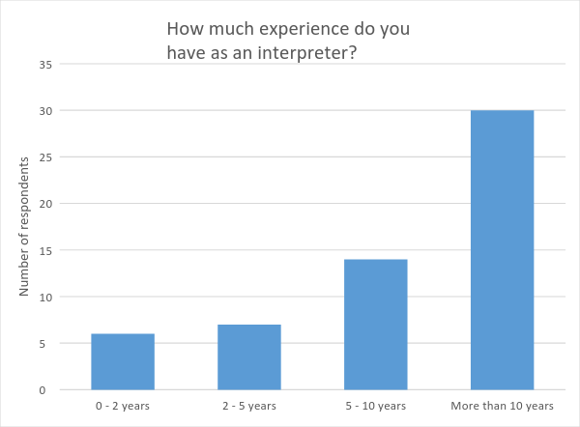

*Figure 4: SLIANZ membership*

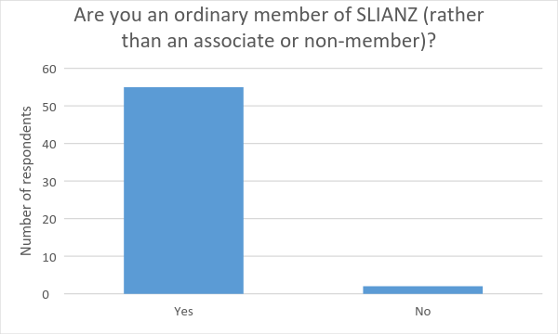

*Table 8: Place of employment*

|  |  |  |  |  |
| --- | --- | --- | --- | --- |
|  | Freelance direct | Agencies | Employed (staff) | Other |
| # of respondents* | 42 | 41 | 23 | 3 |
| Average | 44% | 48% | 71% | 65% |
| Highest percentage | 100% | 100% | 100% | 100% |
| Lowest percentage | 0.5% | 5% | 2% | 10% |

*Figure 5: Volume of work*

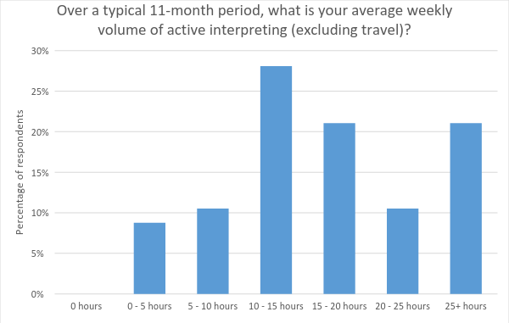

*Figure 6: Registration of new graduates*

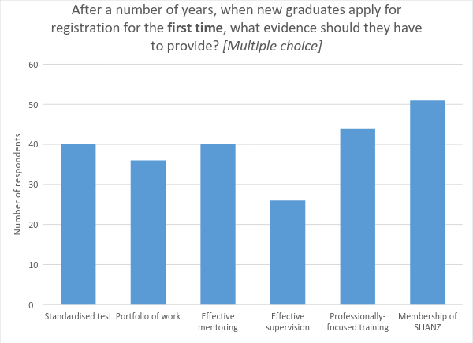

*Figure 7: Re-registration of intermediate interpreters*

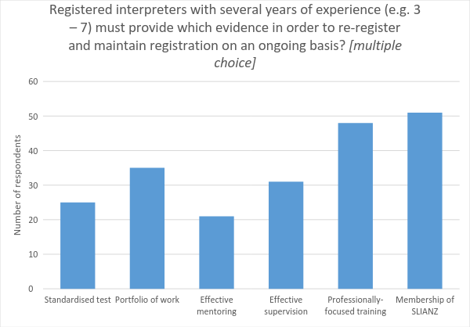

*Figure 8: Reregistration of senior interpreters*

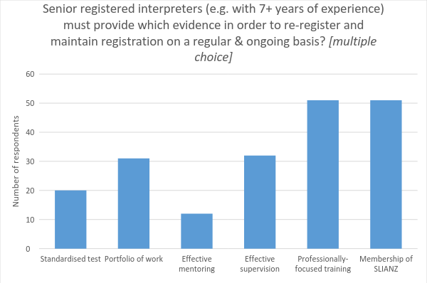

*Figure 9: Registration standard*

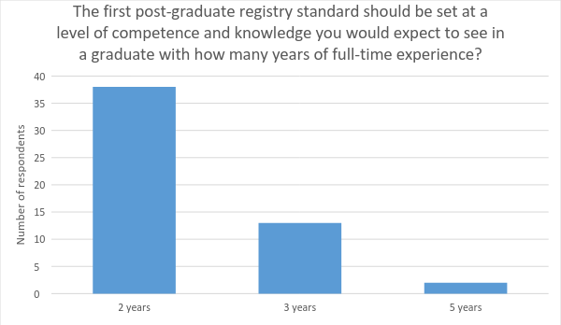

*Figure 10: Early registration*

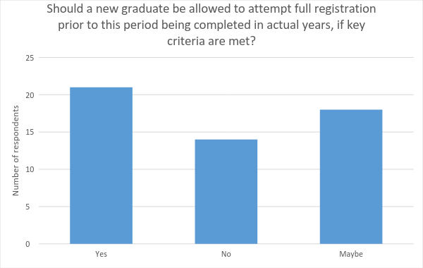

*Figure 11: Frequency of re-registration*

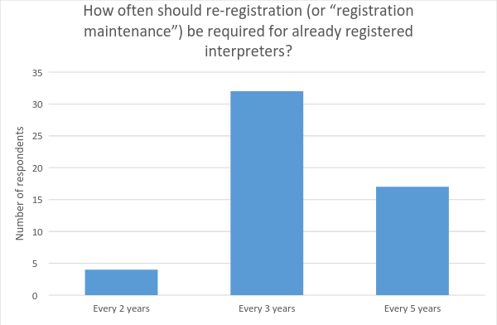

*Figure 12: Absence from interpreting - impact on registration*

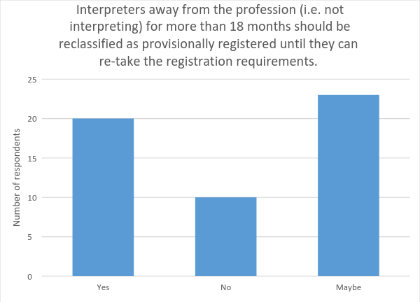

*Figure 13: Registering international interpreters*

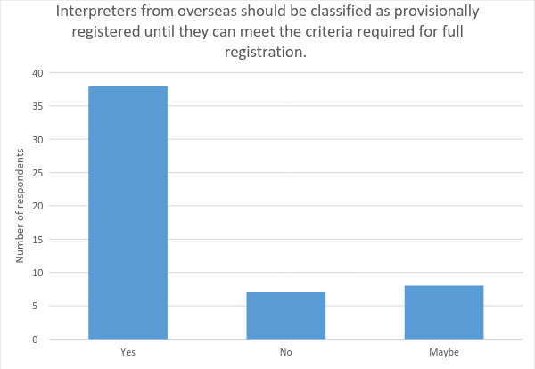

*Figure 14: Mentoring willingness*

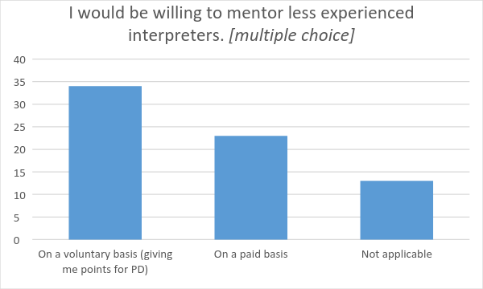

*Figure 15: Interpreting levy*

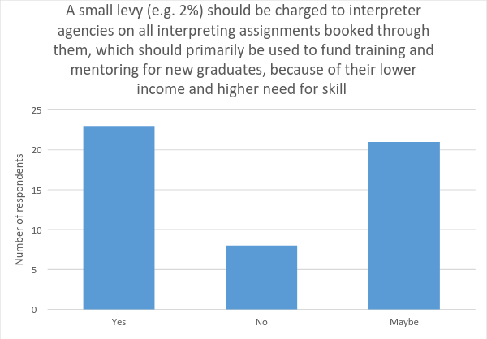

*Figure 16: Impact of levy*

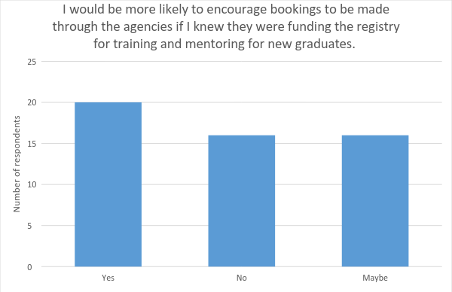

*Figure 17: Registry value to interpreters*

All professional services incur costs running their business, including professional membership, training, supervision, etc. Given that the interpreter registry needs to be self-sustaining in the longer term, some contribution from interpreters may be required. This question seeks to test the value you would place on key components of the registry. What is the maximum amount that would be reasonable to be paid by an experienced full-time interpreter PER YEAR for the following registry components?

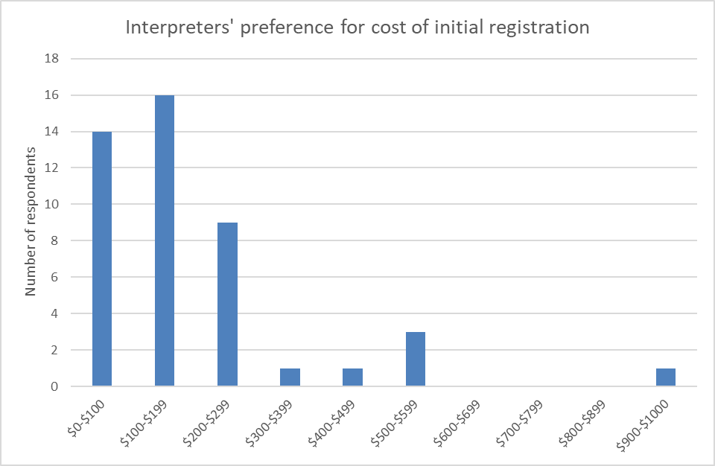

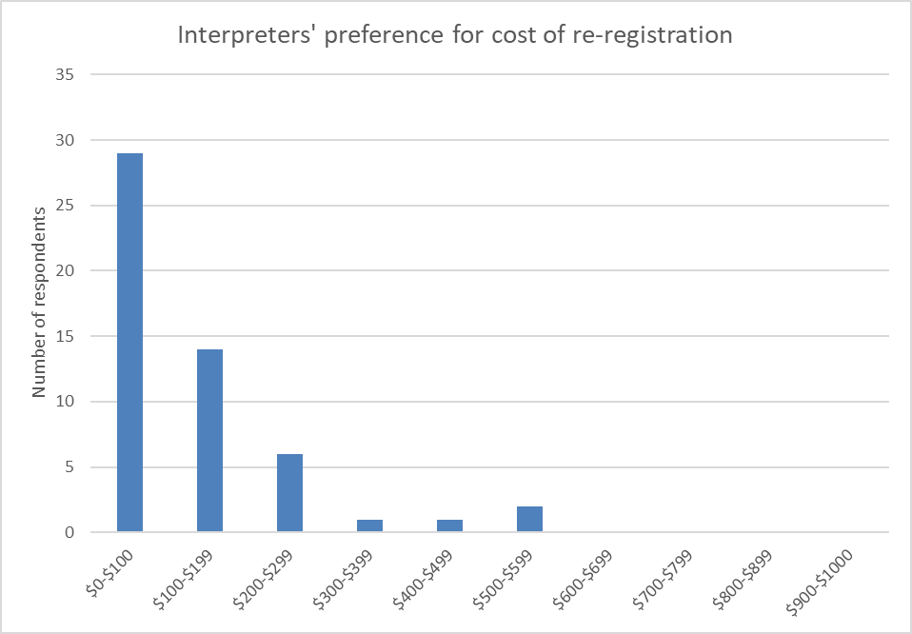

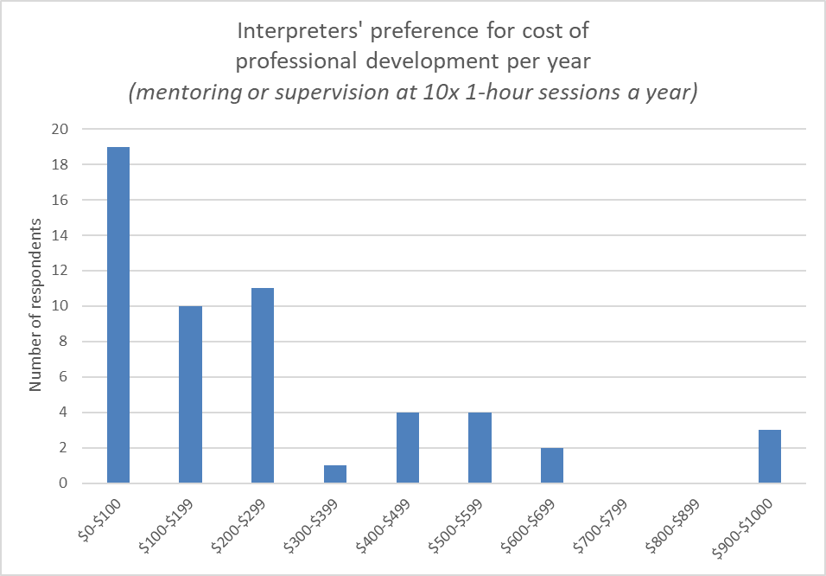

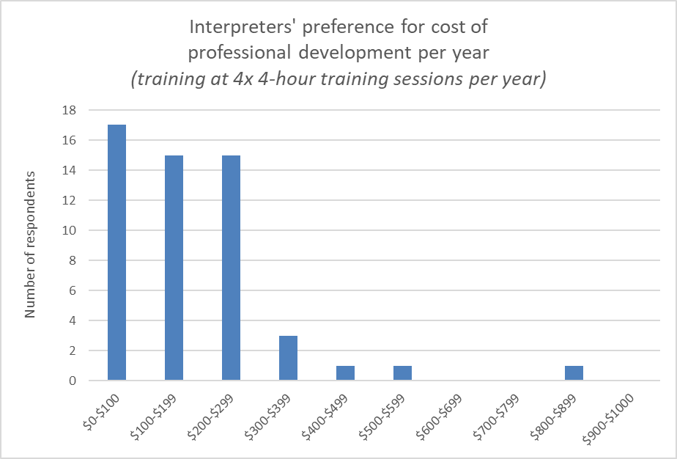

**Average value**

Initial registration - $167.89

Re-registration - $121.28

Professional Development - training - $176.86

Professional Development - mentoring/supervision - $263.64

# Appendix 4: Draft registry overview

Registry and board

Test

Standardised Contracted

twice a year (NI & SI)

Post-qualification training

Contracted providers

Key workforce needs drive training

Mentoring

Contracted: Assessment focused for new grads

Mentor paid for first 5 years

Complaints

Rigorous system for serious complaints

HDC supported by registry & SLIANZ

# Appendix 5: Draft Registrar job description

We’re searching for a senior administrator to manage and coordinate the NZSL interpreter registry, including testing, training, mentoring and complaints systems.

Reports to: Registry Board

Other key relationships: Advisory Board, office holders at SLIANZ, VUW Deaf Studies Research Unit, and AUT interpreter training programme, interpreter providers, and government agencies.

**Purpose:** To effectively operate a NZSL interpreter registry that continuously enhances interpreter quality and accountability.

|  |  |
| --- | --- |
| **Expected Outcomes:** | **Associated Tasks** |
| Registration of interpreters that meet criteria | * Develop and operate system for acknowledging AUT and equivalent qualifications for provisional registration. * Note if the following have been demonstrated and issue registration certification, where appropriate: * Passed skills proficiency and portfolio assessments * proof of 16 points of training (including mentoring and Demonstration of self-reflective practice * proof of mentoring from an approved provider * membership of SLIANZ * Maintains records of registered NZSL interpreters. |
| Contracts are in place for providers of training, mentoring and assessment and complaints. | * Develops, negotiates and monitors contracts for roles. * Identifies where there are problems or inefficiencies and finds solutions using expert assistance. |
| Information from assessment results and mentoring feedback inform contracts with trainers and mentors. | * Coordinate feedback from assessors, trainers, mentors and complaint panellists to feed into the broader system as required. |
| Resources and materials needed to operate the interpreter registry system are in place. | * Supports the development of resources and materials by identifying and coordinating the people required. * Organises training for assessors, mentors and complaint panellists. * Oversees database and website. |
| Assessment tests take place at least twice a year, perhaps repetitively in Auckland, Wellington and Christchurch. | * Promotes and organises interpreter tests in agreed locations. * Runs the tests, ensuring interpreters are aware of clear process. * Organises panellists to review test results at distance and meet virtually if there is any disagreement. |
| Core training programmes are valuable. | * Coordinates input from mentors, assessors, complaint panellists, and evaluations of training to develop the next year’s programme. * Produces a catalogue of approved events. * Communicates decisions to interpreters. |
| Complaints processes are in place | * Clear systems for managing complaints are in place. * Complaints investigators are identified and organised for serious complaints when needed. * Is a contact person for Health and Disability Commission and Human Rights Commission. |
| Funding income is managed | * Identifies and collects revenue from interpreter providers and interpreters where needed. * Provides clear reports on use of all registry funding. |
| Manages budget and expenditure | * Maintains close scrutiny of budget and ensures expenditure remains within set limits. * Authorises and expedites payment of invoices. |
| Registry requirements are clear | * Communicates registry requirements and answers questions on these from interpreters and consumers. |

**Personal qualities/qualification/experience:**

* High degree of interpersonal skills, communicates clearly – written, verbal or in NZSL, with interpreters, Deaf people, Board, and key government officials.
* NZSL interpreting skills is preferred but not essential.
* Inspires and effectively coordinates contractors and team members.
* Is able to work independently and manage time efficiently.
* Passion for and interest in the Deaf community and interpreting
* Experience in managing multiple priorities, administrative coordination, and logistics, and is able to work under pressure.
* Has a problem-solving focus and is able to seek advice and judge the value of key options before recommending or implementing a solution.
* Is confident with communication technology (computer, online meetings, etc)
* Is able to work at a detailed level and at the same time hold a coherent overview of the registry system.
* Eliminates unnecessary expenditure and works within budget.
* Bachelor’s degree or equivalent experience.

**Hours/Days of work:**

This position is required to work 20 hours a week (developing system and then reviewed once system is settled after one year) based in Wellington (close to government) or Auckland (close to the majority of interpreters).

# Appendix 6: Some comparative fees

|  |  |  |  |
| --- | --- | --- | --- |
| **Number of teachers in NZ** | 47,264 | Primary and secondary |  |
| **Education Council** | Registration, including annual practicing certificate | $ 303 | One-off |
|  | Renewal | $ 220 | Three-yearly |
|  |  |  |  |
| **Speech Language Therapists Association** |  | 700 members | |
|  | Full time | $ 465 |  |
|  | Part time | $ 323 |  |
|  | Students | $47 |  |
|  |  |  |  |
| **Social Workers Registration Board** | |  |  |
| Number of social workers in NZ | | 6000 |  |
| **Annual practicing certificate** | $ 365.00 |  |  |
| **Membership** | **Pre-discount, from 1 April 2017** | **Discount for payment by due date** | **GST incl, post discount** |
| Full A Members | $362 | 10% | $326 |
| Full B Members | $267 | 10% | $240 |
| Full C Members | $193 | 10% | $174 |
| Prov A Members | $362 | 10% | $326 |
| Prov B Members | $267 | 10% | $240 |
| Prov C Members | $193 | 10% | $174 |
| Non-Practicing | $178 | 10% | $160 |
| Non-Practicing Overseas | $156 | 10% | $140 |
| Non-Practicing Retainer | $56 | 10% | $50 |
| Associate* | $293 | 10% | $264 |
| Student (full time or no SW Emp) | $30 |  | $30 |
| Student (SW EMP) | $133 |  | $133 |
| New Member provisional year | $133 |  | $133 |
| Recertification Assessment | $153 |  | $153 |
| Competency Assessment (paper-based) | $230 |  | $230 |
| Competency Assessment (kanohi ki kanohi / face-to-face) | $358 |  | $358 |
|  |  |  |  |
|  |  |  |  |
| **Nursing Council of NZ** |  |  |  |
| Number of registered nurses in NZ | 45,000 |  |  |
| **Annual practising certificates** |  |  |  |
| 12 months *(includes $10.00 Disciplinary Levy)* | $110 |  |  |
| **Registration fees (for applicants qualified in New Zealand)** |  |  |  |
| Registration as registered nurse or enrolled nurse | $75 |  |  |
| Application for registration as nurse practitioner (including prescribing) | $1,500 |  |  |
| Nurse practitioner prescribing authorisation | $1,000 |  |  |
| Application for change of condition in scope of practice | $200 |  |  |
|  |  |  |  |
| **Provision of information on national Register of Nurses** |  |  |  |
| Inspection of the Register (search fee) | $70 |  |  |
| Replacement registration practising certificate | $70 |  |  |
| Verification of education programme | $70 |  |  |
| Verification of New Zealand registration | $70 |  |  |
|  |  |  |  |
| **Examination fees** |  |  |  |
| Registered nurse and enrolled nurse (includes New Zealand registration fee) | $240 |  |  |
| Mental health | $51 |  |  |
| Fees for late transcripts | $102 |  |  |
| Analysis of failed examination | $79 |  |  |
| Extension of time | $10 |  |  |
|  |  |  |  |
| **Fees for education programmes** |  |  |  |
| Accreditation or monitoring audit of nurse entry to practice programme | $2,780 |  |  |
| Accreditation or monitoring audit of post-graduate nursing programme | $13,900 |  |  |
| Accreditation or monitoring audit of programme leading to registration as a registered nurse | $13,900 |  |  |
| Accreditation or monitoring audit of enrolled nurse programme | $8,700 |  |  |
| Accreditation or monitoring audit of competence assessment programme | $3,000 |  |  |
|  |  |  |  |
| **NZ Nurses Organisation** |  |  |  |
| NZNO Membership Fees effective 1 April 2017 | |  |  |
| **Category** | **Annual** |  |  |
|
| Registered nurses and midwives, Health Professionals New Zealand members not affiliated to their professional bodies and not mentioned elsewhere: | $538 |  |  |
| Enrolled nurses, registered obstetric nurses and College of Midwives members, Health Professionals New Zealand members with affiliations to their own professional bodies: | $430 |  |  |
| Caregivers, Health Care Assistants, aides, Karitane nurses, clerical, non-clerical support workers and all other support workers: | $324 |  |  |

# Appendix 7: Glossary

|  |  |
| --- | --- |
| Term | Meaning |
| Interpreting | Refers to NZSL interpreting unless reference to spoken or other language interpreting is made |
| NZSL | New Zealand Sign Language |
| NZSLTA | NZ Sign Language Teachers Association |
| ODI | Office for Disability Issues |
| Registrar | The executive managing and implementing the registry |
| Registry | The organisation defining and implementing criteria for registration |
| SLPI | Sign Language Proficiency Interview |

# References

Deloitte Access Economics (2017): *Listen Hear! Social and Economic Costs of Hearing Loss in New Zealand*; the National Foundation for the Deaf; Auckland.

Disability Resource Centre (2010): *The cost of disability*; Ministry of Social Development; Auckland.

Education Council (2017): *Guidelines for Induction and Mentoring and Mentor Teachers*. <https://educationcouncil.org.nz/content/guidelines-induction-and-mentoring-and-mentor-teachers>

Education Council (2017): *Our Code Our Standards: Codes of professional responsibility and standards for the teaching profession*; New Zealand.

Fitzgerald & Associates (2017): *A review of NZSL Interpreting standards*; Auckland.

Human Resources Professional Association (HRPA) (2016): *What does it mean to be a regulated profession*? HRPA series on governance for professional regulatory body; located online at <https://www.hrpa.ca/Documents/Regulation/Series-on-Governance/What-it-means-to-be-a-regulated-profession-20160101.pdf>

Human Rights Commission (2013): *A new era in the right to sign: New Zealand Sign Language and Human Rights*; Wellington.

Interpreter Issues Working Group (IISW) (2004): *New Zealand Sign Language Interpreter Issues: NZSL Interpreting in Court and Systems for Funding and Supply of Interpreter Services*;

Johnston T (2006).*W(h)ither the Deaf Community? Population, Genetics and the Future of Australian Sign Language;* Sign Language Studies Vol 6 (2).

NZ Immigration (2017): *The Language Assistance Services Project* <https://www.immigration.govt.nz/about-us/what-we-do/our-strategies-and-projects/the-language-assistance-services-project>

Social Workers Registration Board (2017): *Policy on when an annual practicing certificate is required*.

The Braille Authority of New Zealand Aotearoa Trust (BANZAT) (2015): Policy 7: *Accreditation of braille producers working in New Zealand*; 2014 <http://www.banzat.org.nz/publications/policies> The Treasury: *Best Practice Regulation*; NZ Government; Wellington.

United Nations Convention on the Rights of Persons with Disabilities, 2006, downloaded from <http://www.un.org/disabilities/convention/conventionfull.shtml>

[Winston](https://www.amazon.com/s/ref=dp_byline_sr_book_1?ie=UTF8&text=Betsy+Winston&search-alias=books&field-author=Betsy+Winston&sort=relevancerank), B and Lee, R (2013): *Mentorship in Sign Language Interpreting*, Alexandria, VA: Registry Of Interpreters for the Deaf.

1. An example of the Education Council’s mentor handbook can be found here: <https://educationcouncil.org.nz/content/guidelines-induction-and-mentoring-and-mentor-teachers>