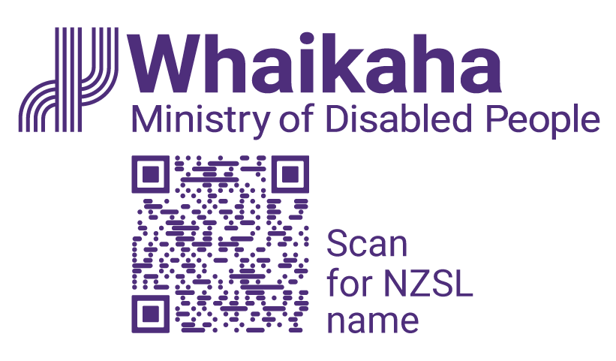
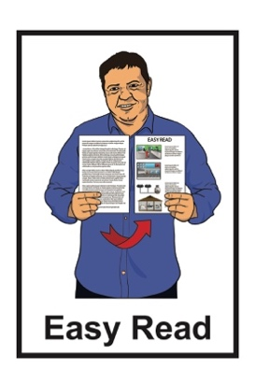

How the Government is getting on with the Disability Action Plan
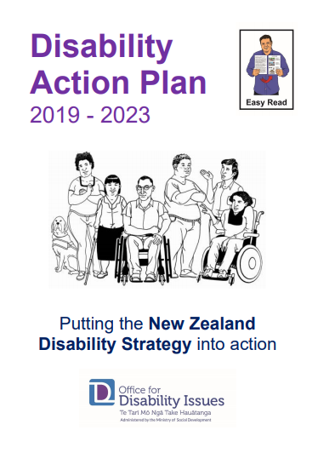

Review of January – June 2022

About this report

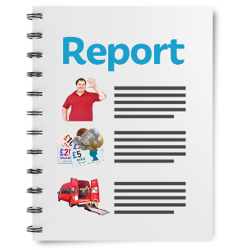
This Easy Read document is a report about how well the Disability Action Plan is working.

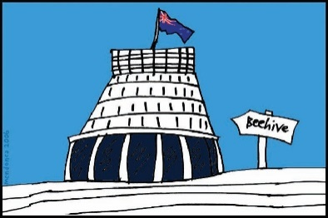
The Disability Action Plan is how the Government will make the New Zealand Disability Strategy happen.

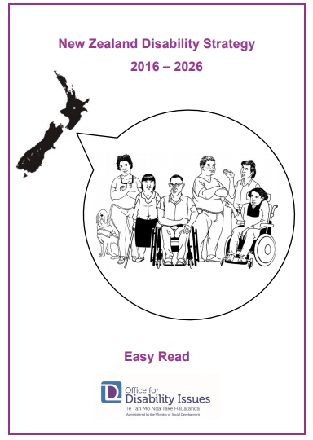
The New Zealand Disability Strategy works to make sure disabled people:

- are treated fairly

- get what they need to have a good life

- are part of the community

- can make their own decisions.
There are Easy Read translations about the:
New Zealand Disability Strategy
Disability Action Plan.

You can find these Easy Read translations on the Office for Disability Issues website:

https://www.odi.govt.nz

What is the Disability Action Plan?

The Disability Action Plan works to improve the wellbeing of disabled people by working on 8 main outcomes.

Wellbeing means how people feel about their lives.

Some of the things that are important to wellbeing are:
- health
- money
- housing.

Outcomes are the things we want to happen from the Disability Action Plan.

These outcomes are:
Education
Jobs and money
Health and wellbeing
Protecting the rights of disabled people
Accessibility
Attitudes towards d isability
Disabled people having choices
and control over their own lives
Disabled people as leaders.

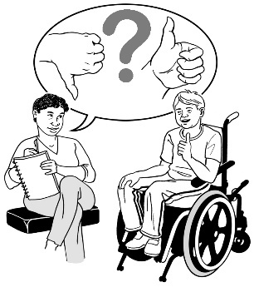
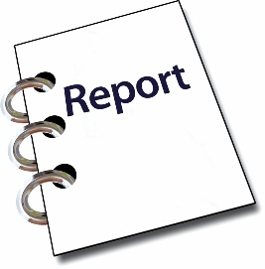
Every 6 months there is a report about what the different parts of Government are doing from the Disability Action Plan.

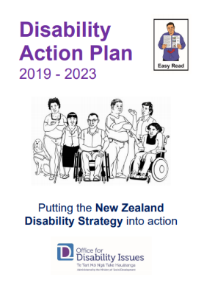
These reports are 1 of the ways to see how well the Disability Action Plan is working.

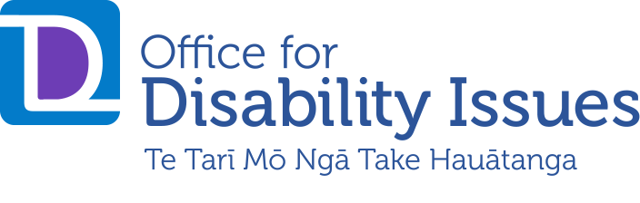
The Office for Disability Issues used to make these reports.

The Office for Disability Issues is now part of Whaikaha – Ministry of Disabled People.

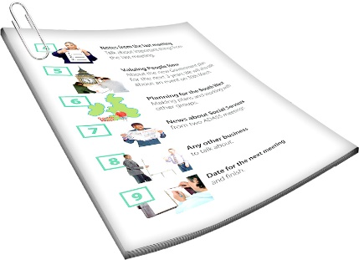
When we talk about Whaikaha – Ministry of Disabled people in this document we will just say Whaikaha.

Whaikaha is a new part of the government that will:
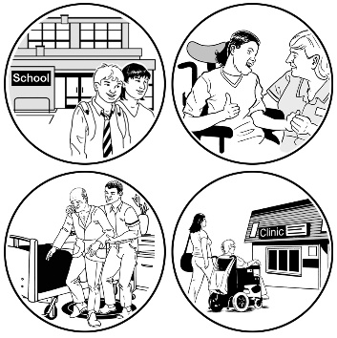
make disability support services better for disabled people and their families / whānau
use an Enabling Good Lives way of doing things
work with other government agencies to better support disabled people.

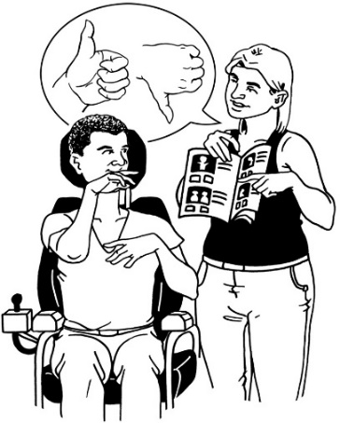
Enabling Good Lives is a different way of thinking about disability support that gives people more choice.

This is the first of the reports that Whaikaha has done.

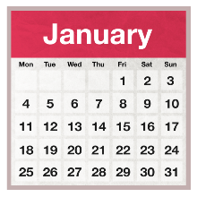
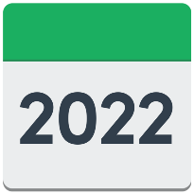
This report looks at what the different parts of Government did from:

January 2022

to

June 2022.

How things are going

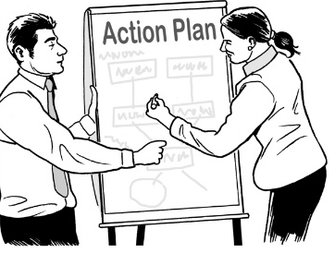
29
The Disability Action Plan has 29 work programmes.

7
The people working on 7 of these programmes said their work is going well.
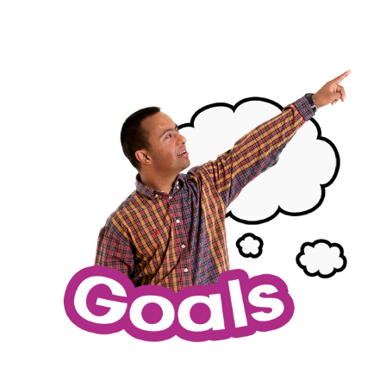

The people working on these 7 programmes said they are meeting the goals set out in the Plan.

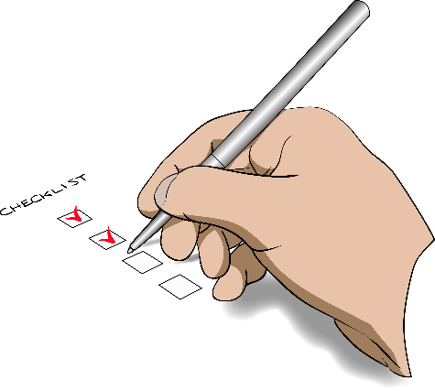
Goals are the things the people planned to do by a certain time.

Some of those 7 people said they are further ahead than planned.
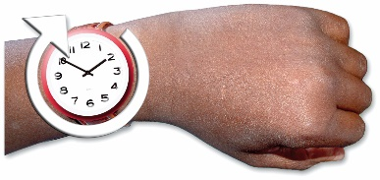
The people working on 14 of the programmes said they will finish on time.
14

The people working on 5 of the programmes said they have not done as much as the plan said.
5

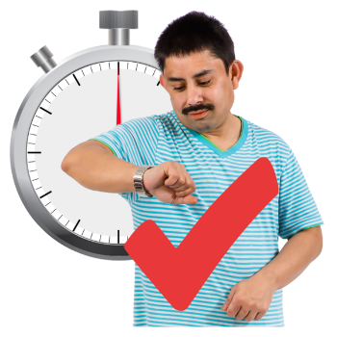
The people working on these 5 programmes said they think they will still finish their work on time.

3 of the work programmes have had problems with doing their work on time.
1

This is better than the last report.

In the last report 5 of the work programmes had problems doing their work on time.
5

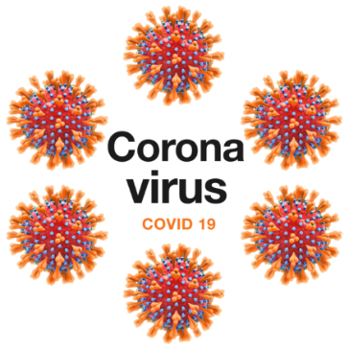
Some of these people say the reason they have problems doing their work on time is the COVID-19 pandemic.

The DPO coalition says they have had enough time to change things to deal with COVID-19.

The DPO Coalition is a group of people who come from different disability organisations.

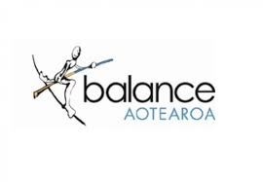
The DPO Coalition is made up of members from these 6 disability organisations:

- Balance Aotearoa
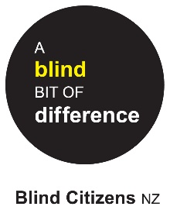

- Blind Citizens New Zealand

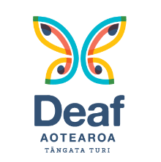
- Deaf Aotearoa

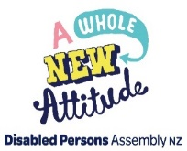
- Disabled Persons Assembly NZ
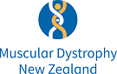
- Muscular Dystrophy Association of New Zealand

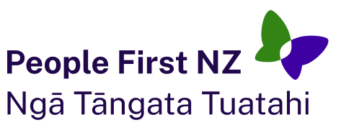
- People First New Zealand – Ngā Tāngata Tuatahi.

What the DAP Review Group has to say

The Disability Action Plan Review Group is a group of people who check how the Disability Action Plan is going.

The Disability Action Plan Review Group is also called the DAP Review Group.

This group is made up of people from:
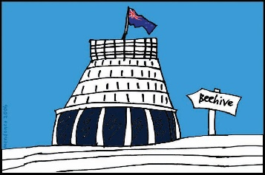
the DPO Coalition
the Government.

The DAP Review Group had some things to say about how the:
work programmes are going
reports talk about the work programmes.

The DAP Review Group said that when people say their work is going well it might:
be going well for how they want to do things
but not be following the plans they agreed to when the Disability Action Plan started.

Contents page

You can find more information about Whaikaha on our website at:

www.whaikaha.govt.nz

You can also contact us by:
email at:
contact@whaikaha.govt.nz
phone on:
0800 556 601
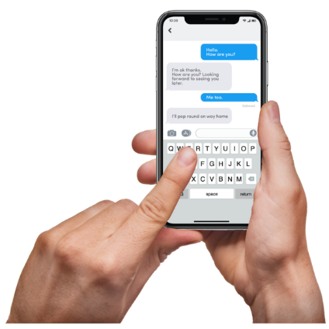
text at:
4206

This information has been written by Whaikaha – Ministry of Disabled People.

It has been translated into Easy Read by the Make it Easy Kia Māmā Mai service of People First New Zealand Ngā Tāngata Tuatahi.

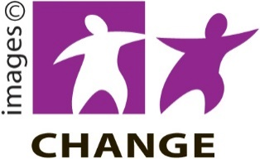
The ideas in this document are not the ideas of People First New Zealand Ngā Tāngata Tuatahi.

Make it Easy uses images from:

- Changepeople.org

            - Photosymbols.com

- SGC Image Works
- Huriana Kopeke-Te Aho
- T.Wood.
All images used in this Easy Read document are subject to copyright rules and cannot be used without permission.

