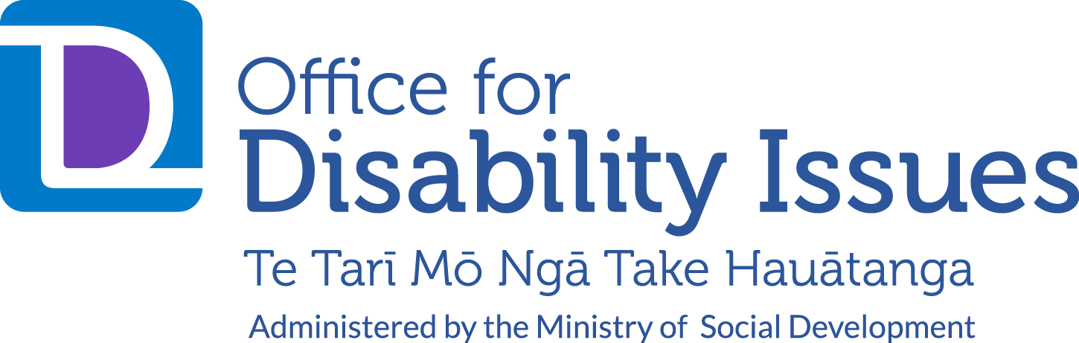

A report about how some
disabled people found things
during the COVID-19 lockdown

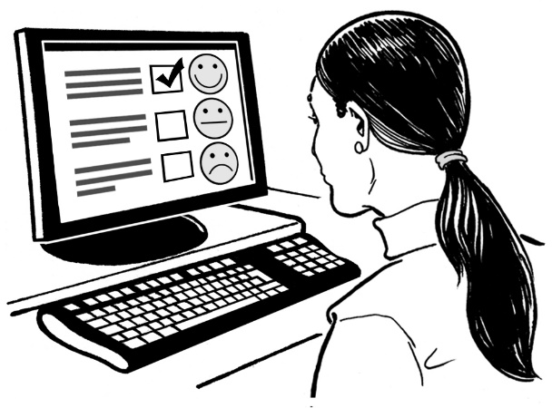

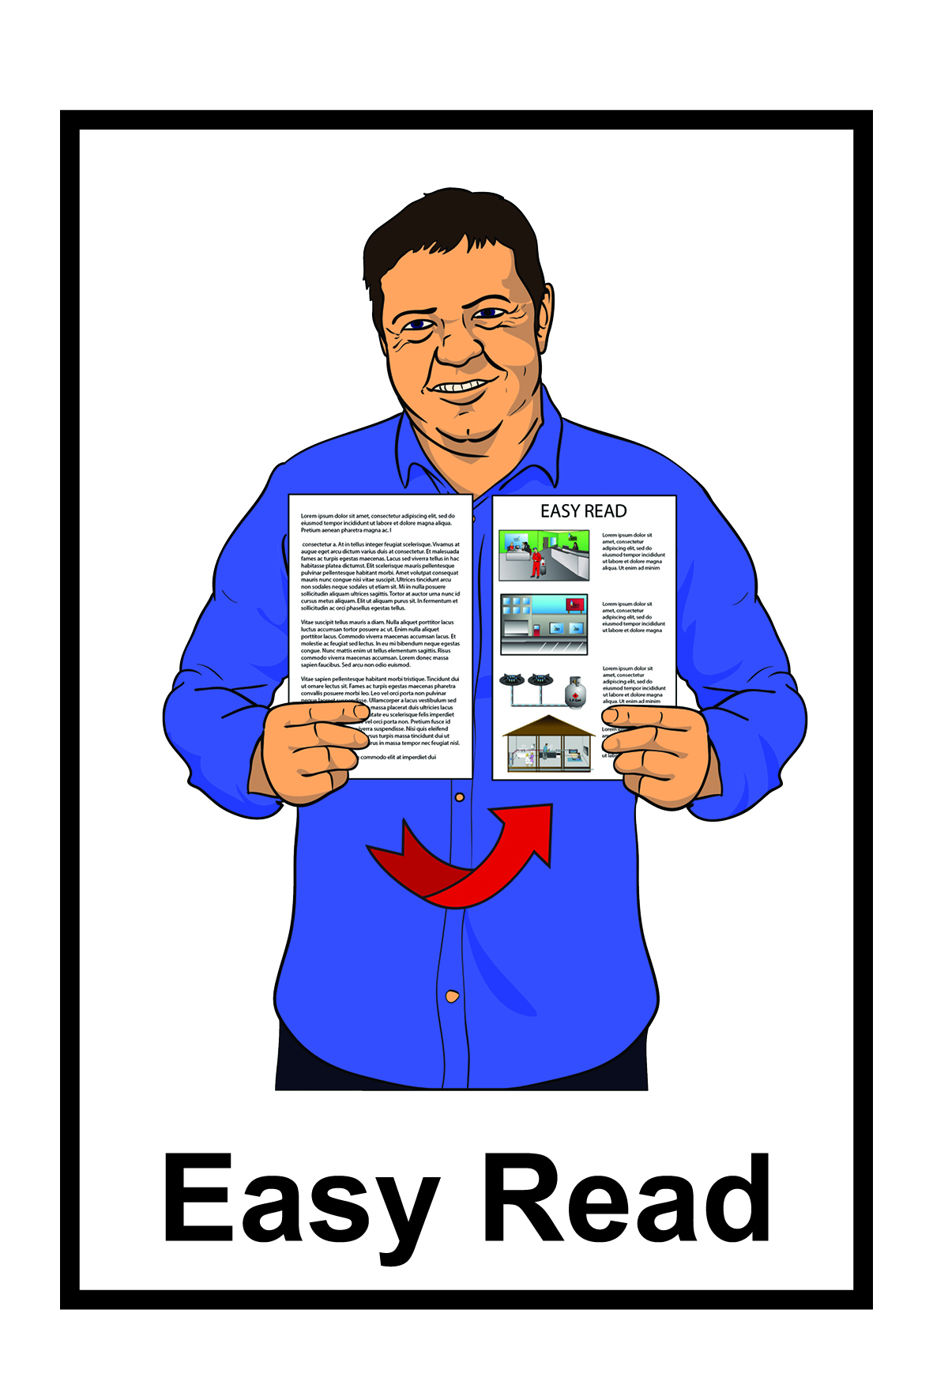

December 2020

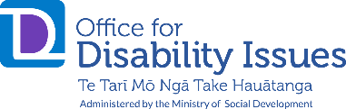
This is a report from the Office for Disability Issues.
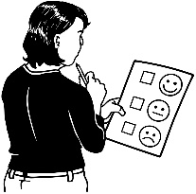

We asked people survey questions.

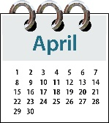
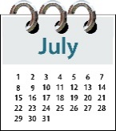
We asked the same questions 4 times between April and July 2020.

The questions were about how some disabled people felt during the
COVID-19 lockdown in 2020.

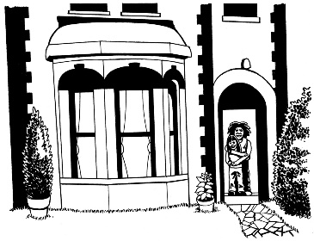
The COVID-19 lockdown was the time when people needed to stay at home because of the COVID-19 virus.

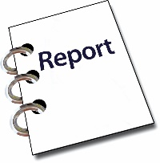
This report is about the answers people gave us.

Who did the survey?

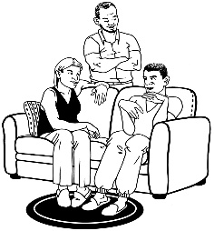
The survey was for:

- disabled people

- families of disabled people
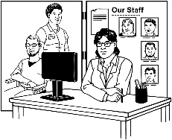
- disability service providers

- community advocates.

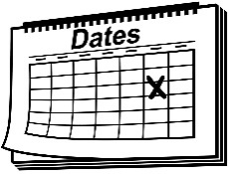
We asked people to do the survey 4 times between April and July 2020.

This was so that we could see how things were changing for people.
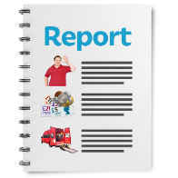

This report tells us some of what those people said.

How did we ask the questions?
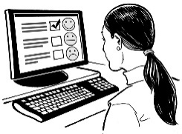

The survey questions were online.

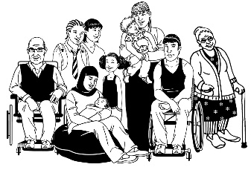
Not all disabled people doing the survey answered all of the questions.

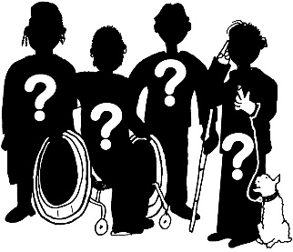
Some disabled people have different experiences that are not in this report.

What will happen to the answers

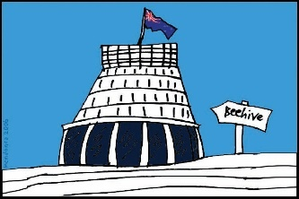
The answers from the survey will help the Government to:
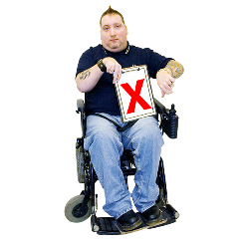
- understand what problems disabled people had during the lockdown

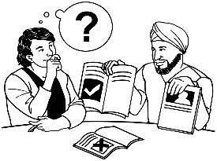
- work out what the Government could do differently.

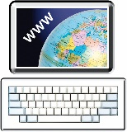
To find out more about the survey go to the Office for Disability Issues website:

https://www.odi.govt.nz/guidance-and-resources/
how-life-is-going-for-the-disability-co/

What were the questions about?

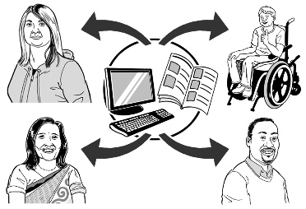
The questions were about:

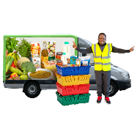
- information

- food shopping

- feeling safe
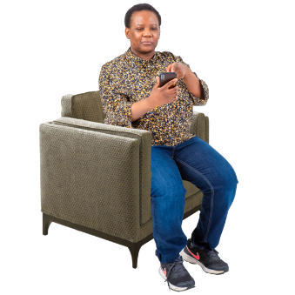
- feeling lonely

- feeling well
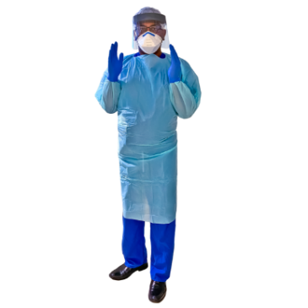
- having enough personal protective equipment.

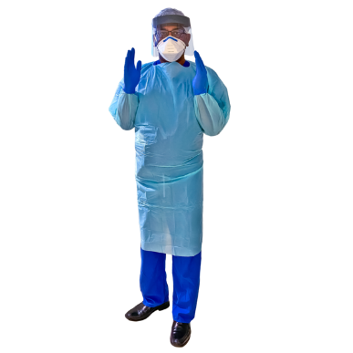
Personal protective equipment means things to keep everyone safe from COVID-19 like:
- masks
- gloves
- gowns.

Personal protective equipment is also called PPE.

What did the survey answers find?

- Information

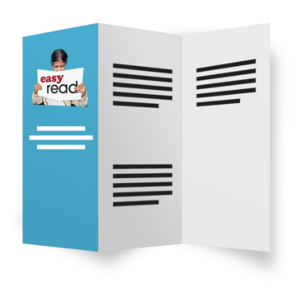
We asked if disabled people had the information they needed about COVID-19.

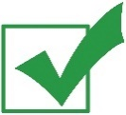
Most disabled people said they had Government information about COVID-19.

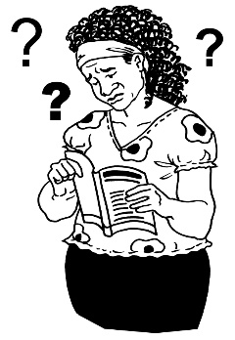
Some disabled people said that there was:

- too much information or it was confusing
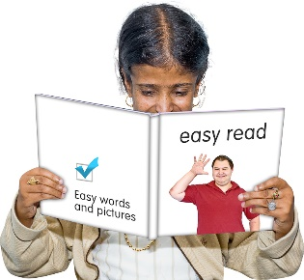
- not enough information in accessible formats like Easy Read.
Some disabled people said that there was:

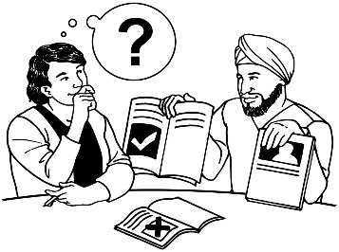
- not enough access to digital technology like computers.

- not enough disability support information during lockdown.

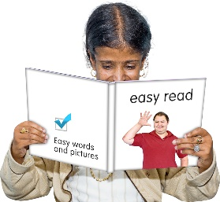
Later in the lockdown there was more information in:

- Easy Read

- New Zealand Sign Language.

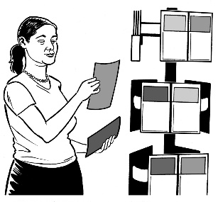
Most service providers said:

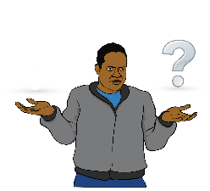
- disabled people had access to Government information about COVID-19

- some disabled people found the information difficult to understand.

- Personal protective
equipment / PPE
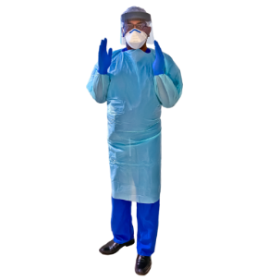

We wanted to know if disabled people had enough PPE.

These people said they did not have enough PPE:

- disabled people

- families of disabled people

- service providers.
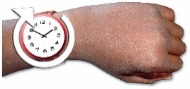

Later in the lockdown service providers said they got more PPE.

- Food
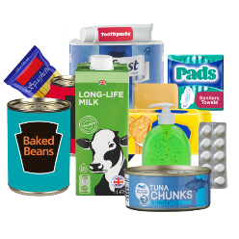

We wanted to know if disabled people had food.

Most disabled people said they had food.
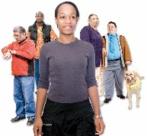

Some disabled people had problems with:
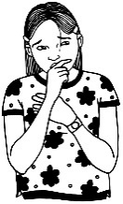
- waiting in long lines

- worrying they might catch COVID-19 at the shops
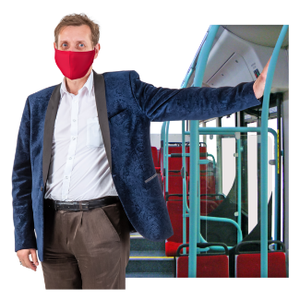
- transport to the shops.

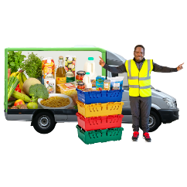
Service providers said disabled people had problems with:

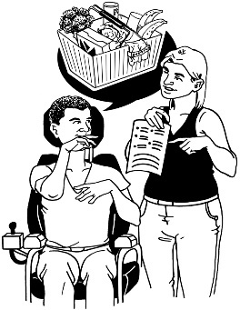
- getting food they had ordered online

- not getting enough support for shopping.

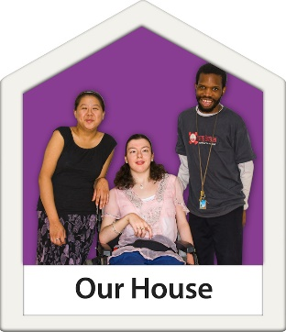
- Feeling safe

We wanted to know if disabled people felt safe at home.

Most disabled people said they felt safe.

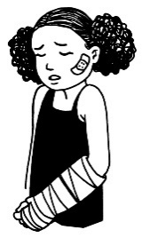
Some disabled people and their families were worried about:

- getting hurt at home
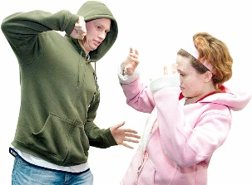
- managing violent behaviour.

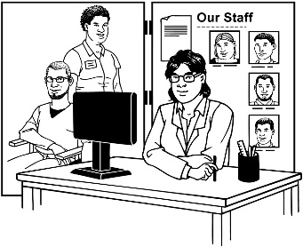
Service providers did not think that disabled people were safe.

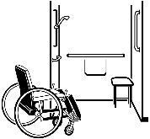
Service providers thought disabled people needed:

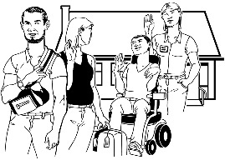
- houses with disability equipment

- more support to get a break from family.

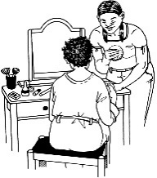
Service providers were worried that caregivers would spread COVID-19 by working in lots of different disabled people’s houses.

- Loneliness

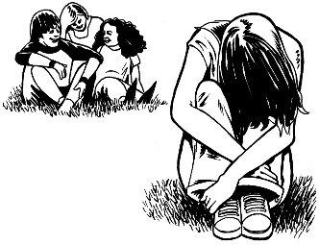
We wanted to know if disabled people felt lonely.

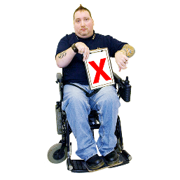
Some disabled people felt lonely.

People who lived on their own felt more lonely.

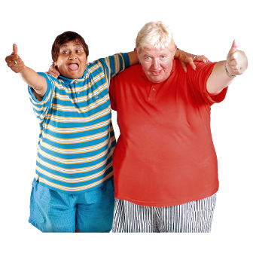
Lots of people missed their:

- friends

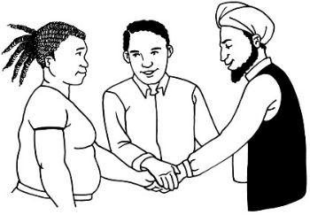
- family

- people they worked with.

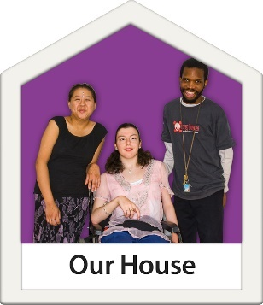
People felt less lonely if they:

- lived with other people
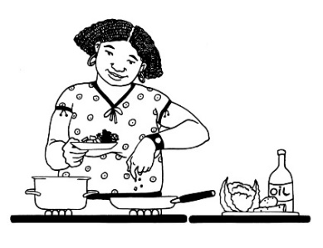
- had lots of things to keep them busy

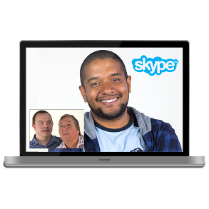
- kept in touch with people using technology like computers.

- Health
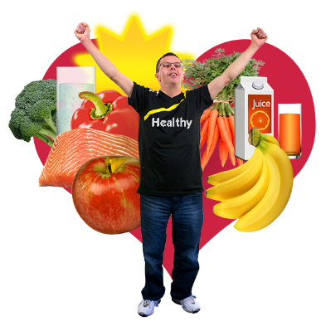

We wanted to know if disabled people felt well during the COVID-19 lockdown.

Most disabled people said they were well.

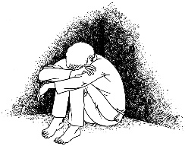
Some people had problems like:

- mental health issues

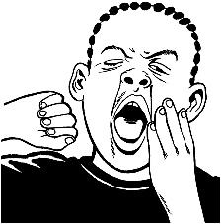
- feeling anxious

- feeling tired

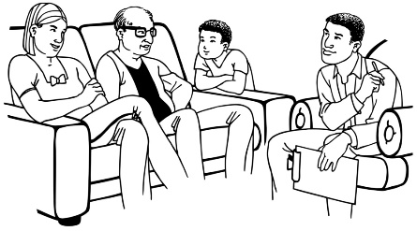
- living alone

- staying away from family members.
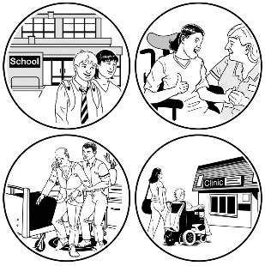
Some people said they had problems with needing more support staff.

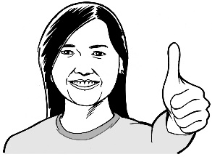
Most people said they felt better in the later surveys.

- Good things that happened
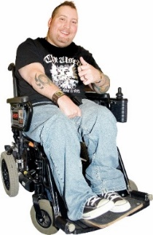

In the third survey we asked people what good things had happened during lockdown.

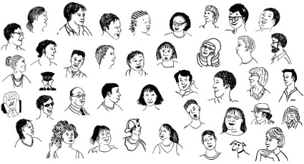
48 disabled people and their family told us about good things that had happened.

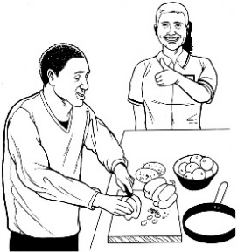
Here are some of the good things:

- great staff
- disability services changing to meet different needs

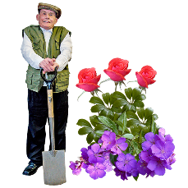
- staying in touch through technology like computers

- having more time for hobbies.

Thank you

Thank you for playing your part in stopping the spread of COVID-19.

You can find the full survey report on the Office for Disability Issues website:

www.odi.govt.nz/guidance-and-resources/how-life-is-going-for-the-disability-co/

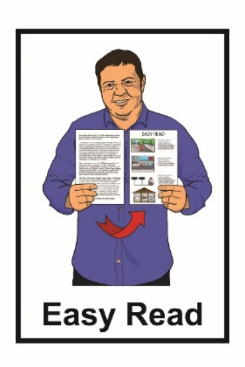
This information has been translated into Easy Read by the Make It Easy service of People First New Zealand Inc. Ngā Tāngata Tuatahi.
The ideas in this document are not the ideas of People First New Zealand Ngā Tāngata Tuatahi.
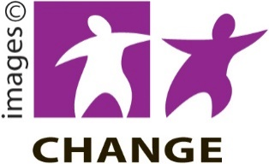
Make It Easy uses images from:

- Changepeople.org

- Photosymbols.com

- Sam Corliss

All images used in this Easy Read document are subject to copyright rules and cannot be used without permission.

